View the History of a File
If versioning is turned on, a version is created whenever a file is saved. If check out/check in is turned on, a version is created whenever a file is checked in. The history lists the versions of the file, the person who made the changes, the date and time the version was created, and any comments describing the changes. Changing the properties of a file creates a version just as changing the content of a file does.

Contents
View History – Method 1
View History – Method 2

View History – Method 1
- Navigate to the library.
- Select the file by clicking the checkbox next to the name of the file.
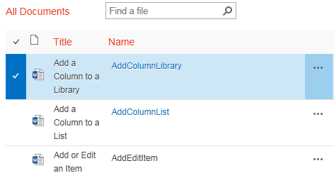
- On the ribbon, click the FILES tab. In the Manage group, click Version History.
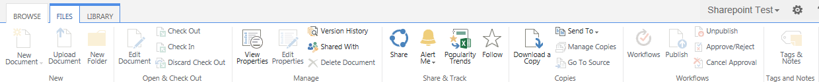
- The Version History dialog displays the history of the file. To open the version in its application (such as Word), click the date and time link.
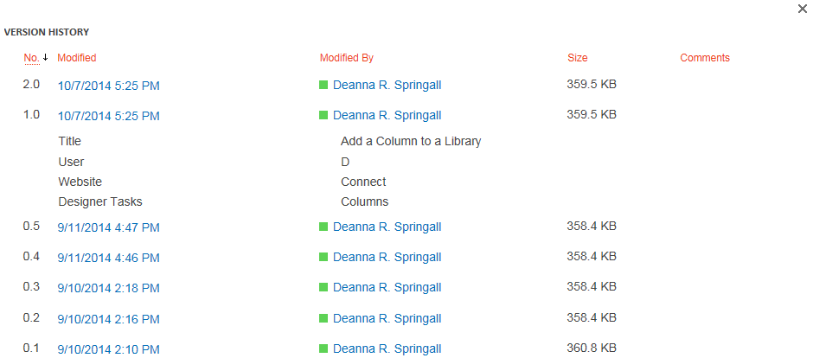
- To view the properties of a particular version of the file, you can hover over the date and time link, click the down arrow, and click View.
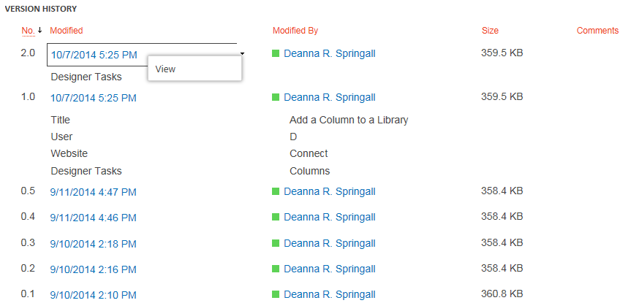The dialog displays the file’s properties, and offers additional options to view and manage the version. Available options depend upon your permissions.
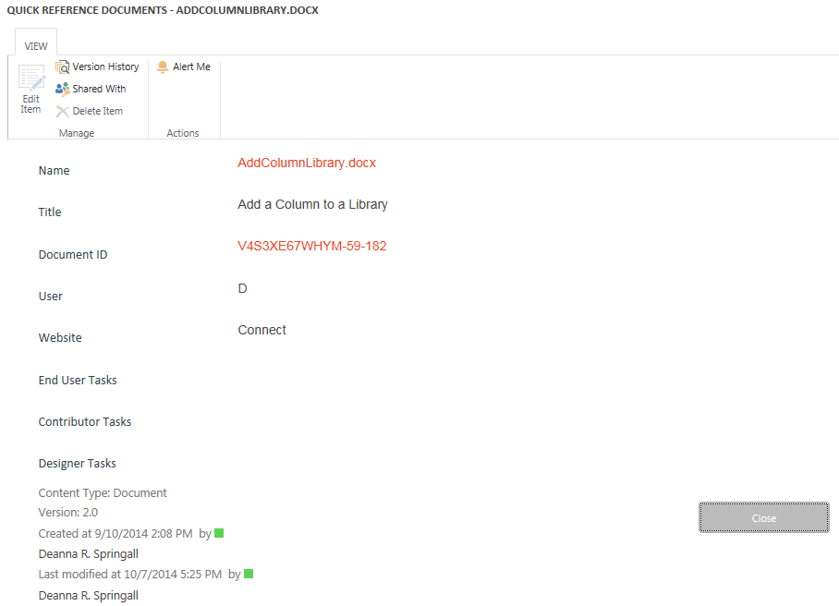

View History – Method 2
- Navigate to the library.
- Select the file by clicking the checkbox next to the name of the file. Click the ellipsis next to the name of the file, and click the ellipsis in the callout. In the context menu, click Version History.
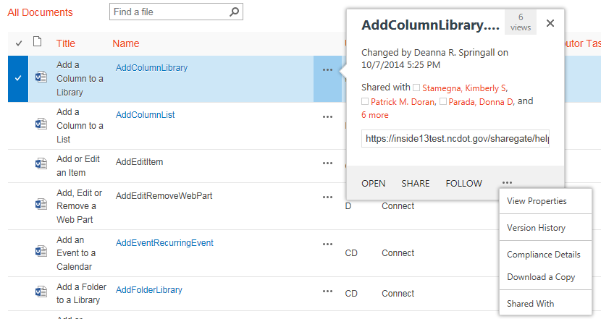
- Continue with step 4 in the previous section.

