View the History of an Item
If versioning is turned on, a version is created whenever an item is saved. The history lists the versions of the item, the person who made the changes, the date and time the version was created, and any comments that describe the changes.

Contents
View History – Method 1
View History – Method 2

View History – Method 1
- Navigate to the list.
- Select the item by clicking the checkbox next to the title of the item.
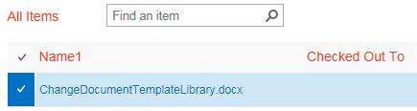
- On the ribbon, click the ITEMS tab. In the Manage group, click Version History.
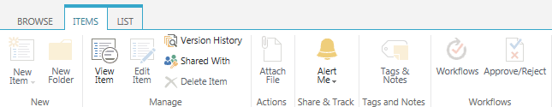
- The Version History dialog displays the history of the item. To view the properties of a particular version of an item, you can click the date and time link or you can hover over the date and time link, click the down arrow, and click View.
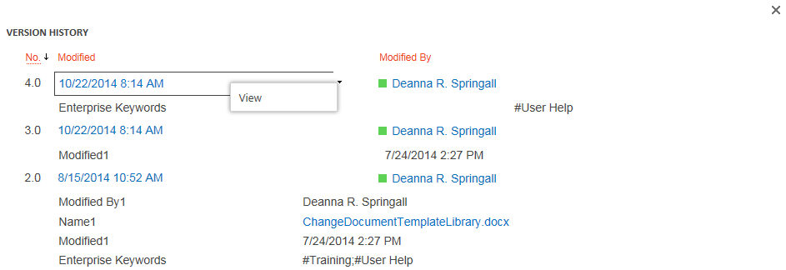The dialog displays the item’s properties, and offers additional options to view and manage the version. Available options depend upon your permissions.
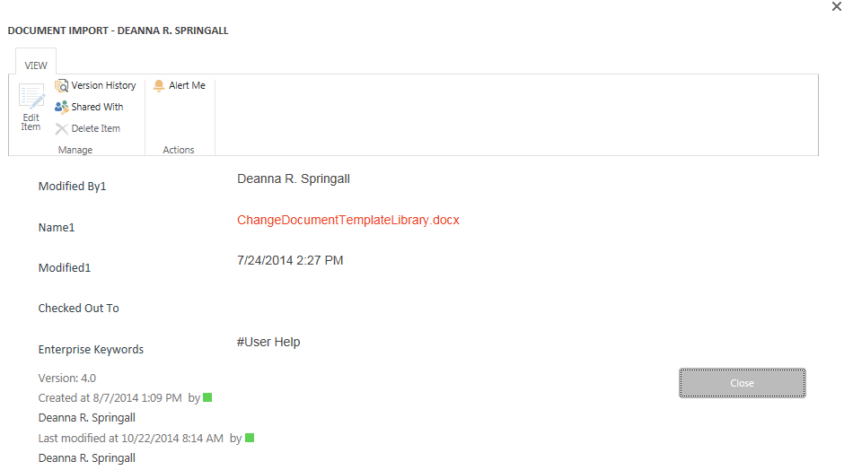

View History – Method 2
- Navigate to the list.
- Select the item by clicking the checkbox next to the title of the item. Click the ellipsis next to the file name, and click Version History.
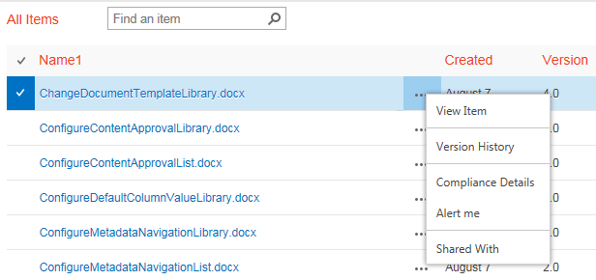
- Continue with step 4 in the previous section.

