Configure Versioning for a Library
Versioning is the tracking of changes to a file as it is revised over time. For example, you can see when a file was changed, who changed it, and what changes were made to the file’s content and properties. You can view and restore earlier versions and read comments entered by those who revised the file.
You can choose to keep either major versions and major/minor versions. If you choose major versions only, revisions are simply tracked as whole numbers (1.0, 2.0, 3.0).
If you choose to create major and minor versions, minor versions are treated as drafts and are tracked as decimal numbers (1.0, 1.1, 1.2). Drafts are useful because they can generally be seen only by their authors and approvers. When a draft is ready for release to others, an author or approver designates it as a major version and its number increments to the next whole number. In this example, the next major version would be 2.0 and subsequent drafts would be 2.1, 2.2, and 2.3.
You can limit the number of major versions that you want to keep; a general guideline is to keep no more than three to five major versions. You can also define how many major versions will store associated minor versions; for example, you can keep minor versions for the last three major versions. Keep these limits low to avoid using too much system space. Finally, if Content Approval is on, you will have additional options.
Note: Content Approval, Versioning, and Check Out/In are interrelated. Refer to the help files on Content Approval and Check Out, Check In or Discard a Check Out. Also, refer to the Designer class materials for a detailed explanation of the interrelationship.

Contents
Go to Versioning Settings
Create Major Versions
Create Major and Minor (Draft) Versions

Go to Versioning Settings
- Navigate to the library.
- On the ribbon, click the LIBRARY tab. In the Settings group, click Library Settings.
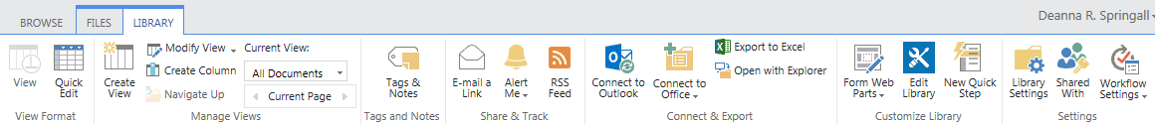
- On the Settings page under General Settings, click Versioning Settings.
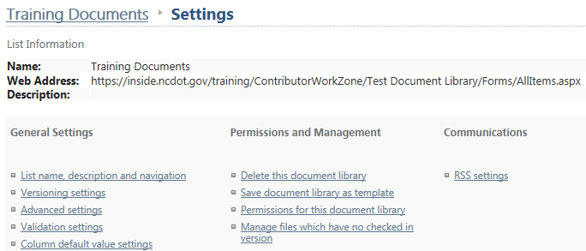
- Choose the versioning option. Additional options become available and are detailed in the next sections. Click OK to store your selection.
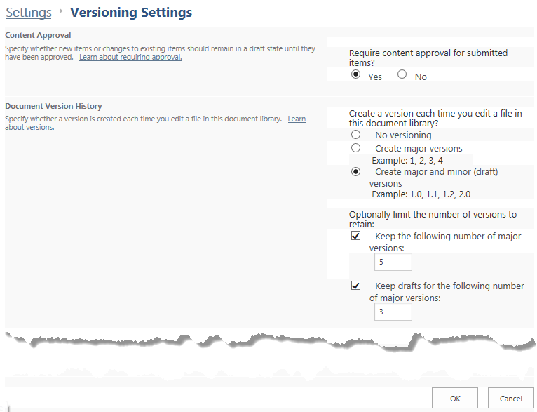

Create Major Versions
If you choose major versions, you can also limit the number of major versions.
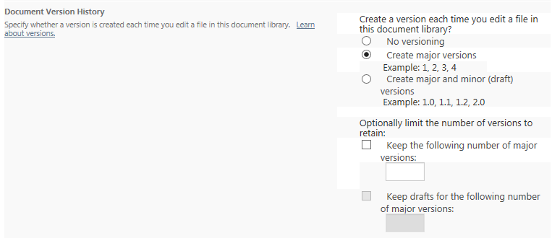
If you choose major versions and if content approval is on, you can limit the number of major versions and define how many major versions will store associated minor versions. Under Draft Item Security, define who can see the drafts; all three options are available.
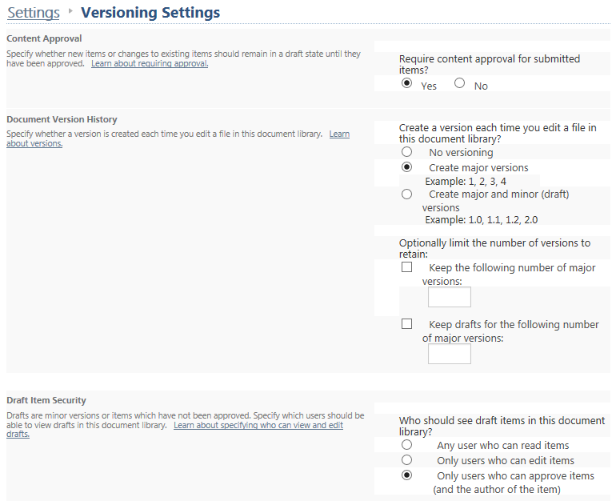

Create Major and Minor (Draft) Versions
If you choose major/minor versions, you can limit the number of major versions and define how many major versions will store associated minor versions. Under Draft Item Security, define who can see the drafts; the first two options are available.
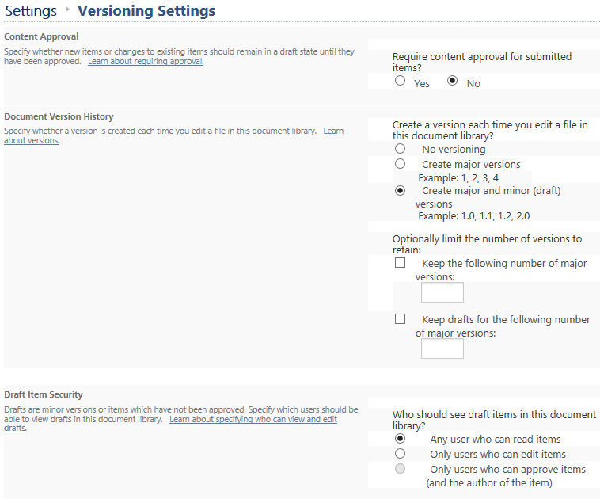

If you choose major/minor versions and if content approval is turned on, you can limit the number of major versions and define how many major versions will store associated minor versions. Under Draft Item Security, define who can see the drafts; all three options are available.
