Configure Versioning for a List
Versioning is the tracking of changes to an item as it is revised over time. For example, you can see when an item was changed, who changed it, and what properties were changed. You can view and restore earlier versions and read comments entered by those who revised the item.
Versions are tracked as whole numbers (1.0, 2.0, 3.0). You can limit the number of versions that you want to keep to avoid using too much system space; a general guideline is to keep no more than three to five versions. If Content Approval is turned on, you will have additional options.
Note: Content Approval and Versioning are interrelated. Refer to the help file on Content Approval and to the Designer class materials for a detailed explanation of the interrelationship.
- Navigate to the list.
- On the ribbon, click the LIST tab. In the Settings group, click List Settings.
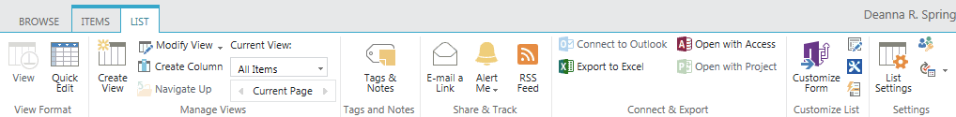
- On the Settings page under General Settings, click Versioning Settings.
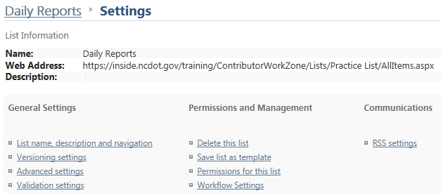

- Click Yes to turn on versioning. You can also define the number of versions to keep for each item.
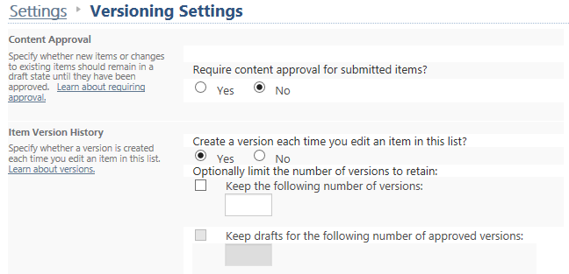If Content Approval is turned on, you can define the number of versions to keep for each item and choose whether to keep drafts for a certain number of approved versions. Under Draft Item Security, you can determine who can see those drafts. Click OK.
