View All Pages in a Site
You may find a list of all pages in the site useful for auditing or for a quick review of page properties.
- Navigate to a page.
- On the ribbon, click the PAGE tab. In the Page Library group, click View All Pages.
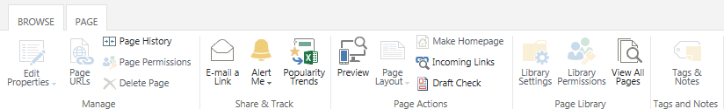The list of all pages appears. This is the same display you would see if you navigated to Site contents and opened the Pages library.
