View Properties of a File
This option displays the name, title and other metadata for a file. On the properties page, you can click the name of the file to open it in its application (such as Word). You can check version history and sharing status and set an alert, and you can review properties.

Contents
Example
View Properties – Method 1
View Properties – Method 2

Example of the Properties Page
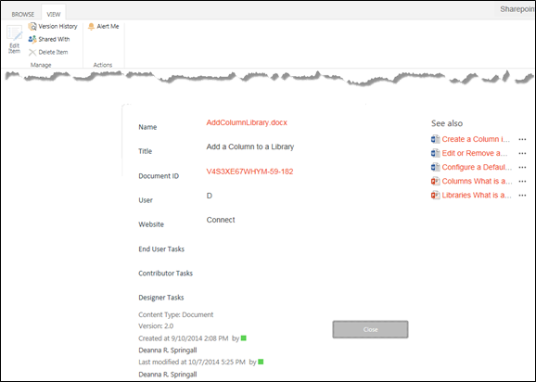

View Properties – Method 1
- Navigate to the library.
- Select the file by clicking the checkbox next to the name of the file. Click the ellipsis next to the name of the file, and click the ellipsis in the callout. In the context menu, click View Properties.
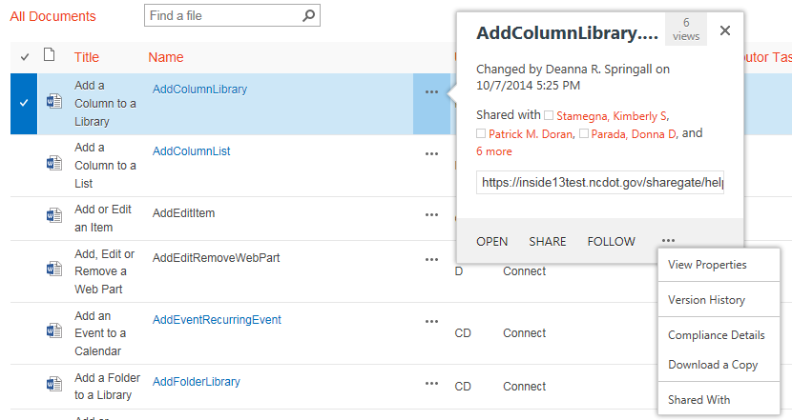The properties page appears.

View Properties – Method 2
- Navigate to the library.
- Select a file by clicking the checkbox next to the name of the file.
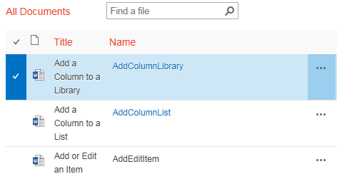
- On the ribbon, click the FILES tab. In the Manage group, click View Properties. 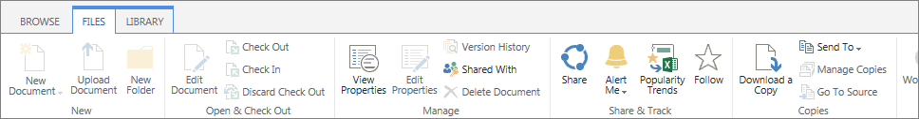The properties page appears.

