View Properties of an Item
This option displays the name, title and other metadata for an item. On the properties page, you can check version history and sharing status and set an alert, and you can review properties.

Contents
Example
View Properties – Method 1
View Properties – Method 2

Example of the Properties Page
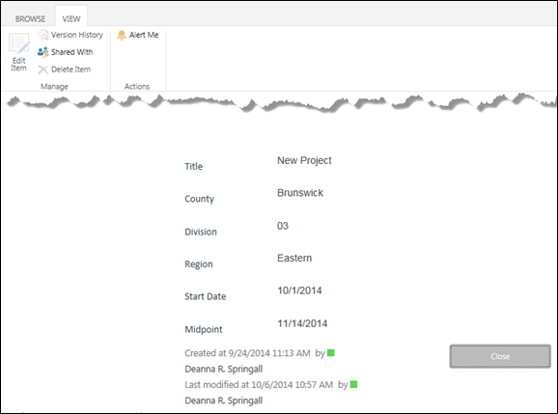

View Properties – Method 1
- Navigate to the list.
- Select the item by clicking the checkbox next to the title of the item. Click the ellipsis next to the item title, and click View Item.
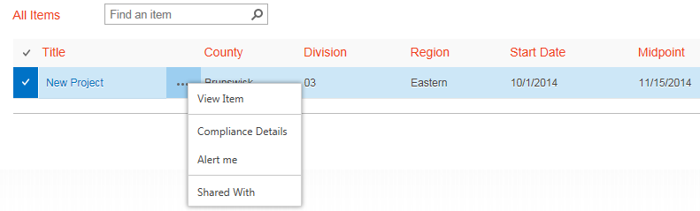 The properties page appears.

View Properties – Method 2
- Navigate to the list.
- Select an item by clicking the checkbox next to the title of the item.
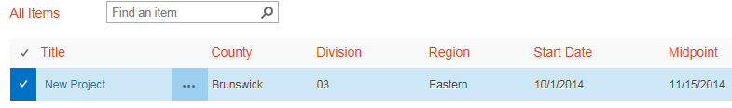
- On the ribbon, click the ITEMS tab. In the Manage group, click View Item.
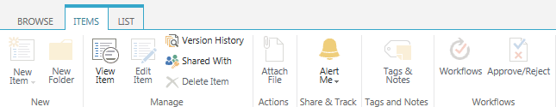The properties page appears.

