View Properties of a Page
Each page has standard properties (such as name, title, comments and contact) and may have custom properties (such as the website on which it should appear or the user for whom it is intended).
Page properties may vary, depending upon whether the page is on Inside NCDOT or Connect NCDOT or is part of a team or project site.

Contents
Page Properties – Ribbon
Example of Page Properties
View Properties – Method 1
View Properties – Method 2
View Properties – Method 3

Page Properties – Ribbon
The View ribbon at the top of the page properties contains options to work with the page.
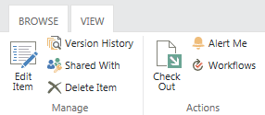

Example of Page Properties
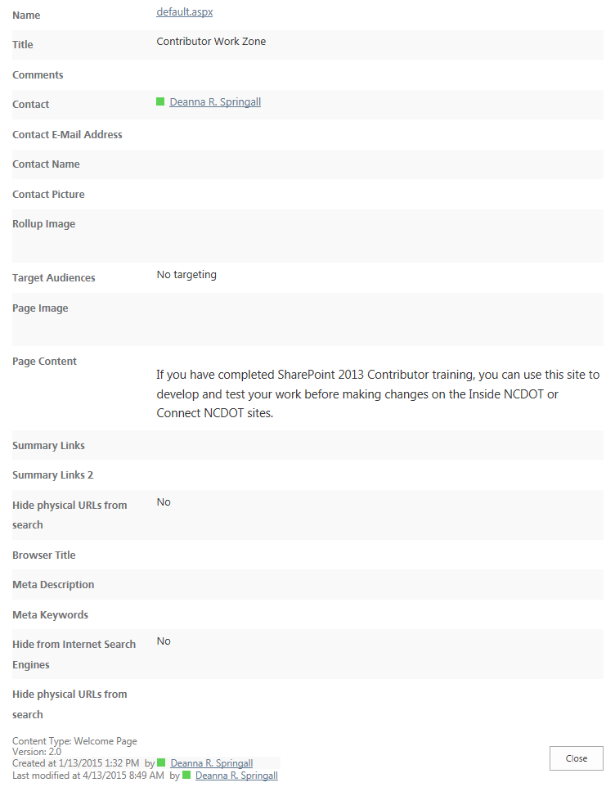

View Properties – Method 1
- Navigate to the page.
- On the ribbon, click the PAGE tab. In the Manage group, click Edit Properties and click View Properties.
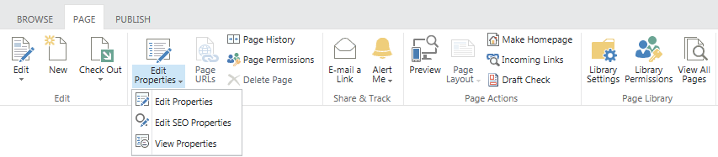 The page properties appear.
- Click Close when you have finished your review.

View Properties – Method 2
- Click the Settings icon and click Site contents.
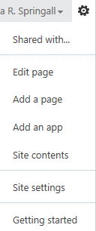
- Click the Pages library.
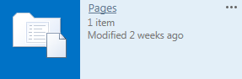

- Click the ellipsis next to the page name, click the ellipsis in the callout, and click View Properties.
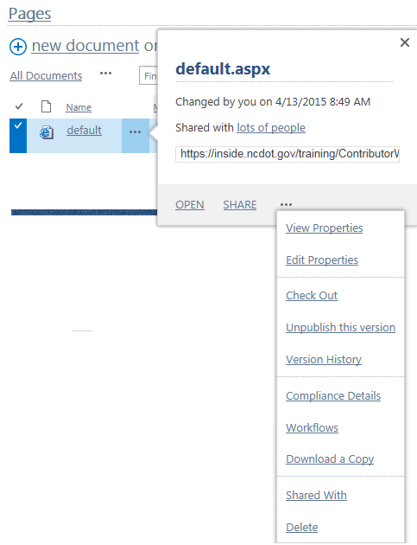
The page properties appear.
- Click Close when you have finished your review.

View Properties – Method 3
- Click the Settings icon and click Site contents.
- Click the Pages library.
- Select a page by clicking the checkbox next to the name of the page.
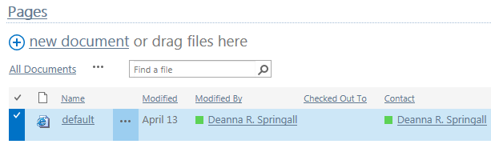
- On the ribbon, click the FILES tab. In the Manage group, click View Properties.
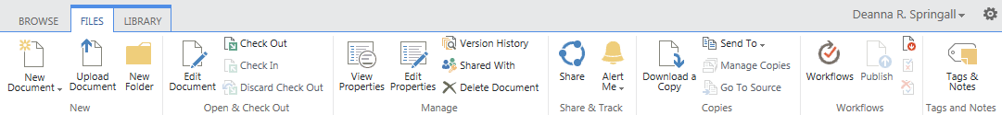 The page properties appear.
- Click Close when you have finished your review.

