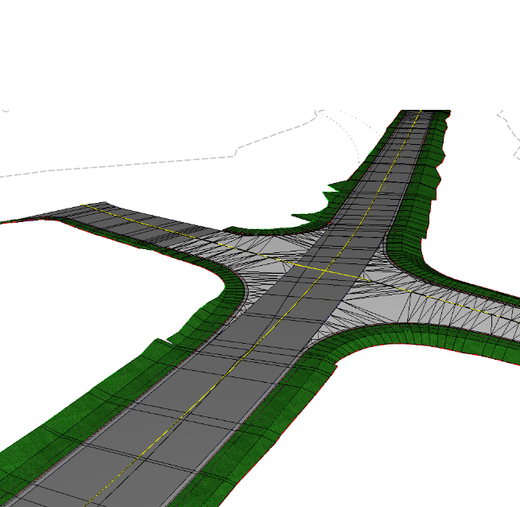
Bluebeam Usage Gudielines
NCDOT – Roadway Design Unit

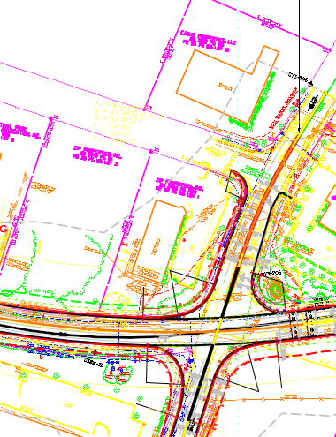

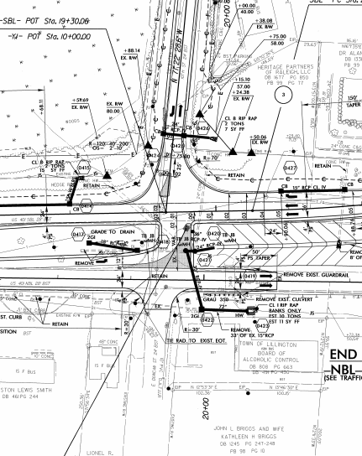

November 14, 2019
Table of Contents

Introduction to Bluebeam Revu

Bluebeam Revu is a software application that allows users to markup, takeoff, organize, and collaborate with PDF files. More than simply a PDF viewer, or annotation tool, Bluebeam Revu is efficiency and collaboration software for anyone who works with technical files.

This is a guide for how to use Bluebeam Revu for your PDF markup and collaboration needs.

Bluebeam Revu provides powerful and easy to use features for marking up Engineering plans and PDF documents.

Configuring Bluebeam DMS (Document Management System) Integration
Bluebeam Revu integrates directly with many Document Management Systems. The following directions describe how to configure your access to ProjectWise and Sharepoint.
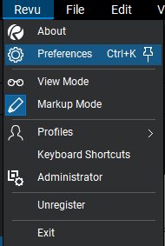
- ProjectWise
To set your ProjectWise DMS preferences:
- Click on the Revu Tab at the top left corner of the Command Bar.
- Then Preferences.
- Then Interface in the left-hand column.
- Then File Access at the top of the preferences dialogue box.
- Click the (+) sign near the bottom left.
- A dialogue box will open, select Type : Project WiseV10
- Select LOAD button. Datasource: will auto-populate to ncdot-pw.bentley.com:ncdot-pw-01
- Enter your Login and Password is the same as NCID.
- Select OK

;

;

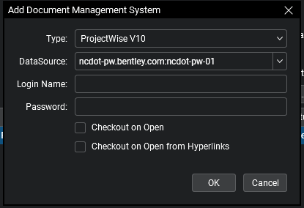
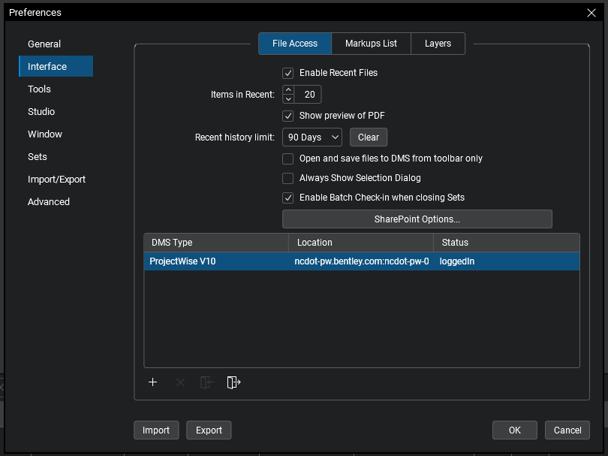

- Sharepoint
To set your Sharepoint DMS preferences:
- Click on the Revu Tab at the top left corner of the Command Bar.
- Then Preferences.
- Then Interface in the left-hand column.
- Then File Access at the top of the preferences dialogue box.
- Click the (+) sign near the bottom left.
- A dialogue box will open, select Type : Project WiseV10
- Select LOAD button. Datasource: will auto-populate to ncdot-pw.bentley.com:ncdot-pw-01
- Enter your Login and Password is the same as NCID.
- Select OK

;

;

To set your REVU Preferences, click on the Revu Tab at the top left corner of the Command Bar. When that opens you will Click on Preferences.
Once the Preferences open up you will click on Interface in the left-hand column. Then click File Access at the top of the preferences dialogue box
Almost at the bottom left you will see a (+) sign; click that:
Type : Project WiseV10 Needs to be CHANGED:
Click the down arrow and then Click on SharePoint
Then Change Site: (Address)

;

;

Revu can open files from ProjectWise when a DMS interface is configured. You can also open your file with the Open for Disk Button that we will discuss below.
To open a file from ProjectWise
- There are three ways to open a file from a DMS in Revu when a DMS interface is configured:
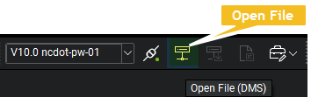
  - Go to File > Open.
  - Press CTRL+O.
  - Click Open File (DMS) on the Document Management toolbar.
    - If you have enabled Toolbar integration only in File Access Preferences, this is the only option that will work for you.
- If you have enabled Always Show Selection Dialog in File Access Preferences, the Open From selection dialog box appears.

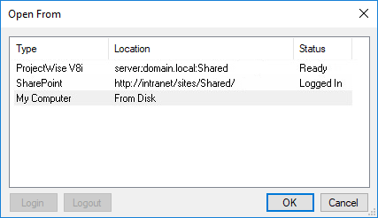
Select the desired ProjectWise datasource and click OK. If you are prompted to log in, do so. The Open Document dialog box appears.
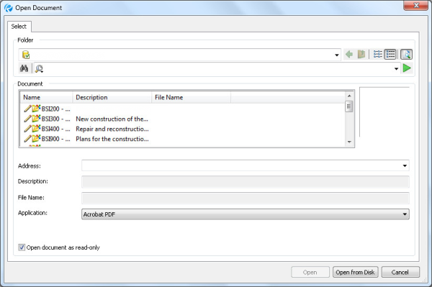

  - If Always Show Selection Dialog is not enabled in File Access Preferences, the Open Document dialog box opens directly.
- Navigate to the desired document in the Document window and select it. The Address, Description, and File Name fields will populate with available data to confirm that the correct document has been selected.
- To both open and check out the file, uncheck Open document as read-only. Otherwise, the file will open without being checked out.
  - If Open document as read-only is already unchecked, the configuration settings for this DMS are set to automatically check out files when they are opened. Check it to open the file without checking it out.
- Click Open. The file appears in the Revu workspace and, if appropriate, is checked out.

Opening a File in Project Store or a Local Drive

Open a PDF file or document in Revu while not using ProjectWise. Start by:
  - Go to File > Open.
  - Press CTRL+O.
  - Click Open File (DMS) on the Document Management toolbar.

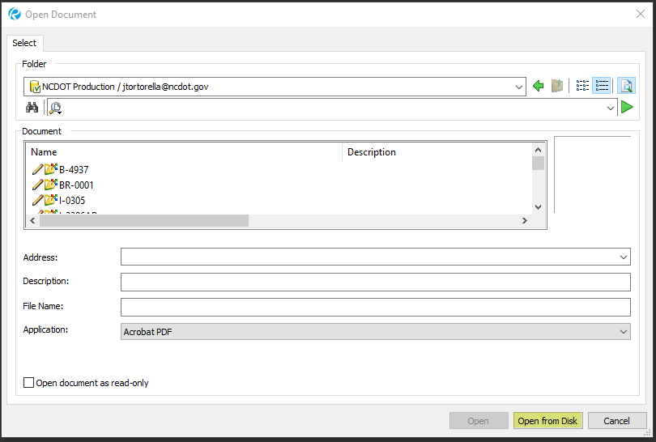

Once the Open Document Dialogue pops up you will see a button in the lower right-hand corner that reads Open from Disk. Click the Open from Disk button and the Open Dialogue box will appear. One would use this method if your document is on a local Drive or Project store.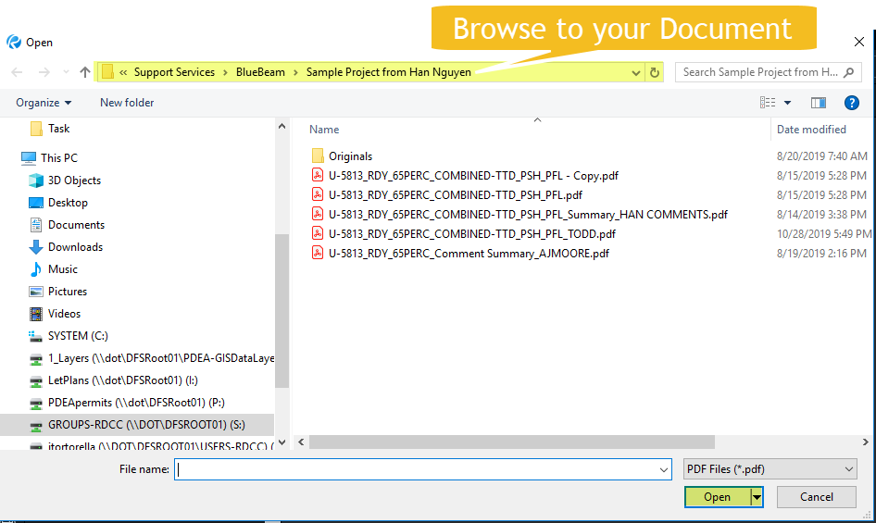

Opening a File in SharePoint
There are a couple ways to open your PDF File in Bluebeam Revu. Though, first we are going to have to set up your REVU Preferences.
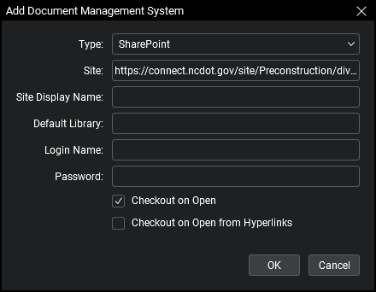

https://connect.ncdot.gov/site/Preconstruction/division/div05/B-5323/
When adding the Site address; Please notice that its everything up to the TIP number. Once the site address is added, you will need to check the box that says Checkout on Open; then you just need to hit OK.

This will create the link to the Disciplines of that associated TIP Number; and it will be set until you delete. You can add as many links to different projects as Needed.

Interface Overview

At the top of the Revu window you will see the Command Bar. The Command Bar provides access to tools and commands organized by group.
Below the Command Bar and to the right edge are optional Toolbars. These toolbars provide customizable, one-click access to the tools you need most. To turn on or off toolbars, on the Command Bar click View, then click Toolbars. 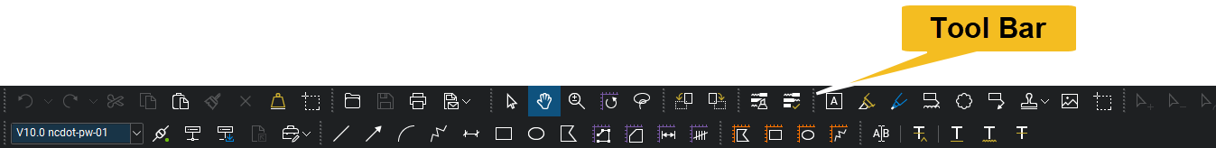

Tool Chest

The Tool Chest is a powerful feature that makes the marking up of documents much more efficient. Once a markup is created, it can be easily recalled using the Tool Chest. The Tool Chest will store your most used markups in a central, easily accessible location.

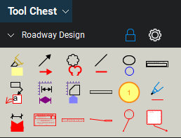

Above you will see the Roadway Tool Chest and what the existing tools look like in it.

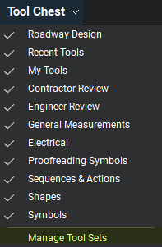
Adding Existing Tool Chest
1.Go to Window > Panels > Tool Chest or press ALT+X to show the Tool Chest panel.
2.Go to Tool Chest > Manage Tool Sets. The Manage Tool Sets dialog box appears. The Click Add : Then add Tool Set Dialogue pops up.
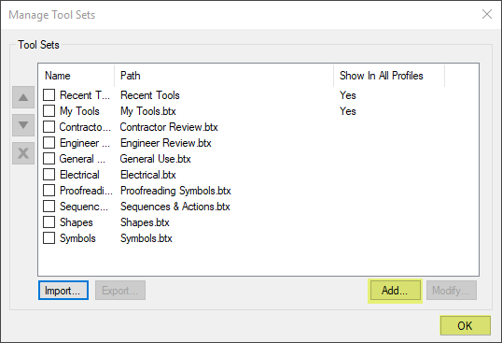

;

;

Then you want to click Existing, and then click the box with the 3 little dots.

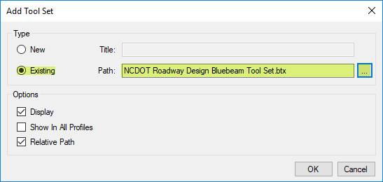

Then the Open Dialogue will open and you Need to Browse to:
S:\Support Services\BlueBeam

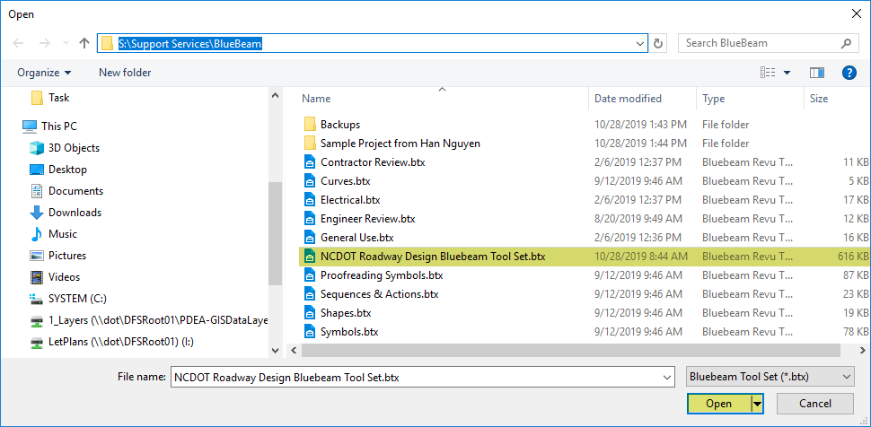

Then scroll down until you find: NCDOT Roadway Design Bluebeam Tool Set.btx
Then click Open.
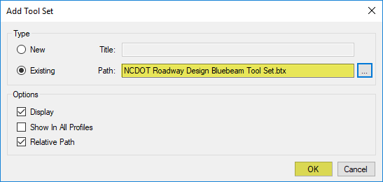

Now you will see the NCDOT Roadway Design Bluebeam Tool Set.btx , loaded in the Path box. Now Click OK.

Now you should see the Roadway Design Tool Set loaded in the Tool Chest viewing Panel.
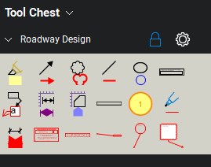

Tool Chest Panel
The Tool Chest is a powerful feature that makes marking up documents much more efficient, giving you a place to store your most used markups in a central, easily accessible location.

Go to Window > Panels > Tool Chest or press ALT+X to show the Tool Chest panel.
Tool Chest menu: Contains a list of available tool sets and the Manage Tool Sets feature. Tool sets that are checked are currently shown in the panel. Select a tool set to toggle its shown/hidden status.
Each Tool Set has its own toolbar with some or all of the following tools:
/ Expand/ Collapse toggle: Expands or collapses the tool set. When tool sets are collapsed, a flyout toggle appears at the right which enables viewing and selecting tools in the tool set without expanding it.
Scale: Enables or disables the scale set for the tool set. Appears only when a tool set has a scale set.
/ Locked / Checked Out: Indicates that the tool set is either locked (and is read-only) or checked out (and is editable). Only appears for shared tool sets.
Properties menu (all tool sets except Recent Tools):
Symbol: When enabled, tools in the tool set are shown as their symbols only.
Detail: When enabled, tools in the tool set are shown in a table with more detailed information.
Set Scale: Sets a scale for tools in the tool set, allowing them to scale up or down when placed in a calibrated drawing.
Remove Scale: Removes the current scale set for the tool set. Appears only when a scale has been set.
Legend: Creates a Markups Legend specific to the tools in the tool set.
Export: Exports the tool set to a local or network drive.
Save: Saves changes made to the tool set (for example, adding a tool or changing the scale).
Pin: Pins a tool set to a specified toolbar.
Hide: Hides the tool set from the Tool Chest. To show a hidden tool set, select it from the Tool Chest menu at the top of the Tool Chest panel.
Properties menu (Recent Tools only):
Properties Mode: When enabled, only the appearance properties of markups are saved in the tool set. When disabled, appearance properties and other details (dimensions, text, and so on) are saved. See Properties Mode vs Drawing Mode.
Add to My Tools: Saves the selected tool to the My Tools tool set. Available only when a tool in the tool set is selected.
Maximum Recents: Sets the maximum number of tools Revu will remember as "recent."
Clear Recents: Removes all tools currently in the Recent Tools tool set.
Hide: Hides the tool set from the Tool Chest. To show a hidden tool set, select it from the Tool Chest menu at the top of the Tool Chest panel.
Tool Sets
The Tool Chest is organized into different tool sets. Each Profile comes with a certain number of additional tool sets enabled by default.

Tool sets can be shown in either Symbol or Detail modes. Click the Properties menu for the desired tool set and select the desired mode.
There are two tool sets that are available in all Profiles: My Tools and Recent Tools.
My Tools is a permanent tool set for markups that you use frequently. Any markup stored in this panel will remain between sessions of Revu.
Recent Tools is a permanent tool set that records recently used markups. This enables you to easily reuse a recent markup without needing to recreate it. Tools in the Recent Tools tool set are temporary; the tool set is cleared when Revu is closed. Tools can be saved permanently by moving them out of Recent Tools to another Tool Set before closing it.
Tool sets that are collapsed have a flyout toggle to the right of their Properties menu. Click this toggle to see a flyout containing tools found in the tool set. Tools can be selected from this flyout and placed on PDFs without expanding the tool set.
Users can also add tool sets to different Profiles, create and import new tool sets, and share tool sets across a network. See Managing Tool Sets for more information.
Also worth special consideration is the Sequences & Actions tool set. A Sequence allows a text based markup to increment in value each time that a markup is added to the PDF. The updating sequence value can be a number or text. An Action allows you to add hyperlinks to tools in the Tool Chest.

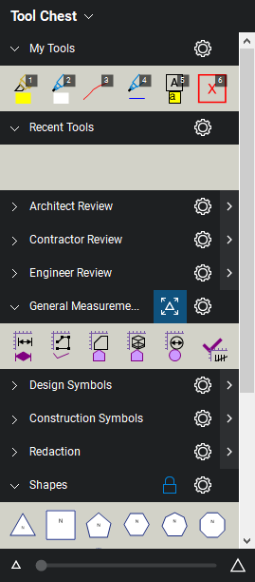
Bottom of Form

Markups List
The Markups list automatically tracks markups placed on a PDF, including author, date, color, and comments associated with each markup. By default it is found in the bottom panel.Go to Window > Panels > Markups or press ALT+L to show the Markups list if it is hidden.

Markups List Toolbar
The Markups list toolbar contains tools for organizing, processing, importing, and exporting data.
Markups List menu:
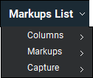

Columns
Columns: Selects which columns are shown in the Markups list.
Manage Columns: Launches the Manage Columns dialog box to add or remove columns from the columns list, change their display order, and add, remove and create Custom Columns. Columns can also be reordered by dragging and dropping column headers in the Markups list itself.

Markups
Import: Takes the markups from a PDF, XML, or BAX file and includes them in the active PDF (this is useful for incorporating and reviewing markups or feedback from multiple sources). FDF files containing annotations generated from other PDF applications may also be imported.
Export: Exports all markups to a BAX or FDF file. The BAX file can be imported into another PDF so that the markups will be shown in the target PDF. The BAX file can also be imported into Excel. Markups can also be exported to the FDF format for interoperability with other PDF applications.
Summary: Publishes a summary report of all the markups in a PDF. A PDF Summary can be saved as a separate PDF or appended to the end of the current PDF. It is also possible to export a Summary as CSV or XML data for use in Excel or other programs.

Capture
Capture Summary: Publishes a summary report of Capture media.
Export Capture Media: Exports Capture media to a selected folder.
Filter: Toggles column filters on and off. To clear filters, click the down arrow to its right and select Clear All.
Hide Markups: Turns on Hide Markups mode, hiding all markups in the current PDF file. Markups will not be shown or printed when this mode is enabled. Click again to exit Hide Markups mode. This mode is temporary and will be reset the next time Revu is started.
Search: Filters the Markups list based on the text entered in the field.
Filter: Toggles column filters on and off. To clear filters, click the down arrow to its right and select Clear All.
Hide Markups: Turns on Hide Markups mode, hiding all markups in the current PDF file. Markups will not be shown or printed when this mode is enabled. Click again to exit Hide Markups mode. This mode is temporary and will be reset the next time Revu is started.
Search: Filters the Markups list based on the text entered in the field.

Markups List
The Markups list is formatted as a table with each row representing a markup that has been added to the active PDF and each columns showing a particular piece of information about the markup.
As a row is selected, the view of the PDF in the workspace will jump to the location of the associated markup. This makes it easy to use the Markups list to step through the markups in PDF using the UP ARROW and DOWN ARROW keys.
To sort by any column, click the desired column header. Click again to reverse the sort order. When markups are sorted by column, they are collected under section headings found in the Subject column. Each section has a toggle triangle; click it to expand or collapse the section.
The following examples show an expanded, collapsed, and partially collapsed list sorted by Page number:
Expanded List
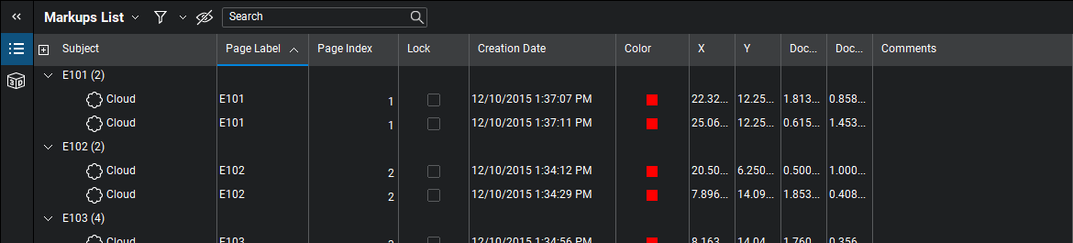
Collapsed List
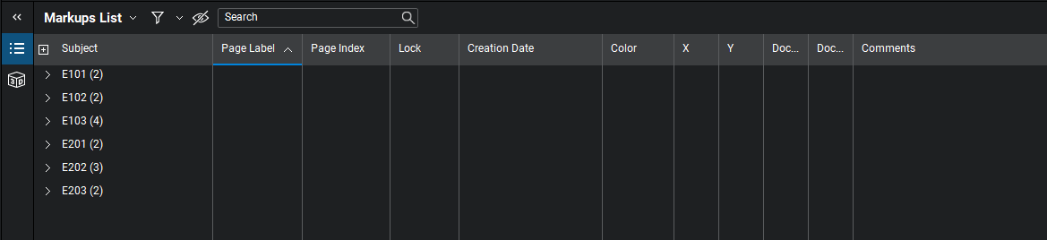
Partially Collapsed List
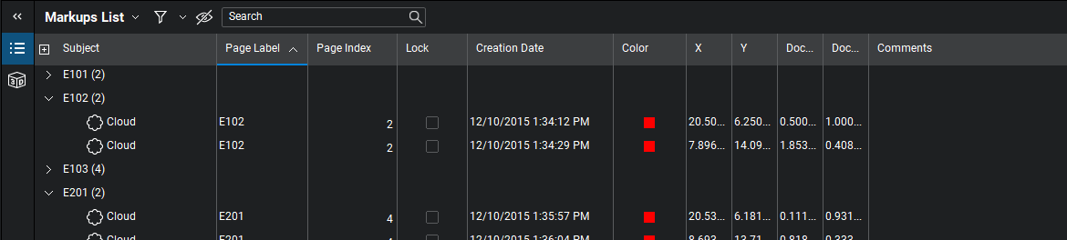
Columns
The columns shown in the Markups list is highly customizable. Toggle various columns on and off by selecting them from the Markups List > Columns menu. The list reveals currently available columns: checked columns are currently shown in the Markups list and unchecked columns are hidden. Data is still stored for hidden columns and columns can be hidden or shown at any time. Simply select a column from this menu to hide or show it.
Not all columns are necessarily shown in this list. For details regarding how to hide or show other columns, and how to create custom columns, see Using the Markups List.
The available built-in columns are:
Subject: Shows both an icon and text that indicate the type of markup used on the PDF. This text can be changed in the Subject field in the Properties panel, or by double-clicking on the Subject text in the Markups list.
Page Label: Shows the page of the PDF on which the markup is located.
Page Index: Shows a numeric value indicating on which page the markup or measurement resides. Page Index is a useful column to use for sorting when exporting to spreadsheet programs.
Lock: Shows whether the markup is locked for editing or not. If locked, a appears in the box, and the markup cannot be moved or changed, though some functions, such as changing the Status or entering a Reply, are still permitted. If unlocked, the box is clear and the markup can be edited. Click to toggle a lock on or off.
Status: Shows the current status of the markup. To set a status, select the markup and use the Status menu in the column header or right-click the markup and go to Set Status to select it.
Checkmark: A simple checkbox that enables the Markups list to be used as a basic checklist. Click to toggle a checkmark on or off.
Author: Indicates the person (identified by username) who created the markup. Double-click this field to edit an author's name. To change your username, go to General Preferences and enter the desired name in the User field.
Date: Shows the date and time the markup was last modified, based on the system time.
Creation Date: Shows the date and time the markup was created, based on the system time.
Color: Shows the line color used for the markup.
X and Y: Shows the coordinates on the PDF page where the markup is located, counted from the lower left.
Document Width and Document Height: Shows the size of the markup on the PDF.
Comments: Shows the comments from the General section of the Properties tab for this markup. Double-click in this field to change the comment associated with the markup.
Wall Area: Shows the total Wall Area for Area or Perimeter markups.
Length, Area, Volume, Count and Measurement: Each shows values associated with Measurement markups.
Label: Shows the label associated with the markup. The label can be changed in the General section of the Properties tab. For measurement markups, it is common to use the Label field to specify the type of material that's being measured, such as "Tile 1" or "Carpet 3."
Sequence: Records the numerical value associated with a Sequence markup.

Capture: Shows whether a markup has embedded images or videos. If embedded images or videos are present, a appears in this column; double-click this icon to preview the embedded media.
Depth: Shows the depth of the markup on the PDF.
Rise/Drop: Shows the length of the rise or drop defined for the Polylength or Perimeter measurement.
Slope: Shows the slope ratio of an Area or Length.
Layer: Shows the layer that contains the markup.
Legend: Shows the name of the markups legend in which the markup included.
Height and Width: Shows the actual height and width of the element represented by the markup on the PDF.
Space: Shows the Space that contains the markup.
Unit: Shows the unit of measure used for the markup.
3D View: Shows the 3D view that contains the markup. Click to jump to that view in the 3D window.

Splitting the Workspace with MultiView
MultiView lets you break the workspace up into independent splits (up to sixteen of them). Splits can be synchronized to pan and zoom in unison, and they can show different files or different areas of the same file. Controls for splitting the screen are found on the Navigation bar at the bottom of the workspace or in the View menu.
- To split the window vertically, click or press CTRL+2.
- To split the workspace horizontally, click or press CTRL+H.
- To remove the current split, click or press CTRL+SHIFT+2.
To synchronize pan and zoom settings and actions across split views, select a synchronization mode from the View menu or the Sync menu on the Status bar (if using the Status bar, be sure to enable sync by clicking the Sync icon as well). The available modes are:
Synchronize Document: When enabled, synchronizes the viewing windows when displaying PDFs in side-by-side Split View mode or in a detached window by page index, thus viewing page 1 on document A will cause document B to automatically also view page 1.
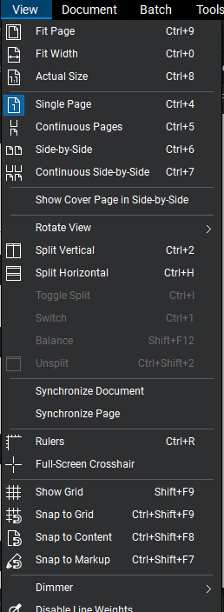
Synchronize Page: When enabled, synchronizes the viewing windows when displaying PDFs in side-by-side Split View mode or in a detached window without regard to page index, allowing the user to synchronize different pages across documents or different pages in the same multi-page document.
Synchronization is useful when you need to compare multiple versions of the same document. Panning or zooming the document in one window will automatically adjust the view in the second window.

Document Comparison
The Compare Documents feature is used to compare two PDF files and highlight the differences. The differences are indicated with markups. Once the markups have been created, the differences can be reviewed using the Markups list.

Comparing Two Versions of the Same Document or Drawing
• On the Command Bar, click Document >
Comparison > Compare Documents...

Defining Documents, A and B
• If the document is already loaded within the current
Revu session, click the Document list in the
Document A section, then click the name of the
file.
• If the document is not loaded, click .
• In the Open dialog, locate the appropriate file, then
click Open.
• Click the Page Range list to define a range of pages
to use for comparison.

Follow the same steps in the Document B section to define Document B.
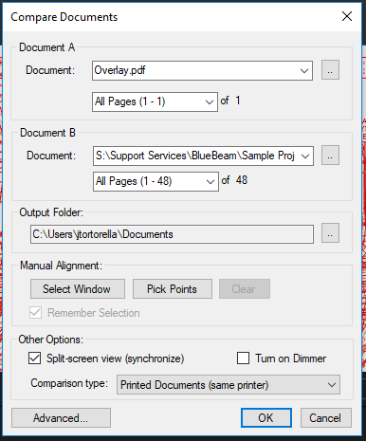

Optionally Defining a Region
If you want to compare only a specific region of each document, click Select Window, then define a rectangle. Otherwise the entire document will be compared.

Aligning the Documents
By default Revu will attempt to line up the document. If you wish to override the automatic alignment, click Pick Points to specify the alignment points. You will need to pick 4 points on each document. The points should be specified in a clockwise order and the alignment points should correspond to one another; for example, Selection Point 1 on Document A should correspond to Selection Point 1 on Document B. file.
• If the document is not loaded, click .
• In the Open dialog, locate the appropriate file, then
click Open.
• Click the Page Range list to define a range of pages
to use for comparison.

Follow the same steps in the Document B section to define Document B

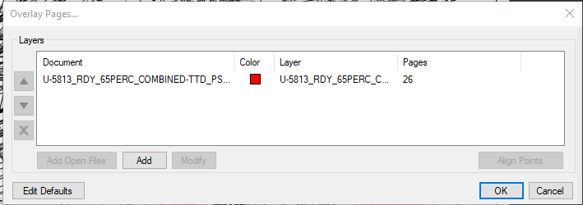

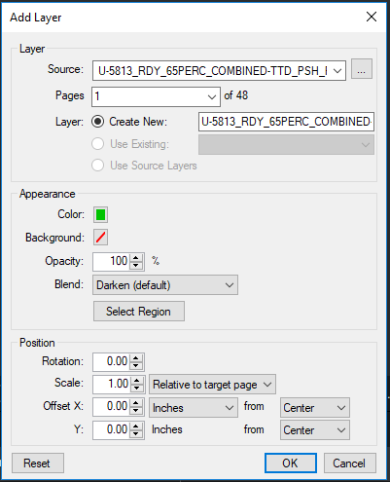

ProjectWise network registry entries
The server-side MicroStation engine used for processing DGN/DWG files displays
a system level modal dialog in the event of a system level error. If this occurs,
MicroStation will pause and prevent jobs using the engine from completing. To
suppress the display of this modal dialog, set the following registry key:
HKEY_LOCAL_MACHINE\SYSTEM\CurrentControlSet\Control\Windows\ErrorMod
e = 2
This registry setting applies to all processes running on the machine. No system
level error dialogs will pop up on the system, however, the errors are written to
the system log. This is a recommended setting on server machines. The system
will log exceptions on client machines without notifying you through a modal
dialog.
Basic File Operations
ProjectWise stores all files on servers in specifically designated folders known as

