Purpose
The Roadway Design and Right of Way units have worked collaboratively to produce a set of Right of Way plans electronically and making them available to everyone in the Department. This effort will reduce reproduction cost, make plans available quicker, and ensure the latest plans are always available.

Section 1 Storage Location

PDF_Distribution

Roadway Design, at the Right of Way submittal, will create an electronic copy of the plans in the form of “pdf” which can be viewed and printed through Adobe reader. These plans will be stored on the Project Store for each TIP and updated as revisions are submitted.

A folder for all projects have been created under the Roadway folder called PDF_Distribution. This folder has two sub-folders called Current_Plans and Past_Plans.

If you will browse to the Roadway folder then click on the
“PDF Distribution” folder, you will see these folders.
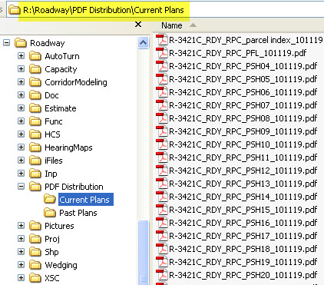

Current Plans
This is the location of the Right of Way plans. Roadway will always post the most recent submittal or revisions

Past Plans
As future submittal dates come, previous plan submittals will be moved to this folder for reference.

Section 2 Creating the Files

Roadway will convert the CADD drawings into “.pdf” files for other units to view and print. They will be created from a copy of the half size ips file and contain all the CADD reference files and levels. Depending on the size and number of sheets in your project, the following are guidelines that should be followed in determining how to break your project into different pdf files. This can vary from project to project. The purpose is to keep the file size of the pdf’s manageable for the field office’s to download. Smaller projects can bundle all plan sheets into one pdf while larger projects should be broken into sections.

File names
File naming conventions have been created for all submittal types to prepare for future expansion. The file name will follow as TIP# - RDY – Submittal Type – Sheet Name – Date (date will always be the latest submittal including revisions). This date should also match date on R/W letter submittals.

Submittal Phase Type |  |  | Sheet Names
DP: | Distribute Plans (To Hydro) |  | TTD | Title, Typical, Details
CFI: | Combined Field Inspection |  | PLAN | All Plan Sheets (DP & FDFI)
FDFI: | Final Design Field Inspection |  | PFL | Profile Sheets
RPC: | Right of Way Plans Complete |  | XSC | Cross Sections
PER: | Permit Plans |  | PSH | Individual plan Sheets (RPC, PER & PLFI)
PLFI: | Pre-Let Field Inspection

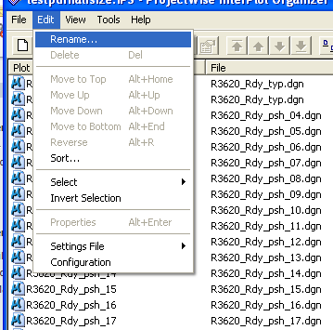
Rename Plots

You must first rename your plots with the correct name which is automated in Iplot Organizer.

- Select or highlight the group of plots to be renamed. In this example I am changing just the names of the plan sheets.

- Select “Rename” from the “Edit” tools.

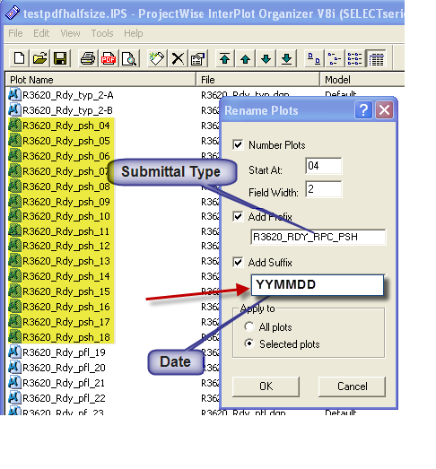

- Check the following boxes and add the correct submittal name in the prefix field and correct date in the suffix field (note under-bar before date).

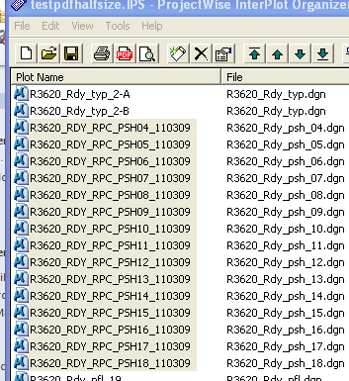

- The files are then renamed to the correct file naming convention.

Convert to PDF
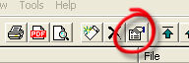
- Before exporting to pdf, two properties need to be changed plots. With the plots still highlighted, click on the “Plot Properties” box.

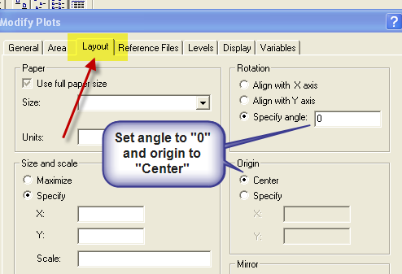
- In the “Layout” tab, change the Rotation to “0” and the Origin to “Center”.

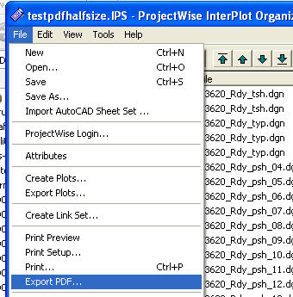
- Create pdf’s of the plots by going thru the File menu and selecting “Export PDF” option.

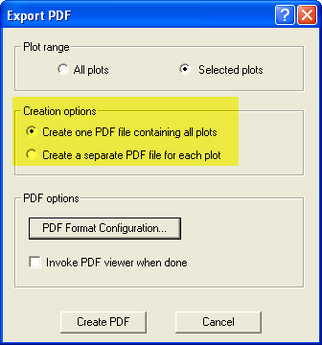
- Check the box under “Creation options”. One option creates one pdf of all the plots and the other box will create a pdf for each plot. This depends on which phase submittal and size of your project. Then select the “PDF Format Configuration” button.

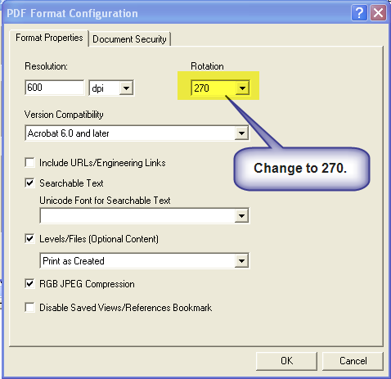

- Change the rotation to 270 so the pdf’s come out rotated correctly. Leave the resolution as 600. We also keep text searchable and we include the levels and referenced files. For larger projects, Level/Files can be unchecked for profile and xsc files to help manage file size. (the reason for addressing rotation twice is your PDF Format Configuration could be set to something different which rotates your ips settings.)

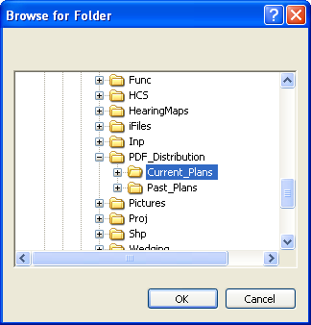
- Choose the correct folder to place the new pdf’s. The pdf’s assume the name of the plot for each pdf. This is only if you selected separate pdf’s for each plot. If you choose the one pdf option, you will have to name the pdf and place it in the correct folder.

- Done!

Section 3 Layers

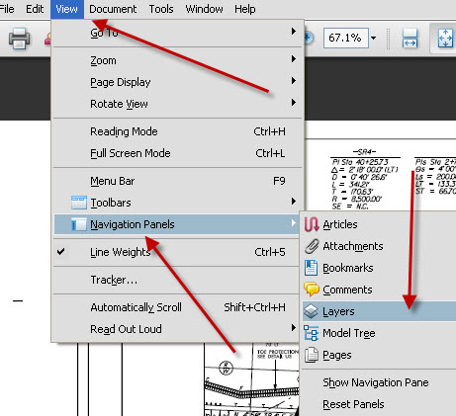
When these files are created, the plans multiple referenced files and levels are saved. This additional information allows you to turn on or off information you may or may not want to see. To view this additional information, you will need to make sure you have the “View Layers” turned on.

To turn the “Layers” panel, go to “View – Navigation Panels – Layers”.

This will turn on the Layers panel and give you the ability to navigate thru the referenced files and the levels in those files.

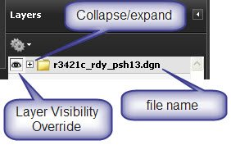
The top layer name is the file that you opened. It has two controls for you to adjust, the eye-shaped Layer Visibility Override icon to turn layers on and off, and the collapse/expand icon that shows you what is included in that file.

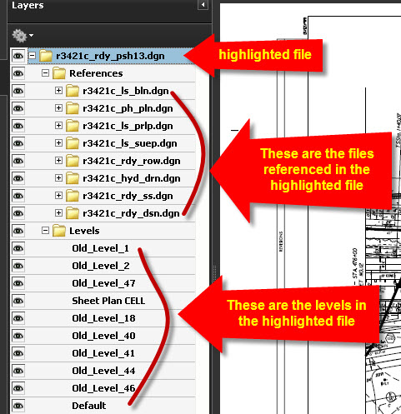
The eye-shaped Layer Visibility Override icon turns everything on or off that is in that file. This is the button you will turn off items you don’t want to print or see on the plan sheet.

You can expand the top layer into the files that are referenced and the levels that were used in that file.

Each referenced file also has the ability to turn off levels that were used in that file so there are lots of different views you might choose to see depending on how much clutter there is on the plan sheet.

