Exercise 1: Corridor Modeling – Getting Started

- Copying ITL File to “Working” Folder

- Copy TIP_rdy.itl (Blank Project File) from:
C:\NCDOT_V8_WORKSPACE\ROADWAY_STDS\English\geopak\Corridor_Modeling\TIP_rdy.itl

- Into the following Directory:

“C:\NCDOT Training\Roadway\CM\Chapter 1 – Intro to Corridor Modeling”

*Actual Project (R:Drive): Copy TIP_rdy.itl into R:\Roadway\CorridorModeling

- Rename TIP_rdy.itl by adding your TIP Project Number:

- Create & Open Corridor Modeling Design File

- Using “Design File Generator”, create a new 3D Corridor Modeling Design File. Name this file “b4834_rdy_cmd.dgn"

(Saved in “CorridorModeling” folder).

- Open “b4834_rdy_cmd.dgn” file.

- Attach Project Related Reference Files

- Under References (File / References) attach the following files:
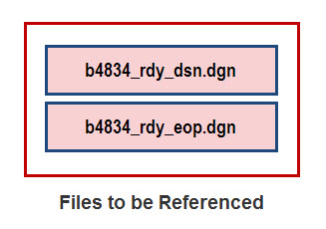
- Start Corridor Modeling

- “Corridor Modeling” can be opened in the two following ways:

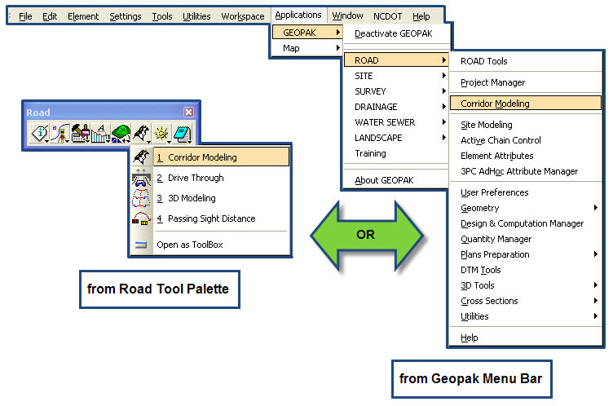

Exercise 2: Setting Up Corridor Modeling Preferences

- Geopak Job Number

  - Note: Before getting started, use Geopak COGO Preferences to update “Job (GPK) Directory:”
  - Under Corridor Modeling Dialog, select next to . Choose project GPK file and select OK.

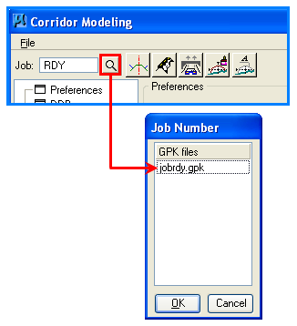

- Preferences

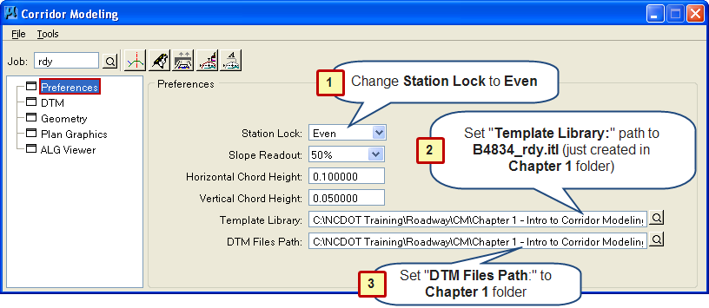

  - Select and highlight Preferences.

- Change Station lock: to Even (This feature controls cross section interval in Roadway Designer)
- Template Library: Set path to Project ITL just created in
Chapter 1 folder (B4834_rdy.itl).
- DTM Files Path: Set path to “Chapter 1” folder.

*Actual Project (R:Drive):

Template Library / DTM Files Path should be set to: CorridorModeling folder

- DTM (Existing Ground DTM Conversion)

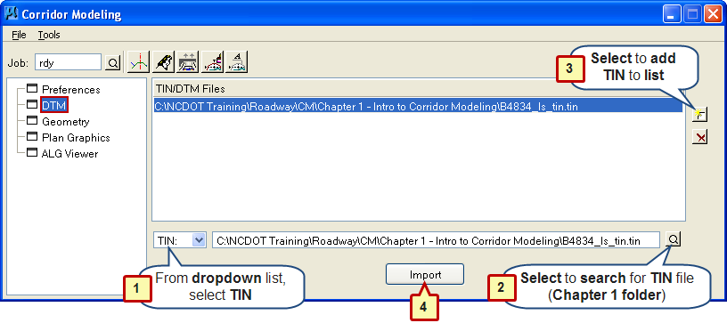

  - Select and highlight DTM Section.

- In the dropdown list, select TIN.
- Select to search for (B4834_ls_tin.tin).
- Click to add TIN to list.
- Select to import TIN into Corridor Modeling. You should see an Information message stating that “Tin file has been imported”.
*Actual Project (R:Drive):
Step 2 / Search for TIN File: Path should be set to DTM Folder

Note: This process will also create an InRoads DTM file using the same name as the Geopak TIN file.

- Geometry (Conversion of GPK to ALG)

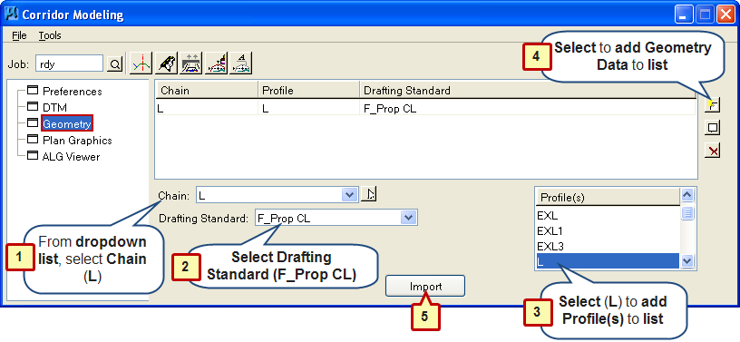
  - Select and highlight Geometry Section.

- In the dropdown list, select Chain (L).
- Next to Drafting Standard: dropdown, select “F_Prop CL”.
- Under Profile(s) select L.
NOTE!: If no Profiles are listed, re-select next to . Choose RDY and select OK.
- Click to add Geometry Data to list.
Note: Multiple “Profiles” can be added to list (such as Ditches, etc.)

- Select to import Geometry into Corridor Modeling. You should see an Information message stating that “Geometry has been imported”.
Note: This will also create a new Corridor Modeling ALG (stored in
RDDBS folder).

- Plan Graphics (Importing into Corridor Modeling)

For this exercise we will be importing the following Plan Graphics (Left & Right Sides):

- Prop EOT
- Bridge
- Paved Shoulder
- Guardrail
- Exist EOP (EEOP)
- Shoulder Berm Gutter (SBG) – Left Side Only
- Shoulder Point

Common Problems to look for when Adding Plan Graphics

- If two (or more) Plan Graphics are on top of one another, Corridor Modeling Templates will not be able to target properly (such as Guardrail, Guardrail Scratch Level and Paved Shoulder).

- There could be times where the location of Plan Graphics (such as Pavement Widths, Paved Shoulder Widths) could fall behind the “Pre-Set” widths that are set in the Default Templates. This will be covered in the “Display References Section (E4.6)”.

How to Add Left Side “Proposed EOT” Plan Graphics

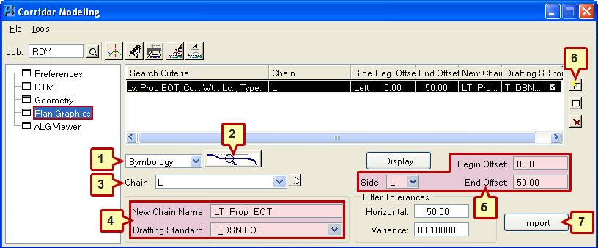

  - Select and highlight Plan Graphics Section.

- In the dropdown list, select (Symbology).
- Select (Element Symbology)
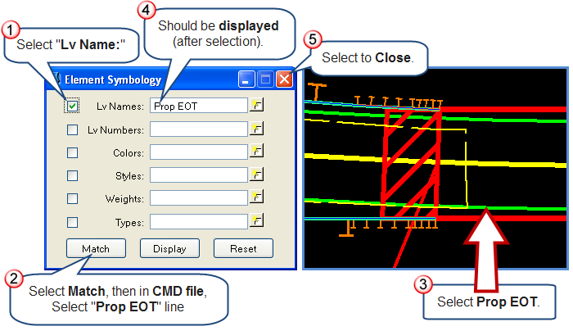

- Next to Chain: dropdown, select (L).
- Next to New Chain Name: type in (LT_Prop_EOT).
Select Drafting Standard: (T_DSN EOT)
- Select Side: (L)
Type in Begin Offset: (0.00)
Type in End Offset: (50.00)
- Click to add Plan Graphics to list.

How to Add Right Side “Prop EOT” Plan Graphics

- Next to New Chain Name: Change Name (RT_Prop_EOT).
Keep same Drafting Standard: (T_DSN EOT)
- Select Side: (R)
Type in Begin Offset: (0.00)
Type in End Offset: (50.00)
- Click to add Plan Graphics to list.

Add “Prop Roadway Bridge” Plan Graphics
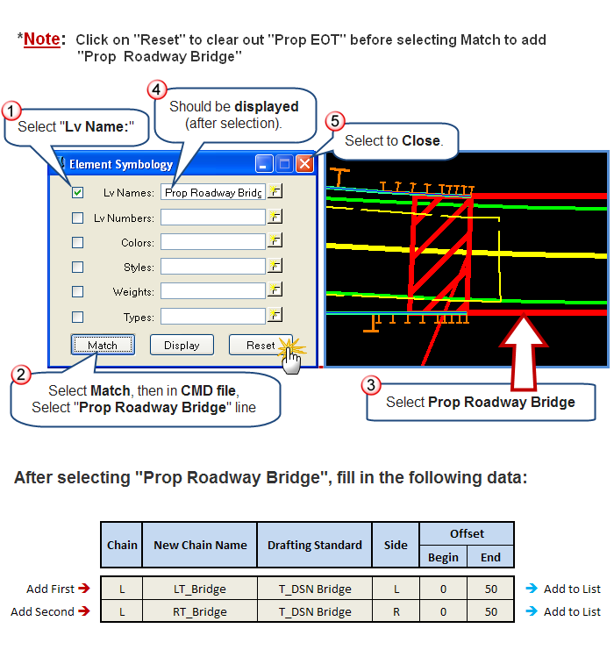

Add “Prop Paved Shoulder” Plan Graphics
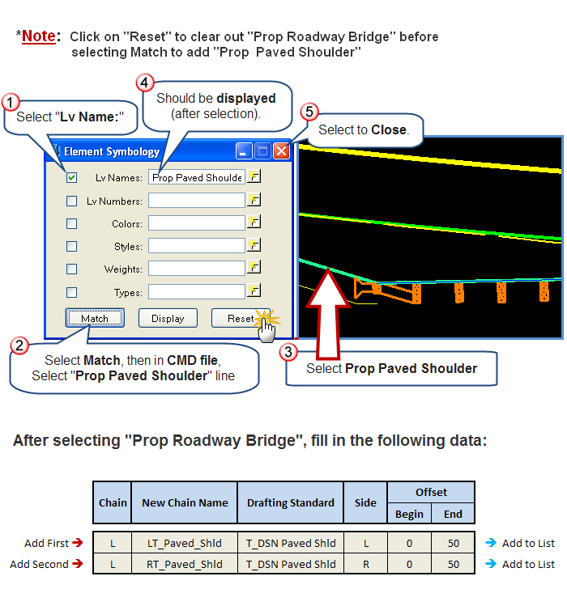

Add “Prop Guardrail” Plan Graphics
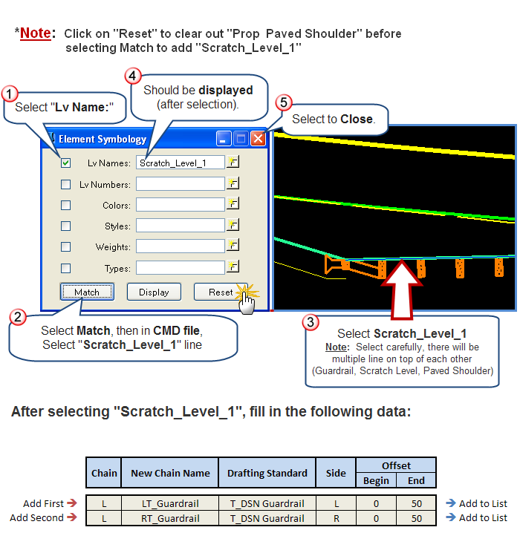
Note: As an example, the New Chain Name for -Y- Lines could be named as:

LT_Y15_Guardrail

Add “Existing Edge of Pavement (EEOP)” Plan Graphics
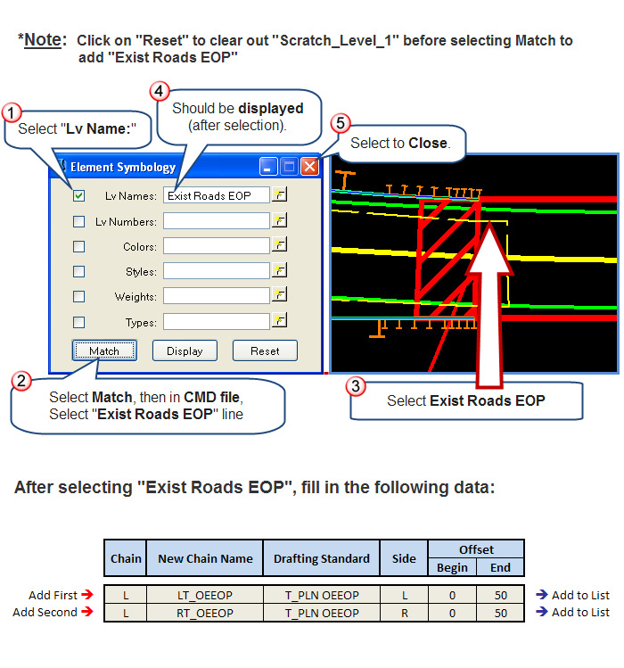

Add “Proposed Shoulder Berm Gutter (SBG)” Plan Graphics

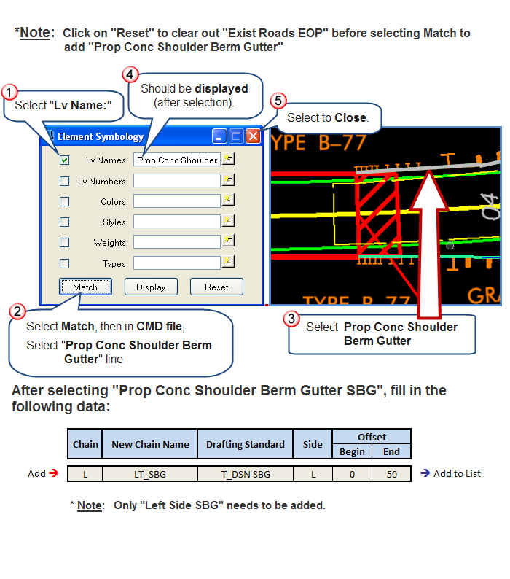

Add “Shoulder Point” Plan Graphics

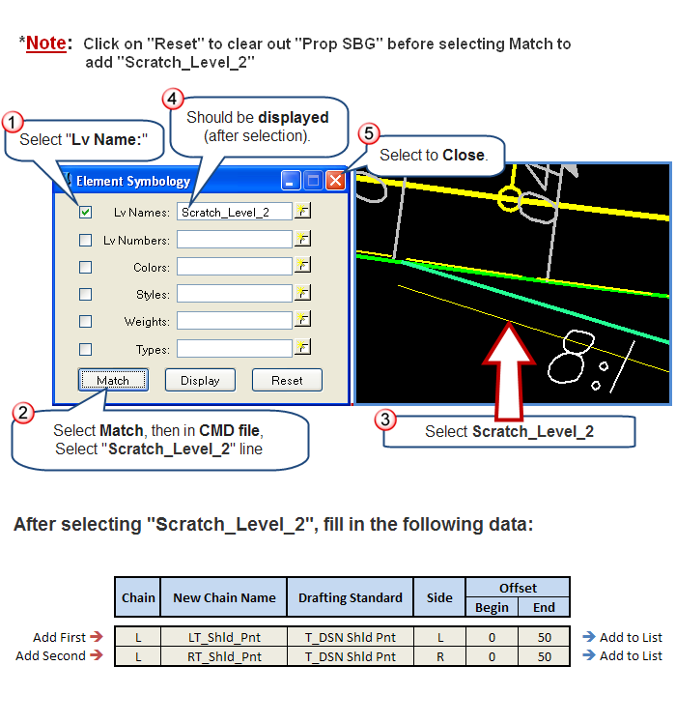

Importing Plan Graphics

- All of Plan Graphics necessary for Roadway Designer should now be added.
- Click on “Import” to import Plan Graphics.
- You should see an Information Message stating that “13 Chain(s) successfully stored”.

- Saving Roadway Designer Preference File (RDP)

- Under Corridor Modeling Dialog - File Dropdown Menu, select Save As.
- Next to Save in: Select path to “Chapter 1” folder.
- Next to File name: Type in B4834.rdp
- Click on , to Save RDP File.
- You should see an Information Message stating that:

“C:\NCDOT Training\Roadway\CM\Chapter 1 – Intro to Corridor Modeling”\B4834.rdp Saved”

*Actual Project (R:Drive):

RDP File should be saved to: CorridorModeling folder

- ALG Viewer

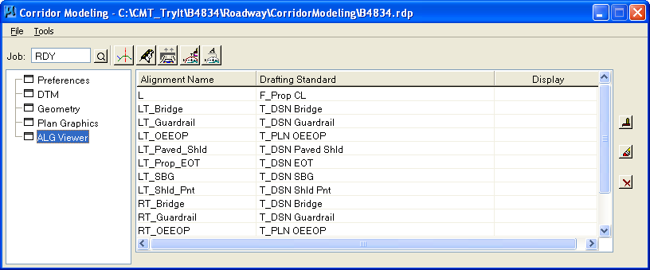

- The ALG Viewer accesses and manipulates data directly within the ALG file.
- Allows the designer to delete alignments from the ALG.
- Allows the designer to visualize alignments for review.
Click on the ALG Tab to list the alignments in the ALG file. For each alignment displayed, the associated drafting standard and display status are shown. The user can select single or multiple alignments.
Click to Display all selected alignments
Click to Undisplay all selected alignments
Click to Delete all selected alignments from ALG file. As alignments are deleted from the ALG file, the software synchronizes the Geometry and Plan graphics portions of Corridor Modeling.

Exercise 3: Create Template Dialog Window

- How to Start “Open Create Template”

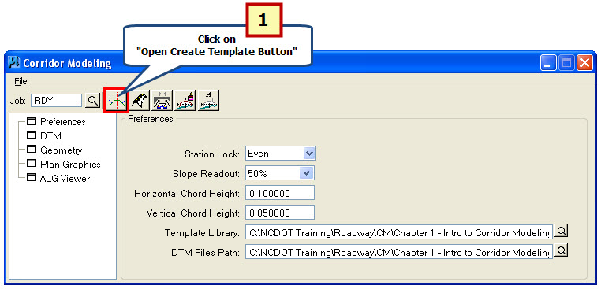

- Under “Corridor Modeling Dialog Window” click on “Open Create Template Button”.

- Copying Standard Templates with “Template Library Organizer…”

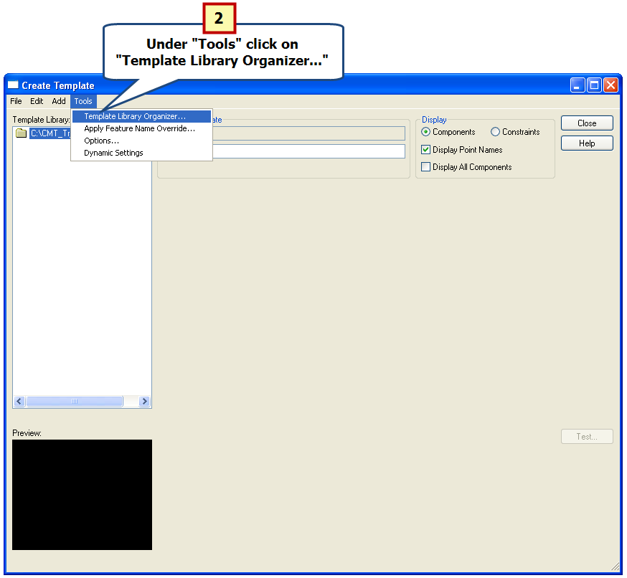

- Under “Create Template” select “Tools” then “Template Library Organizer…”

- Set Path to Access NCDOT_RDY_STANDARD Library (ITL)
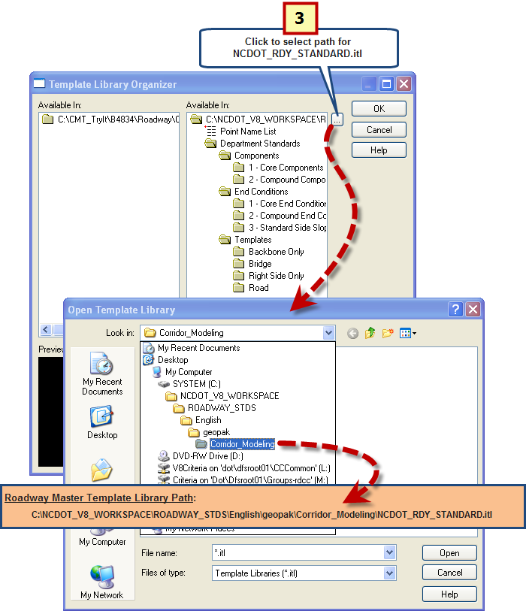

- In right window of “Template Library Organizer” click on to set path for Master Template Library.

- Select and Drag Templates into “Project Specific Library (B4834_rdy.itl)”

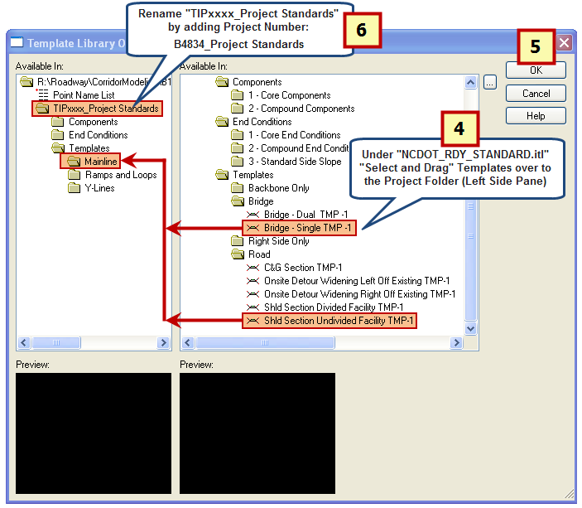
- Under “NCDOT_RDY_STANDARD.itl” select and drag “Bridge – Single TMP-1” and “Shld Section Undivided Facility TMP-1” over to Mainline Folder under B4834_rdy.itl Template Library.
- Select .
- Rename “TIPxxxx_Project Standards” by adding Project Number:
B4834_Project Standards

Exercise 4: Roadway Designer

- How to Start “Roadway Designer”
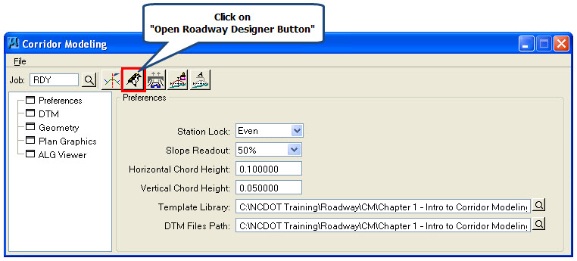

  - Under “Corridor Modeling Dialog Window” click on “Open Roadway Designer Button”.

- Open “Manage Corridors”
  - By using the Corridor Dropdown Menu or by using the Roadway Designer Toolbar:

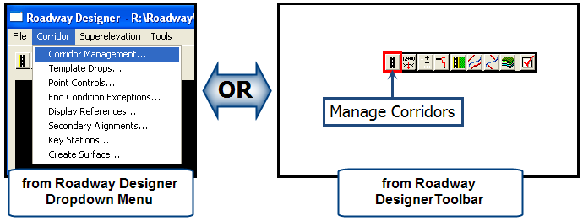

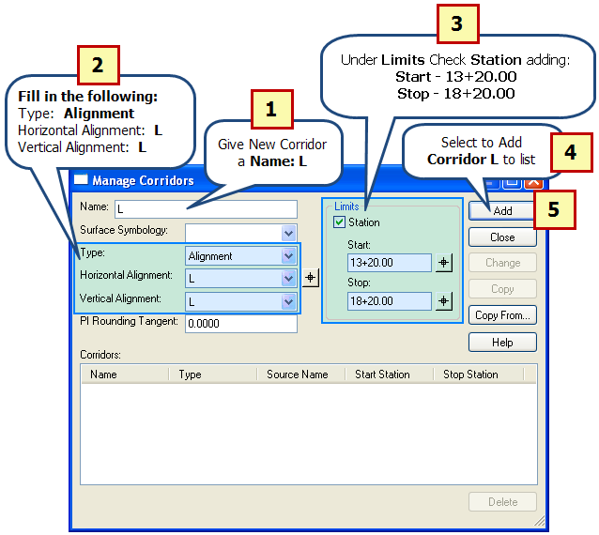

- Next to Name: Type L
- Next to Type: Choose Alignment
Next to Horizontal Alignment: Choose L
Next to Vertical Alignment: Choose L
- Under “Limits” select next to Station
Next to Start: type 13+20.00
Next to Stop: type 18+20.00
- Click to add Corridor L to list.
- Select to Close Manage Corridors Dialog Window.

- Open “Template Drops”

  - By using the Corridor Dropdown Menu or by using the Roadway Designer Toolbar:

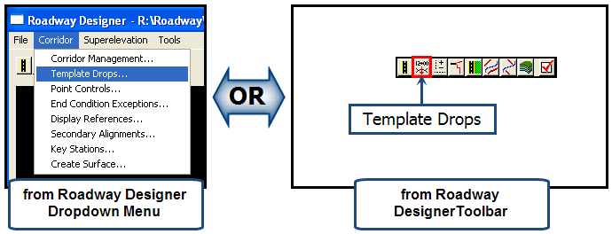

Add First “Template Drop” at Station 13+20.00
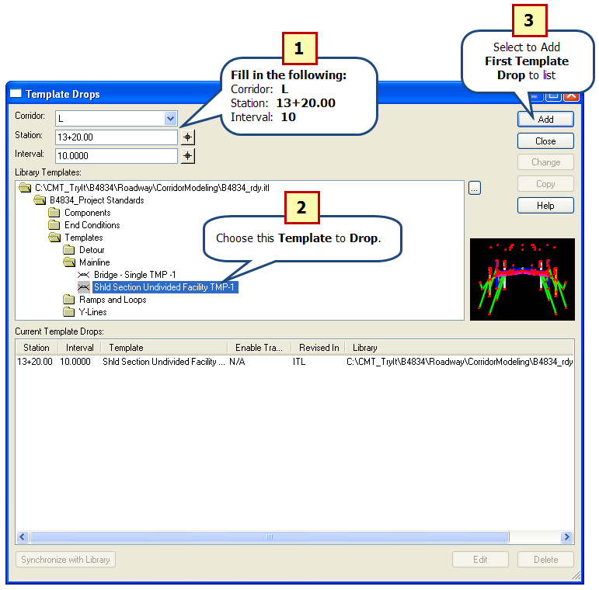

- Next to Corridor: Choose L
Next to Station: Type 13+20.00
Next to Interval: Type 10
- Under “Library Templates” select Template (under Mainline)
Choose: Shld Section Undivided Facility TMP-1
- Click to add First Template Drop to list.
- Repeat this process for adding additional Template Drops (shown on next page).

Repeating Previous “Template Drop” process, Add the following Template Drops:

2nd “Template Drop”: Corridor: L
Station: 15+46.99
Interval: 10
Choose: Shld Section Undivided Facility TMP-1
Click to add 2nd Template Drop

3rd “Template Drop”: Corridor: L
Station: 15+47 (Begin Bridge)
Interval: 10
Choose: Bridge – Single TMP-1
Click to add 3rd Template Drop

4th “Template Drop”: Corridor: L
Station: 16+36 (End Bridge)
Interval: 10
Choose: Bridge – Single TMP-1
Click to add 4th Template Drop

5th “Template Drop”: Corridor: L
Station: 16+36.01
Interval: 10
Choose: Shld Section Undivided Facility TMP-1
Click to add 5th Template Drop

Final “Template Drop”: Corridor: L
Station: 18+20
Interval: 10
Choose: Shld Section Undivided Facility TMP-1
Click to add Final Template Drop

After Adding All Template Drops the “Template Drop Dialog” should look like the following:

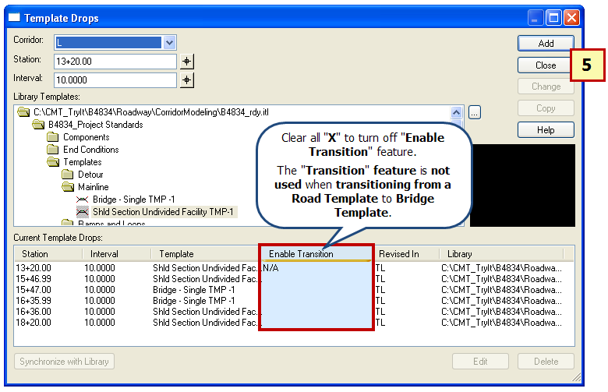

- Once all Template Drops have been added, select to Close Template Drops Dialog Window.

- Save IRD File

- Under File Dropdown Menu, select Save.
- Next to Save: Select path to “Chapter 1” folder.
- Next to File name: Type in B4834.ird.
- Click on , to Save IRD File.

*Actual Project (R:Drive):

IRD File should be saved to : CorridorModeling folder

Note:
- For Bridge Projects save IRD using Project Number.
- For larger projects (with multiple alignments) you will need to save a IRD for each alignment (example: L.ird, Y1.ird)

- Using “Plan, Profile and Cross Section Views” in Roadway Designer Dialog Window

  - After adding all Template Drops the user should scan through the cross sections to check for errors.
  - Using “Display References…” (under “Corridor Dropdown Menu”) allows the user to show (in Cross Section View) Plan Graphics (shown as vertical lines).

Roadway Designer Dialog Window:
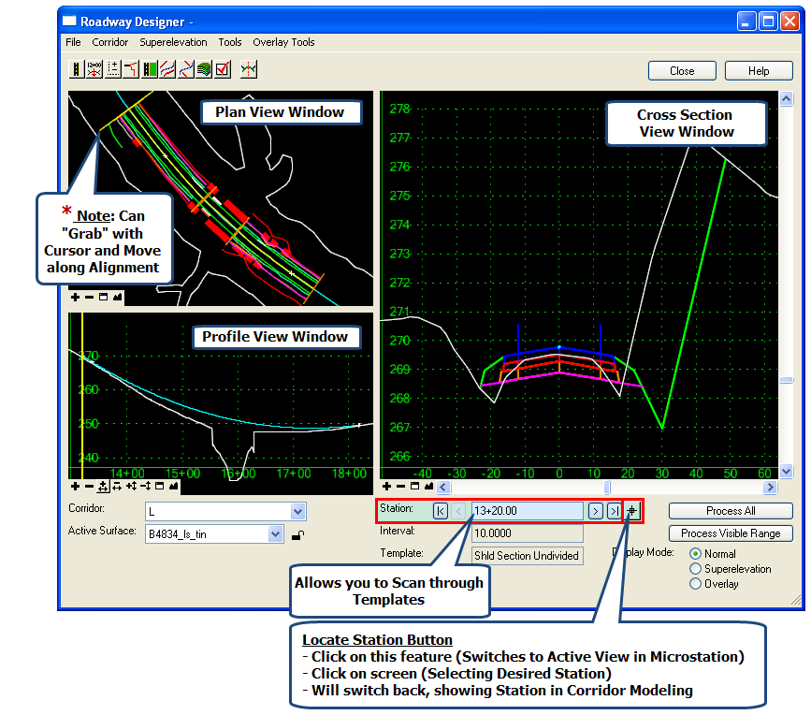

- Superelevation

  - Superelevation is created and applied using the Roadway Designer after the corridor is created and template drops are assigned.
  - Superelevation is stored and saved in the Roadway Design File (IRD) and is applied to a corridor.

* Important: It has been determined that “Import Superelevation from INP…” will

work best for Roadway Design’s workflow and should be the

Primary Method for applying Superelevation in Corridor Modeling.

How to “Import Superelevation from INP file…”

  - By using the Tools Dropdown Menu:

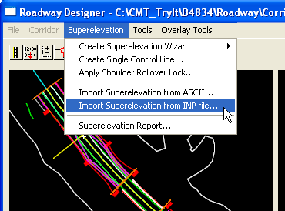

How to “Import Superelevation from INP file…”

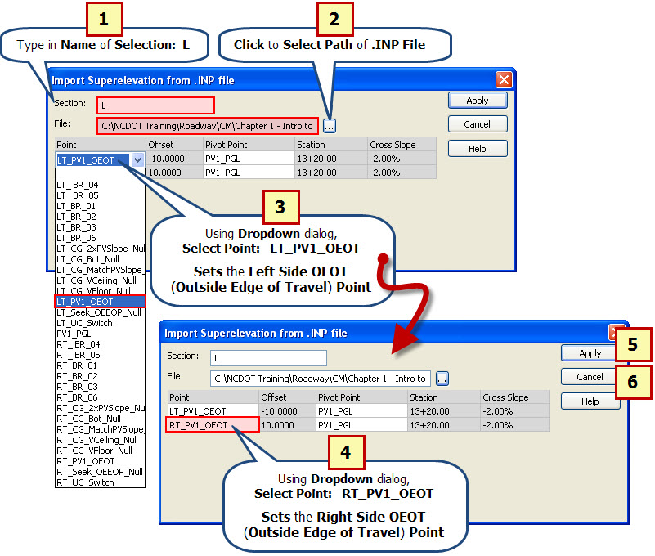

- Type in Name of Selection: L
- Click to Select Path of .INP File (Chapter 1 folder):
- Using Dropdown dialog, select Point: LT_PV1_OEOT
- Using Dropdown dialog, select Point: RT_PV1_OEOT
- Click on to add “Superelevation” to the Model.
- Click to Close “Import Superelevation from .INP file”

Scan Through Templates to View Superelevation:

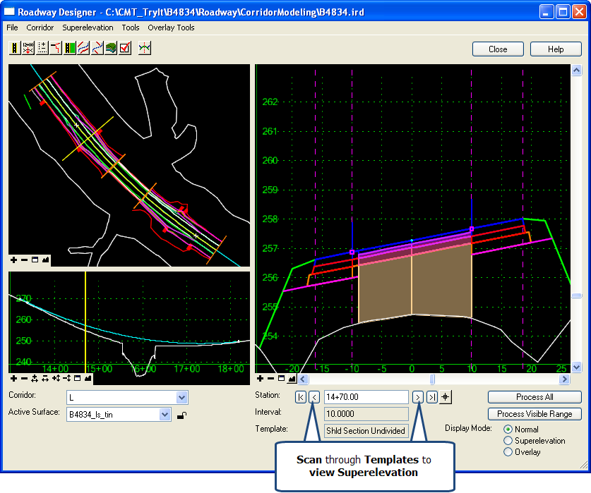

- Display References…

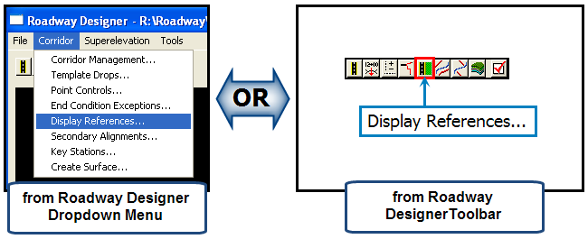

Using “Display References…” to Check for Errors

Listed below are Two Common Problems which “Display References…” could help the user to visualize:

- Default Template is designed to seek for “Proposed EOT” Plan Graphics from a default pavement width of 12’. If your project Plan Graphics is shown using a 10’ proposed pavement width then the default template will not be able to find Plan Graphics (because it falls behind the 12’ point).

- Default Template is designed to use a 4’ “Proposed Paved Shoulder”. If your project Plan Graphics shows the Proposed Paved Shoulder of less than 4’ then the default template will not be able to find the Plan Graphics (because it falls behind the 4’ point).

Using “Display References…” to Add “Left Side Proposed EOT” Plan Graphic
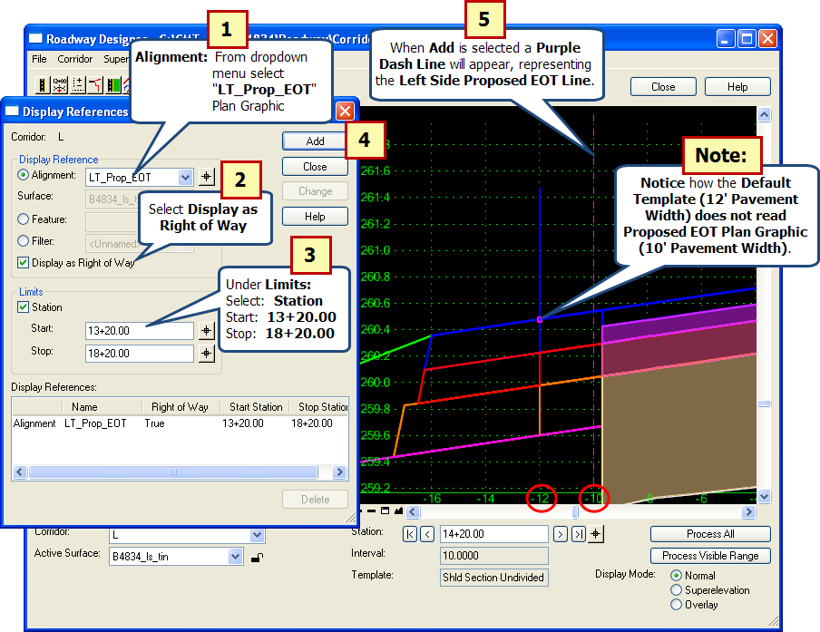

- Under “Display Reference” select Alignment drop down:
Choose LT_Prop_EOT
- Select next to “Display as Right of Way”
- Under “Limits” select next to Station
Next to Start: type 13+20.00
Next to Stop: type 18+20.00
- Click to add LT_Prop_EOT to list.
- After adding to list, a Purple Dashed Line will display in Cross Section View (representing the left Side Proposed EOT Line).
Note: Repeat this process to add RT_Prop_EOT to list.

How to Open Parametric Constraints

  - By using the Tools Dropdown Menu:

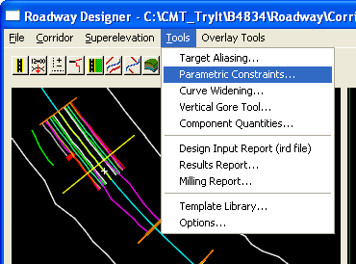

Using “Parametric Constraints” to Correct Pavement Width

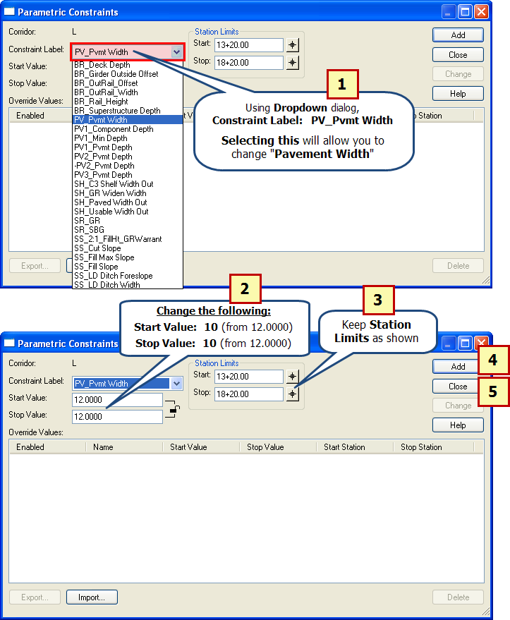
- Using Dropdown dialog, Constraint Label: PV_Pvmt_Width
- Change Start & Stop Value: 10 (from 12.0000)
- Keep Station Limits as shown:
Start: 13+20.00
Stop: 18+20.00
- Click on to Change “Pavement Width” in Model.
- Click to Close “Parametric Constraints”

Scanning through Cross Sections to Verify “Pavement Width” Change

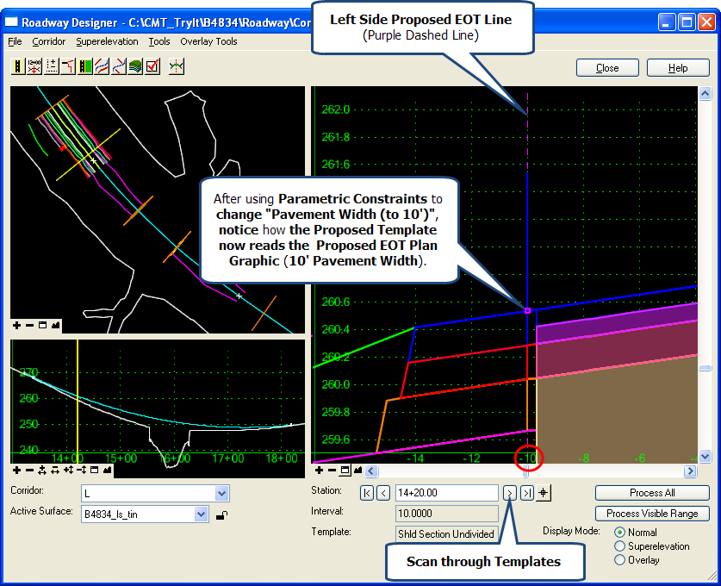

Using “Display References…” to Add “Left Side Proposed Paved Shoulder” Plan Graphic
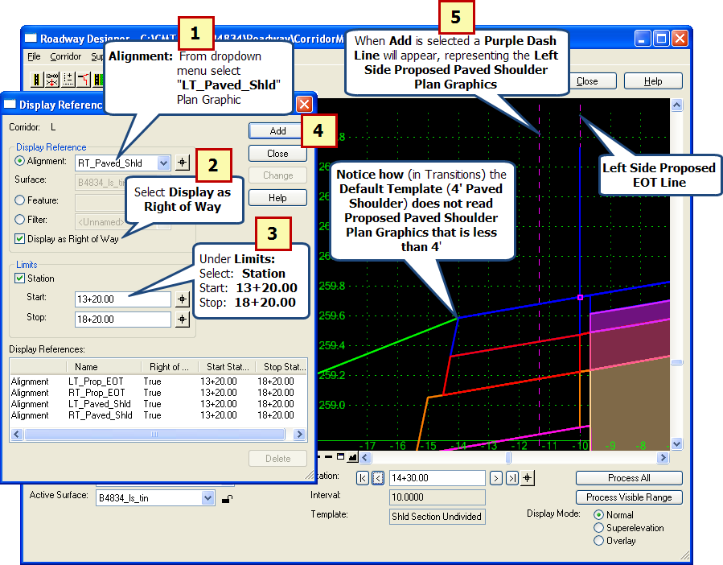

- Under “Display Reference” select Alignment drop down:
Choose LT_Paved_Shld
- Select next to “Display as Right of Way”
- Under “Limits” select next to Station
Next to Start: type 13+20.00
Next to Stop: type 18+20.00
- Click to add LT_Paved_Shld to list.
- After adding to list, a Purple Dashed Line will display in Cross Section View (representing the Left Side Paved Shoulder).
Note: Repeat this process to add RT_Paved_Shld to list.
Using “Parametric Constraints” to Change “Paved Shoulder Width”

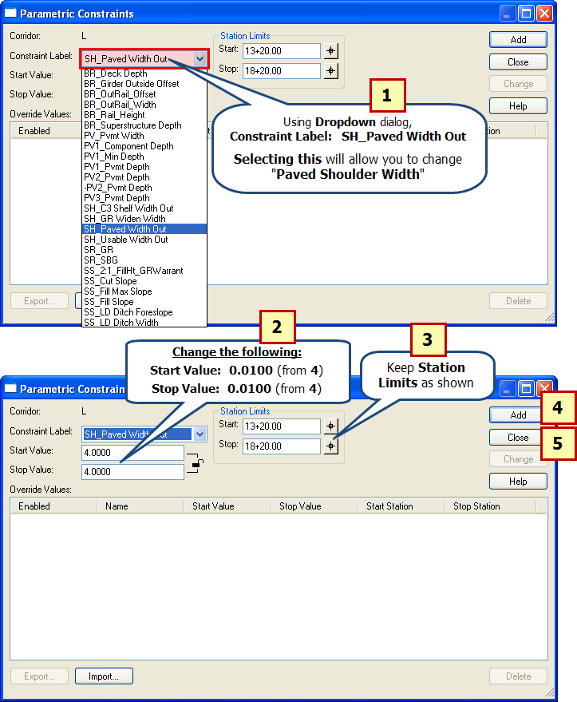
- Using Dropdown dialog, Constraint Label: SH_Paved Width Out
- Change Start & Stop Value: 0.0100 (from 4.0000)
- Keep Station Limits as shown:
Start: 13+20.00
Stop: 18+20.00
- Click on to Change “Paved Shoulder Width” in Model.
- Click to Close “Parametric Constraints”

Scanning through Cross Sections to Verify “Paved Shoulder Width” Change

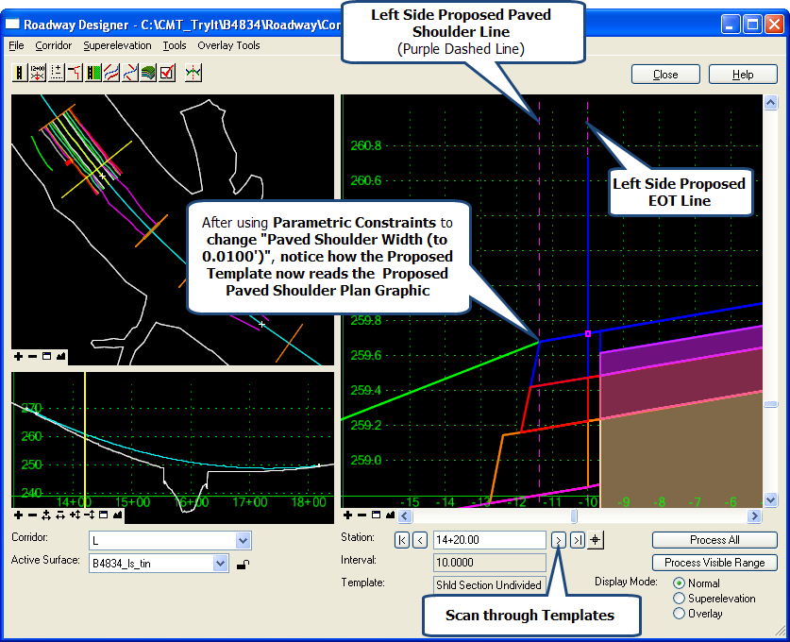

- Create Surface

Open “Create Surface(s)…”

  - By using the Corridor Dropdown Menu or by using the Roadway Designer Toolbar:

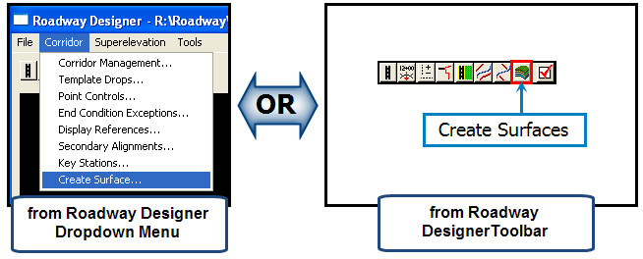

How to Create Surface

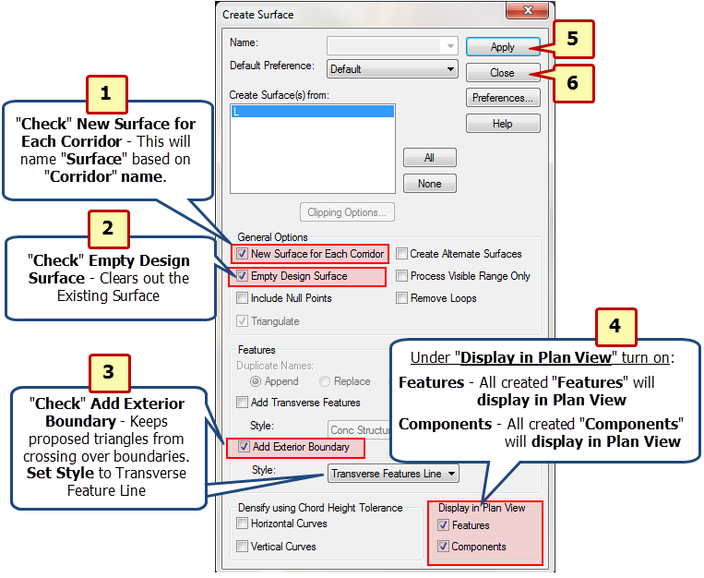
- Click New Surface for Each Corridor.
- Click Empty Design Surface.
- Click Features.
Click Components.
- Click on to create “Surface L”.
- Click to Close “Create Surface”.
- Save IRD File.

Files Created during “Create Surface” Process

The Create Surface Process creates the following files (stored in the
CorridorModeling Folder):

L.DTM – Proposed 3D Model DTM
L.TIN – Geopak Tin File

- Basic Rendering of 3D Model
Use “View Display Mode” to View Basic Rendering of Model

- Turn off both Reference Files.
- “Fit View” to center Model.
- In Lower Left Corner of “View 1” click on “View Display Mode” scrolling up to select “Illustration”.
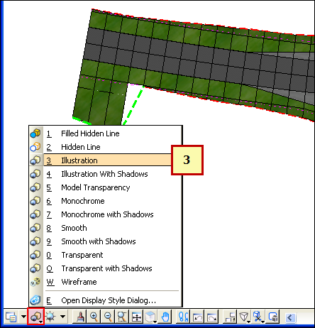

- Select “Adjust View Brightness” and Slide “Bar” to the Right to make Lighting Brighter.

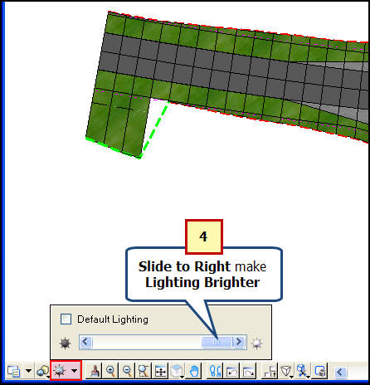

- Under ”View Rotation”, Select “Rotate View”. Select and Hold Down “Left” Mouse Button (while moving mouse) to Rotate Model (in 3D).

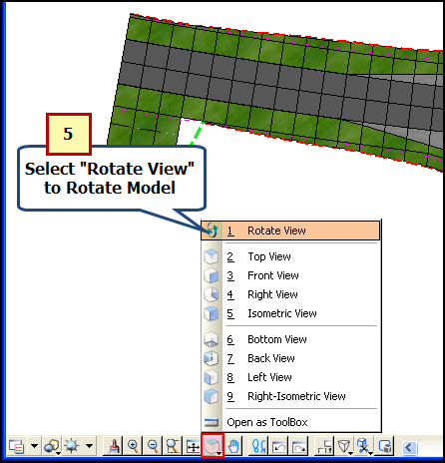

Picture of Rotated Rendered 3D Model

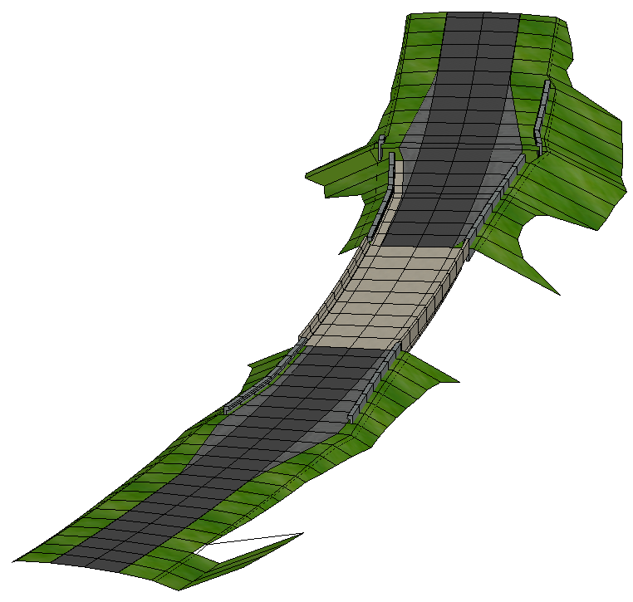

- Close “Roadway Designer”
- Click on “Close” to End “Roadway Designer” Session.

Exercise 5: Drive Roadway

- How to Start “Drive Roadway”

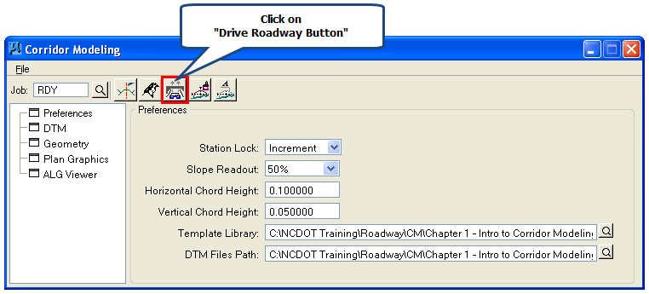

  - Under “Corridor Modeling Dialog Window” click on “Drive Roadway Button”.

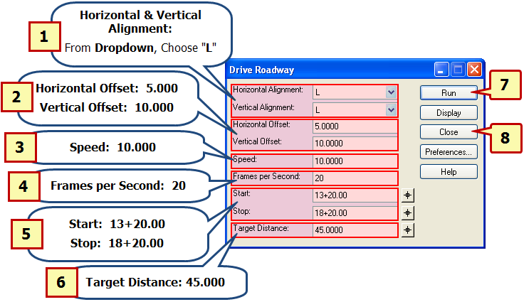

- Horizontal Alignment: Choose L
Vertical Alignment: Choose L
- Horizontal Offset: 5.000
Vertical Offset: 10.000
- Speed: 10.000
- Frames per Second: 20
- Next to Start: 13+20.00
Next to Stop: 18+20.00
- Target Distance: 45.000
- Click to Start Drive Roadway.
- Select to Drive Roadway.

Drive Roadway Example

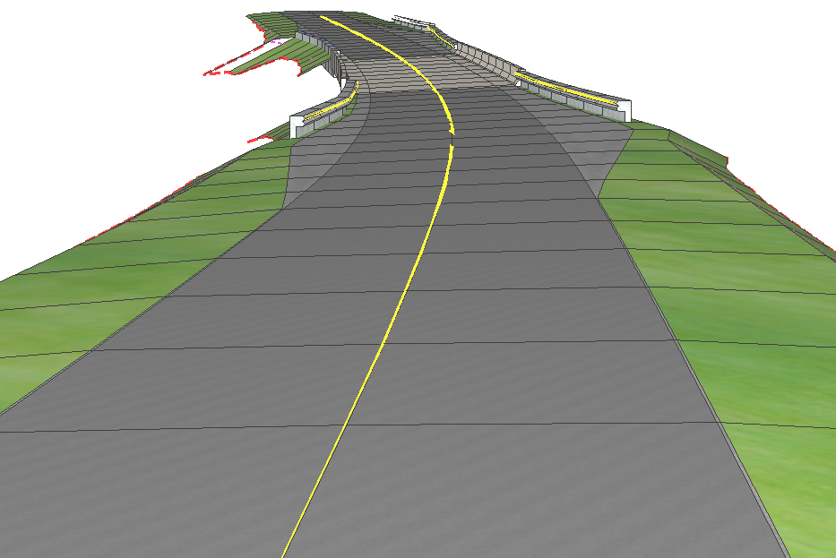

Exercise 6: Draw Cross Sections from Surfaces

Draw Cross Sections from Surfaces Overview

  - Draws Cross Sections based on “Existing Ground” and “Proposed Model DTM” DTM files.
  - Even though “Draw Cross Sections from Surfaces” is accessed from “Corridor Modeling Dialog Window” it is the same “dialog” used in Geopak.
  - Allows user to draw “Existing Ground & Proposed” cross sections at the same time.

- How to Start “Draw Cross Sections from Surfaces”

Note: Before Getting Started….
You will need to Move and Open the “b4834_rdy_xsc_cm.dgn (located in Roadway\XSC folder) into the “CorridorModeling” folder.

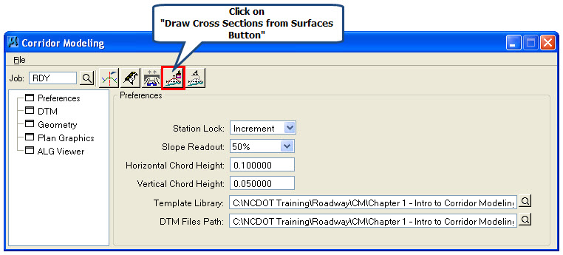

  - Under “Corridor Modeling Dialog Window” click on “Drive Roadway Button”.

- “XS Cells” Tab
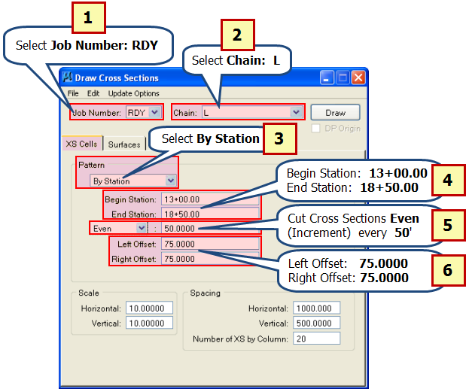
- Select Geopak Job Number: RDY
- Select Geopak Chain: L
- Under Pattern, Select By Station
- Begin Station: type 13+00.00
End Station: type 18+50.00
- Choose Even increment cut every 50 feet.
- Left Offset: type 75.0000
Right Offset: type 75.0000

- “Surfaces” Tab – Adding Existing Ground Cross Section Data

  - Add “Existing Ground Cross Section Data” as shown below:

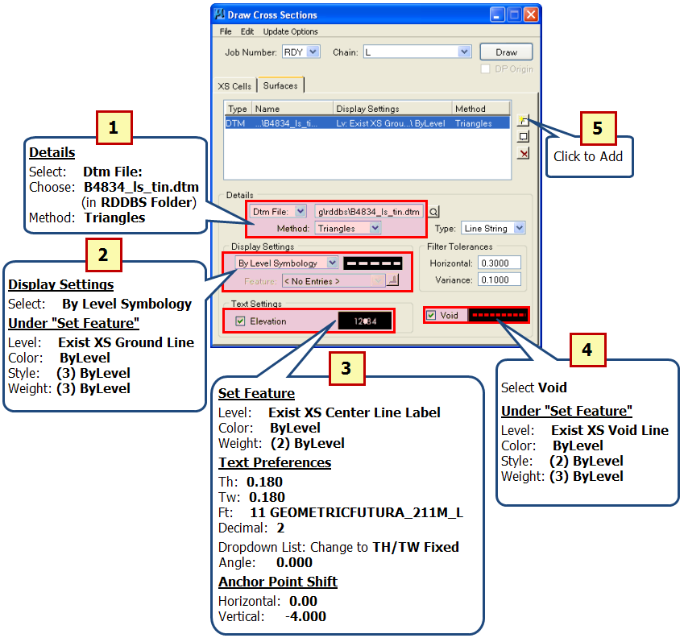

- “Surfaces” Tab – Adding Proposed Cross Section Data

  - Add “Proposed Cross Section Data” as shown below:

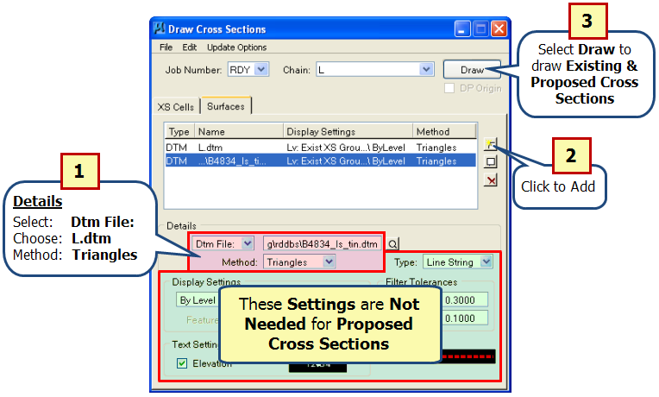

Exercise 7: Cross Section Labeling

- Starting “Cross Section Labeling”

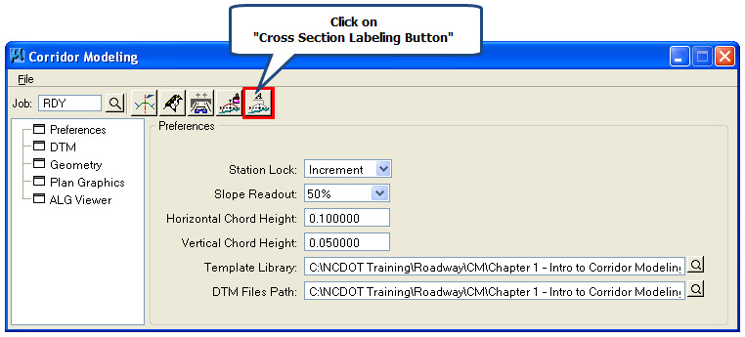

- Using “Cross Section Labeling”

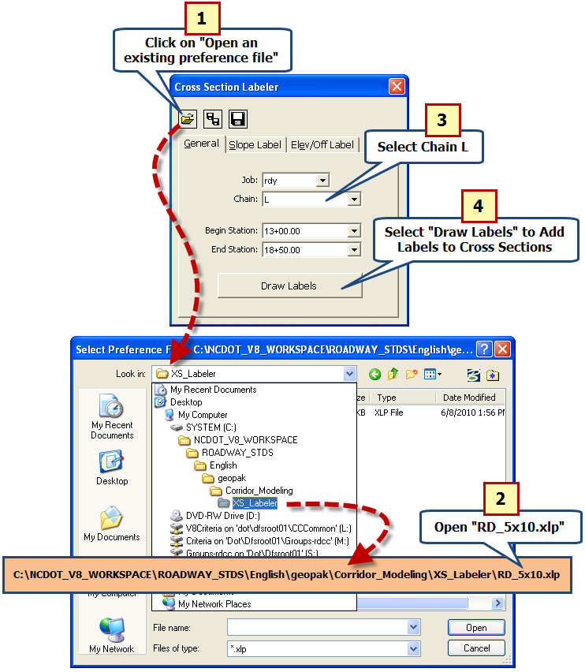

- Click on “Open an existing preference file”
- Using path shown above, Open: RD_5x10.xlp
- Select Chain: L
- Select Draw Labels to Add Labels to Cross Sections.

