STEEL ROAD PLATES
(8/18/2026)

Description

Furnish, install, maintain, and remove Steel Road Plates to cover trenches, excavation sites, or road cuts.

Materials

Provide Steel Road Plates and anchoring bolts conforming to ASTM A36 Standards. Steel Road Plates shall have a minimum thickness of 1”.

Construction Methods

Steel Road Plates shall be approved for use by the Engineer prior to installation.

Steel Road Plates shall be installed to resist bending and vibrations from traffic loads and anchored securely to prevent movement. Trenches, excavation sites, or road cuts shall be backfilled in accordance with the 2024 Standard Specifications for Roads and Structures prior to the installation of Steel Road Plates, unless used in a bridging application. For bridging applications, refer to the bridging applications section found elsewhere in this provision.

Steel Road Plates may only be used on roadways 45 mph or less. Steel Road Plates on freeways, expressways, or any road with a posted speed limit of 50 mph or higher shall not be permitted.

Use appropriate fasteners or securing methods to keep the plates in place. A wedge of compacted asphalt shall be used on all sides of Steel Road Plate installations to transition to existing pavement surface. Install 12” of Cold Applied Plastic Type 4 – Removable Tape (4” width) in both directions of each corner on the Steel Road Plate in accordance with Article 1205-6 and as shown in the diagram below:

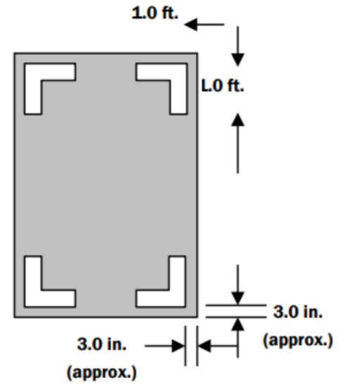
Install 48”x48” W8-1 “BUMP” or W8-24 “STEEL PLATE AHEAD” warning sign(s) in advance of Steel Road Plate(s), in accordance with the Roadway Standard Drawings.

Steel Road Plates shall not be used in a single location for a period exceeding 5 calendar days, unless otherwise directed by the Engineer.

Do not use Steel Road Plates in locations at risk of snow events or snow plowing operations as determined by the Engineer.

- Bridging Applications

For bridging applications, the Contractor shall have a professional engineer registered in the State of North Carolina perform computations and render a set of sealed, signed, and dated drawings detailing the Steel Road Plate bridging operation.

The shop drawings shall include, at minimum:
- Details showing the intended method to brace, sheet, support, or shore the excavation to prevent a trench failure.
- Details of the plating design, the method of fastening the plates, plate thickness, span, bearing, and the method of preventing plate movement.

Submit to the Engineer for review and acceptance complete design and fabrication details for each bridging operation.

Submit electronic (pdf) copies of completely detailed working drawings and the design calculations including all design assumptions for each bridging operation to the Engineer for approval prior to installation.

Allow 40 days for initial shop drawing review after the Engineer receives them. If revisions to shop drawings are required, an additional 40 days shall be required for review and approval of the final shop drawings. Approval of shop drawings by the Engineer shall not relieve the Contractor of responsibility for the correctness of the drawings.

All other requirements outlined in this provision also apply to bridging applications.

Maintenance

The Contractor shall be responsible for maintaining Steel Road Plate installations at all times. Steel Road Plates shall be marked to identify the responsible Contractor and a 24/7 contact number while the Steel Road Plate is installed.

Measurement and Payment

The cost of providing, placing, maintaining, and removing Steel Road Plates will be considered incidental to the operation that requires their use including but not limited to steel plate, anchoring bolts, fasteners, asphalt, warning signs, or Cold Applied Plastic Type 4 – Removable Tape.

