**Equipment Watch Blue Book Rental Rate Web Service**

The Department access to the Equipment Watch Blue Book Rental Rates website has now transitioned to individual account access.    Previous access to the site was provided through the internal NCDOT specific URL link on the Chief Engineer’s Link section of Inside NCDOT.   This link will expire on December 6, 2019.

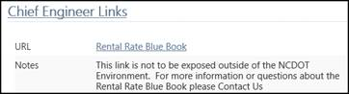

Beginning December 6, 2019, access to the website will require a licensed individual account.  (This access will be available beginning December 1st). NCDOT User accounts have already been created for all existing users that were provided by each DCE to Central Construction in November 2019.  Additionally, new user accounts can be setup anytime at no additional charge.   To request a new account, simply click on this [link](https://inside.ncdot.gov/TransportationServices/Lists/Division%20of%20Highways%20%20Chief%20Engineer/DispForm.aspx?ID=13) to Inside NCDOT enter the user specific information into the form email and then click send.

Below is the new link access the service:

<https://app.equipmentwatch.com/>

**Step 1:  Sign-in**

To sign in, click on the Sign In button in the upper right corner.     Your username is your email address and the temporary password is “welcome”

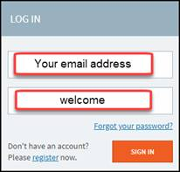

**Step 2: Change Password**

Once you are logged in, please change your password to something known only to you by clicking on the profile icon in the upper right corner.   Then select Edit Profile as shown below to establish a new password.  This password does not expire.

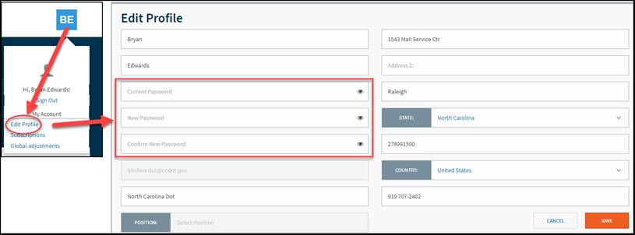

You should now be able to access the Blue Book Rental Rates as per usual.   If you have any problems or need any additional assistance, please feel free to contact me at 919-707-2492 or email me at [bledwards1@ncdot.gov](mailto:bledwards1@ncdot.gov).