CTP-ICE Existing Conditions Assessment
TECHNICAL MEMORANDUM
(CTP-ICE Product 1)
Date: | Revision: Date:  Date of Original Version:
To: | NCDOT Transportation Planning Branch Regional Unit Head, TPB  NCDOT Community Studies Team Leader, HES
From: | Staff, TPB/MPO/RPO
Subject: | CTP-ICE - Set the Scene – Technical Memorandum for  Existing Conditions for the XXXX CTP

This Technical Memorandum template provides instruction for documenting the Product 1 Comprehensive Transportation Plan-Indirect and Cumulative Effects (CTP-ICE) – Set the Scene: Existing Conditions and subsequent ICE analysis.
Metropolitan Planning Organizations (MPOs), Rural Planning Organizations (RPOs), and/or Transportation Planning Branch will conduct the existing conditions assessment and produce the CTP Plan ICE Screening Tool Matrix and Technical Memorandum. The NCDOT Human Environment Section-Community Studies (HES-CS) planners will review the work products and provide comments to the MPO/RPO and Transportation Planning Branch (TPB) Staff to ensure consistency between long-range planning and the National Environmental Policy Act (NEPA) process during project development.

Overview and Characterization of the CTP Study Area
Provide a written description of the CTP Study Area context and summarize its characteristics.

CTP-ICE Plan-Level Existing Conditions Matrix Results
Summarize the results of the screening matrix. Highlight the primary factors that affected the result.
The following sections of the Technical Memorandum correspond to the categories within the matrix. These sections will contain brief paragraphs documenting the important variables that have been assessed, using the staff’s best professional judgment, to qualitatively rank the categories.
CTP Plan ICE Screening Tool Matrix Methodology
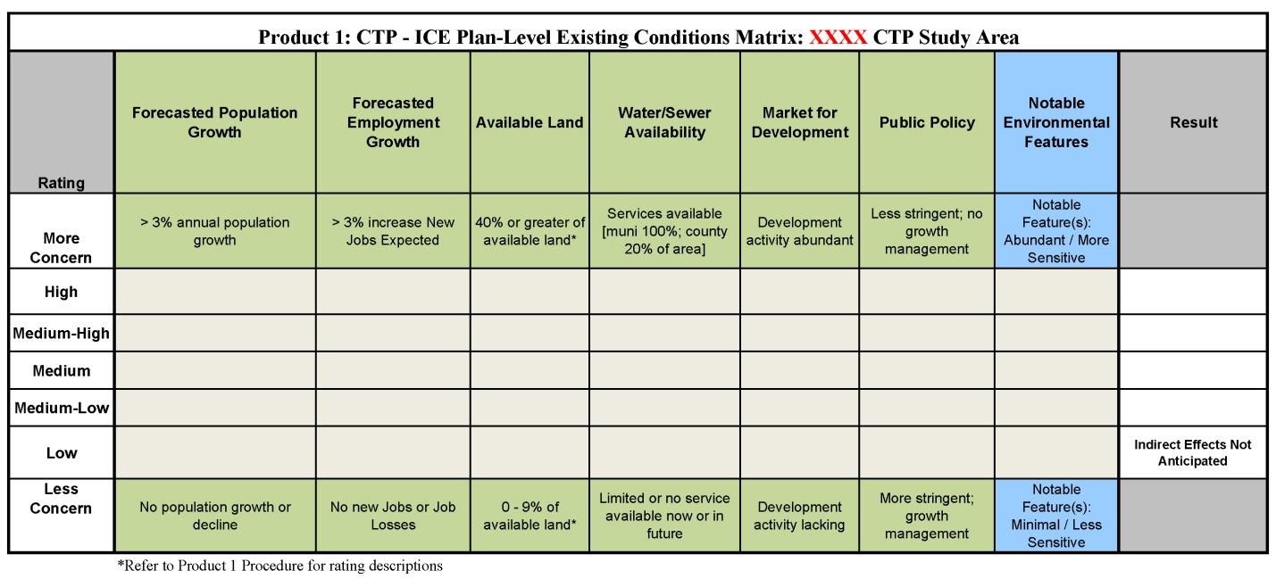
Figure 1 – See attached matrix for larger image

Forecasted Population Growth
Provide a written description of the ranking of the population growth or decline expected in the CTP Study Area, and why the rating of more concern, or less concern was selected. The documentation will be based on best professional judgment of growth and planned development, as well as data and projections contained in Community Understanding Report (CUR) report and elsewhere within the CTP dataset. Any methodology used to create a more localized or regional population rate should be provided.

Forecasted Employment Growth
Provide a written description of the ranking of the growth expected in the CTP Study Area, and why the rating of more concern, or less concern was selected. The documentation will be based on best professional judgment of the CTP Study Area trends, as well as data and projections contained in CUR report and elsewhere within the CTP dataset. Any methodology used to create a more localized, or regional employment rate should be provided.

Available Land
Document and describe the quantitative (GIS) or qualitative methodology used to estimate the amount of land available for development contained in the identified CTP Study Area. If a GIS quantitative methodology was used, note the amount of land that is already developed, how this acreage was calculated, and how the ranking of the matrix was determined. Describe the qualitative methodology for assessing available land, how staff estimated percentages of land available for development, and how a ranking of more concern or less concern of the matrix was determined.

Water and Sewer Availability
Document and describe the ranking of the availability of water and sewer service in the CTP Study Area by the time horizon. This narrative will describe the general location of existing service areas, and the areas where extension of service is planned under capital programs (G.SSS. 153A-82(5) for counties, and G.SS. 160A-148(5) for cities).

Market for Development
Document and describe the current development pressures occurring in the CTP Study Area. Describe how a ranking was selected; for example, a high ranking would denote abundant development activity, while a low ranking would indicate development activity is lacking, and note development trends or characteristics.

Public Policy
Document and describe the prevalence and applicability of the development policies and regulations in the jurisdictions contained in the CTP Study Area. The summary will note that less stringent policies and regulations would be ranked as high, whereas more stringent regulations and growth management policies would be ranked low.

Notable Environmental Features
Document and describe the sensitivity and abundance of notable environmental features in the CTP Study Area. Examples of sensitive environmental features would include, but are not limited to: major waterways, significant natural heritage areas, important habitat areas, land designated for conservation/preservation, water supply watershed areas, 303 (d) listed streams, high quality waters, outstanding resource waters, trout streams, etc... The ranking will relate to the sensitivity and abundance of these resources. A high ranking would constitute several environmental features that are more sensitive, and a low ranking would indicate that there are very few environmental features that are less sensitive.

