INTERVIEW FORM: CTP – ICE Product 3 Part 2 – Cumulative Effects
Document the cumulative impacts on notable cultural, community, water quality, and natural habitat features as a result of the CTP. The degree of concern should reflect more concern for unique resources that are not protected or recognized, and less concern for features incorporated in local planning and protection. The ranking will be based on past actions, current activities, and potential CTP Study Area future development.
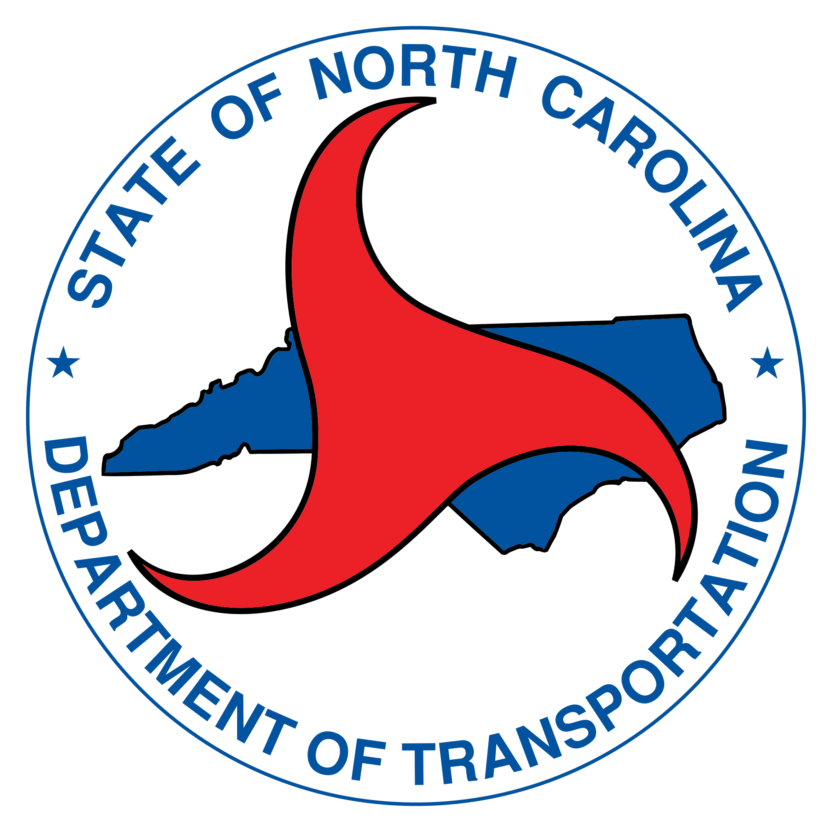
Municipality name:
Date:
Interviewee:
Interviewer:

Cultural Features | Please list notable cultural features located in the CTP Study Area (e.g. specific historic sites and districts, number of archeological features). These features will be considered in the analysis for past, current, and future activities that follows below. Use the Environmental Features Map as a source for information.
Past Actions
Please describe in detail past actions (if any) that have provided recognition and/or protection of cultural features in the CTP Study Area.

This includes official designations and/or protective policies/regulations for above identified cultural features.

 | Please rank the level of concern based on past actions that recognize / protect cultural features.  Higher concern = not recognized/protected Lower concern = recognized/protected | High | Med-High | Medium | Med-Low | Low
Cultural Features | Current Activities  Please describe in detail current activities (if any) that provide recognition and/or protection of cultural features in the CTP Study Area.  This includes official designations, policies, and/or legal regulations for above identified cultural features.
 | Please rank the level of concern based on current activities that recognize / protect cultural features.  Higher concern = not recognized/protected Lower concern = recognized/protected | High | Med-High | Medium | Med-Low | Low
Future Development
Please describe in detail future development activities (if any) that aim to provide recognition and/or protection of cultural features in the CTP Study Area.

This includes official designations, policies, and/or legal regulations for above identified cultural features.

 | Please rank the level of concern based on future development activities that recognize / protect cultural features.  Higher concern = not recognized/protected Lower concern = recognized/protected | High | Med-High | Medium | Med-Low | Low

Community Features | Please list notable community features located in the CTP Study Area (e.g. parks and/or key recreation areas, sites of community significance). These features will be considered in the analysis for past, current, and future activities that follows below. Use the Environmental Features Map and the Community Understanding Report (CUR) as sources for information.
Past Actions
Please describe in detail past actions (if any) that have provided recognition and/or protection of community features in the CTP Study Area.

This includes official designations and/or protective policies/regulations for above identified community features.

 | Please rank the level of concern based on past actions that recognize / protect community features.  Higher concern = not recognized/protected Lower concern = recognized/protected | High | Med-High | Medium | Med-Low | Low
Community Features | Current Activities  Please describe in detail current activities (if any) that provide recognition and/or protection of community features in the CTP Study Area.  This includes official designations, policies, and/or legal regulations for above identified community features.
 | Please rank the level of concern based on current activities that recognize / protect community features.  Higher concern = not recognized/protected Lower concern = recognized/protected | High | Med-High | Medium | Med-Low | Low
Future Development
Please describe in detail future development activities (if any) that aim to provide recognition and/or protection of community features in the CTP Study Area.

This includes official designations, policies, and/or legal regulations for above identified community features.

 | Please rank the level of concern based on future development activities that recognize / protect community features  Higher concern = not recognized/protected Lower concern = recognized/protected | High | Med-High | Medium | Med-Low | Low

Water Quality Features | Please list notable water quality features located in the CTP Study Area (e.g. water quality concerns in the CTP Study Area including that of wetlands/bodies of water). These features will be considered in the analysis for past, current, and future activities that follows below. Use the Environmental Features Map as a source for information.
Past Actions
Please describe in detail past actions (if any) that have provided recognition and/or protection of water quality features in the CTP Study Area.

This includes official designations and/or protective policies/regulations for above identified water quality features.

 | Please rank the level of concern based on past actions that recognize / protect water quality features  Higher concern = not recognized/protected Lower concern = recognized/protected | High | Med-High | Medium | Med-Low | Low
Water Quality Features | Current Activities  Please describe in detail current activities (if any) that provide recognition and/or protection of water quality features in the CTP Study Area.  This includes official designations, policies, and/or legal regulations for above identified water quality features.
 | Please rank the level of concern based on current activities that recognize / protect water quality features  Higher concern = not recognized/protected Lower concern = recognized/protected | High | Med-High | Medium | Med-Low | Low
Future Development
Please describe in detail future development activities (if any) that aim to provide recognition and/or protection of water quality features in the CTP Study Area.

This includes official designations, policies, and/or legal regulations for above identified water quality features.

 | Please rank the level of concern based on future development activities that recognize / protect water quality features  Higher concern = not recognized/protected Lower concern = recognized/protected | High | Med-High | Medium | Med-Low | Low

Natural Habitat Features | Please list notable natural habitat features located in the CTP Study Area (e.g. natural heritage sites, rare plant/animal species, and/or threatened/endangered species). These features will be considered in the analysis for past, current, and future activities that follows below. Use the Environmental Features Map as a source of information.
Past Actions
Please describe in detail past actions (if any) that have provided recognition and/or protection of natural habitat features in the CTP Study Area.

This includes official designations and/or protective policies/regulations for above identified natural habitat features.

 | Please rank the level of concern based on past actions that recognize / protect natural habitat features  Higher concern = not recognized/protected Lower concern = recognized/protected | High | Med-High | Medium | Med-Low | Low
Natural Habitat Features | Current Activities  Please describe in detail current activities (if any) that provide recognition and/or protection of natural habitat features in the CTP Study Area.  This includes official designations, policies, and/or legal regulations for above identified natural habitat features.
 | Please rank the level of concern based on current activities that recognize / protect natural habitat features  Higher concern = not recognized/protected Lower concern = recognized/protected | High | Med-High | Medium | Med-Low | Low
Future Development
Please describe in detail future development activities (if any) that aim to provide recognition and/or protection of natural habitat features in the CTP Study Area.

This includes official designations, policies, and/or legal regulations for above identified natural habitat features.

 | Please rank the level of concern based on future development activities that recognize / protect natural habitat features  Higher concern = not recognized/protected Lower concern = recognized/protected | High | Med-High | Medium | Med-Low | Low

