CTP-ICE Screening for Cumulative Effects
TECHNICAL MEMORANDUM
(CTP-ICE Product 3 – Part 2)
Date: | Revision: Date:  Date of Original Version:
To: | NCDOT Transportation Planning Branch Regional Unit Head, TPB  NCDOT Community Studies Team Leader, HES
From: | Staff, TPB/MPO/RPO
Subject: | CTP-ICE Screening for Cumulative Effects for the XXXX CTP
This Technical Memorandum template provides instruction for documenting Part 2 of the Product 3 Comprehensive Transportation Plan-Indirect and Cumulative Effects (CTP-ICE) Screening for Cumulative Effects of the CTP Alternatives. Part 2 documents the alternatives screening for cumulative effects. In Part 1, a separate matrix and technical memorandum are prepared for each alternative whereas in Part 2, only one matrix and technical memo are prepared for assessing cumulative effects at the CTP level.
The Metropolitan Planning Organization (MPO), Rural Planning Organization (RPO), and/or Transportation Planning Branch staff will conduct the Cumulative Effects Screening of alternatives and draft the Technical Memorandum summarizing the results. The NCDOT Human Environment Section-Community Studies (HES-CS) staff will review the Cumulative Effects Screening Technical Memorandum and Screening Matrix and provide comments to the MPO/RPO and Transportation Planning Branch (TPB) Staff to ensure consistency between long-range planning and the National Environmental Policy Act (NEPA) process during project development.

CTP-ICE Screening Results for the XXXX CTP Study Area
Summarize the results of the screening matrix. Highlight the primary factors that affected the result.
The following sections of the Technical Memorandum will contain sections that correspond to the categories within the matrix. These sections will contain brief paragraphs documenting the important variables which have been assessed, using the staff’s best professional judgment, to qualitatively rank categories.
CTP-ICE Screening Matrix for Cumulative Effects: XXXX CTP Study Area
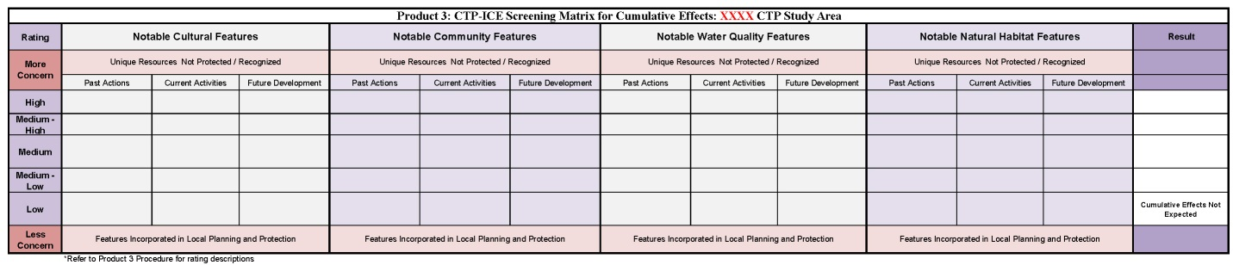Figure 1 – See attached matrix for larger image

Notable Cultural Features
Provide a written description of the ranking provided in the matrix that addresses the Notable Cultural Features and the ranking that reflects the degree of concern with more concern for unique resources that are not protected or recognized, and less concern for features incorporated in local planning and protection. The qualitative ranking will explain the basis of the assessment of past actions, current activities, and potential future anticipated development.

Notable Community Features
Provide a written description of the ranking provided in the matrix that addresses the Notable Community Features and the ranking that reflects the degree of concern with more concern for unique resources that are not protected or recognized, and less concern for features incorporated in local planning and protection. The qualitative ranking will explain the basis of the assessment of past actions, current activities, and potential future anticipated development.

Notable Water Quality Features
Provide a written description of the ranking provided in the matrix that addresses the Notable Water Quality Features and the ranking that reflects the degree of concern with more concern for unique resources that are not protected or recognized, and less concern for features incorporated in local planning and protection. The qualitative ranking will explain the basis of the assessment of past actions, current activities, and potential future anticipated development.

Notable Natural Habitat Features
Provide a written description of the ranking provided in the matrix that addresses the Notable Natural Habitat Features and the ranking that reflects the degree of concern with more concern for unique resources that are not protected or recognized, and less concern for features incorporated in local planning and protection. The qualitative ranking will explain the basis of the assessment of past actions, current activities, and potential future anticipated development.

