Yadkin County CTP Steering Committee Summary
May 19, 2014 – 10:00am
Yadkin County Commissioners Meeting Room
Human Services Building – 217 E. Willow Street, Yadkinville

Attendance:

Kevin Austin Yadkin County Commissioner
Gilbert Hemric Yadkin County Commissioner
Marion Welborn Yadkin County Commissioner
David Moxley Yadkin County Commissioner
Aaron Church Yadkin County Manager
Michael Poston Yadkin County Planning Director
Tom Bastable, PE Town of Boonville
Wayne Moore Town of Jonesville
Scott Buffkin Town of Jonesville
Daniel Tulbert Yadkin County Citizen
Christina Walsh Northwest Piedmont Rural Planning Organization
Earlene Thomas, PE NCDOT, Western Unit Head – Transportation Planning Branch
Vernia Wilson NCDOT, Project Engineer – Transportation Planning Branch
Dean Ledbetter NCDOT – Division 11, Division Planning Engineer
Shirley Williams NCDOT – Planning & Development Manager, NCDOT Rail Division (via teleconference)

There were no representatives from Yadkinville or East Bend in attendance.

Summary of Agenda Items:
Steps in the CTP Process
After a brief introduction, Vernia Wilson gave a power point presentation which covered the development of the CTP, from the beginning of the process to the current phase. The timeline, given in the meeting agenda, for the study development was also reviewed.
Action Items: Place the following items on the study website: CTP Brochure; Power point presentation from the meeting; Goals & Objectives Survey summary; Base (2012) and future (2040) year volume/capacity maps; Crash map; Deficient Bridges map; and environmental mapping.
Status: This item has been completed. All documents can be viewed on the study website using the following link: https://connect.ncdot.gov/projects/planning/Pages/Comprehensive-Transportation-Plans.aspx.
Where Are We Now?
The CTP is currently in the Develop Final Plan phase. The Draft CTP maps and project documentation were presented to all jurisdictions within the county during the January to March 2014 timeframe. A summary of all feedback received on the Draft CTP was provided and reviewed.

Objectives for Moving Forward
During the meeting, an exercise was conducted to categorize the comments received into one of three groups: CTP, Division, or Other. All CTP comments were discussed and changes will be incorporated into a revised Draft CTP. All Division comments would be forwarded to the appropriate NCDOT 11 staff. All comments in the other category would be forwarded to the appropriate entity or filed for information only. The resolution of all comments is given in Attachment A.
Action Items:
- Provide links to survey and project submittal forms for the North Carolina Comprehensive State Rail Plan. These forms as well as additional information regarding the plan can be accessed at: http://www.ncbytrain.org/projects/rail-plan.html.
- Provide a copy of high level preliminary rail assessment completed for Yadkin County. Shirley Williams referenced this assessment during the discussion regarding the potential for rail service within Yadkin County. The document is being provided as an attachment to this meeting summary as Attachment B.
- Forward all Division related comments to Dean Ledbetter for distribution to the appropriate NCDOT Division 11 Staff. This item has been completed.
- Incorporate all revisions into the revised Draft CTP maps and documentation. This item is currently underway.
- Schedule a meeting with representatives from Yadkinville to resolve comments received on US 601, review recommendations from the completed corridor study and develop a project proposal to address deficiencies along the facility. This meeting has been tentatively scheduled for May 30, 2014.

Next Steps
Upon completing the action items detailed above, the revised Draft CTP maps and documentation will be finalized. The revised Draft CTP will be distributed to all meeting attendees for a final review. At that time, consensus will be sought to move forward with holding a public workshop. Below is the tentative revised schedule that was shared during the meeting.
Tentative Schedule
Develop Final Draft CTP June 2014
Public Workshop July 2014
Local Adoption/Endorsement August 2014
NCDOT Adoption October 2014
Distribute CTP Report November 2014

Additional Items
During the meeting, the following additional items were discussed:
- Mr. Tolbert requested information regarding several bridge replacement projects. The NCDOT Division 12 Bridge Manager was contacted on May 20, 2014 and asked to contact Mr. Tolbert directly for more information and to address his questions.

Attachment A

CTP Category:
- US 601 in Yadkinville: The commissioners were concerned with the boulevard recommendation which is a four lane median divided facility with turn bays for left turns. They were concerned that access (turning points) would be too limited with the median divided facility. Their preference is a five lane undivided facility with a continuous two-way left turn lane.
- US 601: A recommendation was made for US 601 N to be widened to five lanes instead of a four lane boulevard.
- Roundabouts: There was some discussion regarding roundabout options instead of widening along US 601.
- Proposed Beroth Road (SR 1415) Realignment: The commissioners recommended the re-alignment of Beroth Road (SR1415) just north of the interchange on US 601 in Yadkinville.
- Beroth Road – Realign to connect to US 601 at Sara Lee Boulevard with a connection to the US 421/601 on ramp. It was stated that this was the previous configuration at this location.
- A pedestrian refuge island is needed on US 601 at the Dollar General.
Resolution (Items 1-6): A meeting has been tentatively scheduled for May 30, 2014 with Yadkinville and others to resolve comments received on US 601, review recommendations from the completed corridor study and develop a project proposal to address deficiencies along the facility.
- Proposed US 421 Connector and Interchange: The commissioners recommended construction of a new interchange on US 421 south of the Billy Reynolds Road (SR 1134) and Beamer Road (SR1415) intersection. The construction of a two lane minor thoroughfare on new location to connect the proposed US 421 interchange to Billy Reynolds Road (SR 1134) was also recommended.
- I-77: The County Commissioner’s would like a new interchange on I-77 at Asbury Church Road (SR 1125).
Resolution (Items 7-8): The new interchanges will be added to the revised Draft CTP maps. Vernia Wilson and Michael Poston will coordinate on supportive economic development language from the existing land use plan(s) to include in the project proposal documentation.
- Rail: There was a concern that there are no rail recommendations included in the plan. The commissioners recommended including a proposed north-south rail route on the western side of I-77.
Resolution: There will not be a recommendation for new rail service proposed within the CTP. However, the County’s desire to pursue rail will be documented within the technical report. After a robust discussion with NCDOT’s Rail Division, the county will consider submitting their rail proposal as a potential project for evaluation within the NC Comprehensive Rail Plan. Additional information provided as previously noted.
- Bicycle Routes: The commissioners expressed concerns that there were too many bicycle routes. They wanted to know why there were so many routes and inquired about widening roads for bicycles?
Resolution: The majority of the facilities listed within the county are a part of NC Bicycle Route 2. Each time the name of the road changes, there is a new listing. The bicycle section will be modified to provide more clarity.
- Two additional bicycle loops were requested to be added to the bicycle element of the CTP (Yadkinville).
- US 601/NC 67 Intersection Modification –Turning lanes requested to be installed on NC 67 at the intersection with US 601. It was noted that this is an alternate route for I-77. (Boonville)
- Pedestrian facilities: Additional information provided on sidewalks, multi-use paths and some bicycle routes (Boonville).
- Flint Hill Road (SR 1549) – Upgrade to minimum standards (minor widening). It was noted that this project would be to accommodate bicycles.
- There was a question about a greenway project that is on the map, but not listed in the recommendations section of the report (Jonesville).
- East Bend – Sidewalk recommendations map presented and updates made.
- Bridge Replacement (Jonesville): The Town would like to see the project added to the CTP to replace the old bridge between Jonesville and Elkin. The consensus was to construct a new roadway from the NC 67/Valley Drive intersection in Jonesville to the NC 268 Business/Johnson Ridge Road (SR 1144) intersection in Elkin.
Resolution (Items 11-17): All of these changes will be incorporated into the revised Draft CTP maps and documentation.
Division Category:
- Yadkinville: Main Street: Concerns were raised regarding reducing truck traffic reduced on Main Street due to pedestrian conflicts. It was also noted that there could be a potential for economic development on East Main Street if truck traffic was reduced.
- Yadkinville: There was a question regarding installing flashing lights at the Fire Department.
- Yadkinville: An additional meeting was requested for further discussion of highway, bicycle and pedestrian projects.
- Boonville: Concerns were raised regarding drainage issues on NC 67 (Main Street) starting from the super market (D & J Galaxy of Booneville) and continuing to River Road (SR 1367).
Resolution (Items 1-4): All Division related comments were forwarded to Dean Ledbetter for distribution to the appropriate NCDOT Division 11 staff.

Other Category:
- A PART route schedule is needed at the Park and Ride Lot located on US 601 north of Pine Street for the bus route. It was noted that this is along Route 13.
Resolution (Items 1): This feedback has been shared with PART.
- Quaker Avenue (SR 1548): Add from Fairgrounds to end of Quaker as state maintained road.
- Union Hill Road (SR 1550): Add from Main Street northward as state maintained road.
- Shady Grove Church Road (SR 1538): Add as a state maintained road.
Resolution (Items 2-4): These are all currently state maintained roads. However, they were not evaluated as a part of the CTP.

Attachment B

Rail Service for Yadkin County

Rail Service Opportunities
- There are no railroad tracks in Yadkin County.
- Access available by transload
  - The Yadkin Valley Railroad operates a transload near the northern county line off of US 601 and can handle: propane, grain, steel coil, lumber, plastic etc. The railroad has talked with Blue Rhino about the possibility of transloading propane for them.
  - The Norfolk Southern operates a transload in Winston Salem and currently handles transload product for the Unifi yarn plant in Yadkinville.
- Cost and issues associated with constructing track and operating a new rail line :
  - Construction cost for a rail line from the southwest quadrant of the I-77 and US 421 intersection and from Black Shoals Road (SR 1103) just south of the intersection with Windsor Road (SR 1100) to:
    - the Alexander Railroad in Statesville would require 25.5 miles of track at an approximate cost of $190,000,000 (plus ROW)
    - the Yadkin Valley Railroad would require 15 miles of track and at an approximate cost of $150,000,000 (plus ROW)
    - the NS in Statesville was not feasible because of the impacts to the city to make the connection
    - Cost for railroad in this area is high due to rolling terrain and the need to maintain a reasonable grade which requires significant grading and numbers of bridges.
  - Operations and maintenance (only)
    - Rail service must cover the operations and maintenance cost for the rail line and a profit for the railroad
    - 100 carloads per mile per year is used as a rule of thumb used to determine if a rail line can cover its operations and maintenance cost.
    - In the two options above there would need to be at least:
      - 2,550 Carloads per years based on the number of miles of track that would need to be constructed to connect to Alexander RR in Statesville or
      - 1,500 Carloads per year based on the number of miles of track that would need to be constructed to connect to the Yadkin Valley Railroad
  - Attracting a railroad operator to provide service over a rail line
    - A railroad must agree to operate the service and may require commitment for more carloads that 100 carloads per mile per year to initiate service.
  - Considering the number of carload shipments required to cover operating and maintenance cost and the significant ROW and construction cost for new location rail lines, little if any new location rail corridors have been added to the rail network in NC for many years. Most new location tracks are short spurs to connect an industry to an existing corridor or add capacity on high density lines.
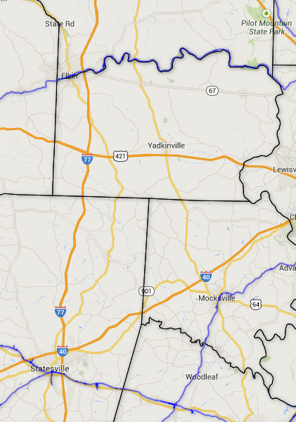
Industrial Site
Alex. RR
25.5 Miles
15 Miles
Yadkin River
Yadkin Valley RR
Norfolk Southern
Norfolk Southern

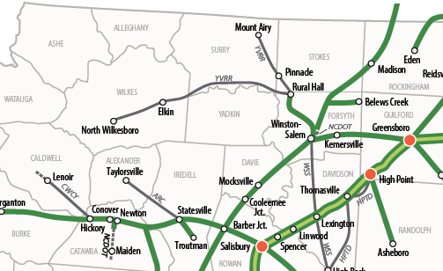
Industrial Site

