Appendix 2 Growth Rate Calculations

All AADT data was collected from the North Carolina Department of Transportation (NCDOT) ArcGIS AADT Mapping Application and is summarized in Table 4. Some years had no available AADT data; some sites had a one-year gap between available AADT data. Site #7 (Brier Leaf Ln & Brier Creek Pkwy) and Site #8 (NC-55 & O'Kelly Chapel Rd) had the least AADT data out of the eight sites. Site #1 (N Peartree Ln & New Bern Ave) and Site #6 (Brentwood Rd & Capital Blvd) had the most AADT data out of the eight sites. Site #5 (Trawick Rd/Huntleigh Dr & Capital Blvd) had the highest AADT range of 62,000 and 80,000 vehicles. Site #1 (N Peartree Ln & New Bern Ave) had the lowest AADT range of 21,000 and 24,000 vehicles.

To estimate 2023 and 2043 AADT at each site, a scatterplot of AADT vs. the year was created for each site. Due to COVID-19 effects, data from 2020 and 2021 were excluded. A regression line was then fitted to each scatterplot; the corresponding regression equation was used to estimate 2023 and 2043 AADT as shown in Table 5. Based on the results, Site #6 (Brentwood Rd & Capital Blvd) has the highest 2023 and 2043 AADT of 70,300 and 74,400 vehicles, respectively. Site #1 (N Peartree Ln & New Bern Ave) has the lowest 2023 and 2043 AADT of 21,700 and 20,400 vehicles, respectively. Of the eight sites, Site #1 (N Peartree Ln & New Bern Ave) and Site #5 (Trawick Rd/Huntleigh Dr & Capital Blvd) are the only two sites with a negative correlation between AADT and the year.

Site #1
LocationID: 0920000593
COUNTY: WAKE
RTE_CLS: Secondary Routes
ROUTE: SR 2911 (NEW BERN AVE)
LOCATION: EAST OF DONALD ROSS RD
AADT_2002:
AADT_2003: 23000
AADT_2004:
AADT_2005: 23000
AADT_2006:
AADT_2007: 24000
AADT_2008:
AADT_2009: 22000
AADT_2010:
AADT_2011: 22000
AADT_2012:
AADT_2013: 21000
AADT_2014:
AADT_2015: 23000
AADT_2016:
AADT_2017: 22000
AADT_2018:
AADT_2019: 22500
EST_AADT_2023: 21700
EST_AADT_2043: 20400

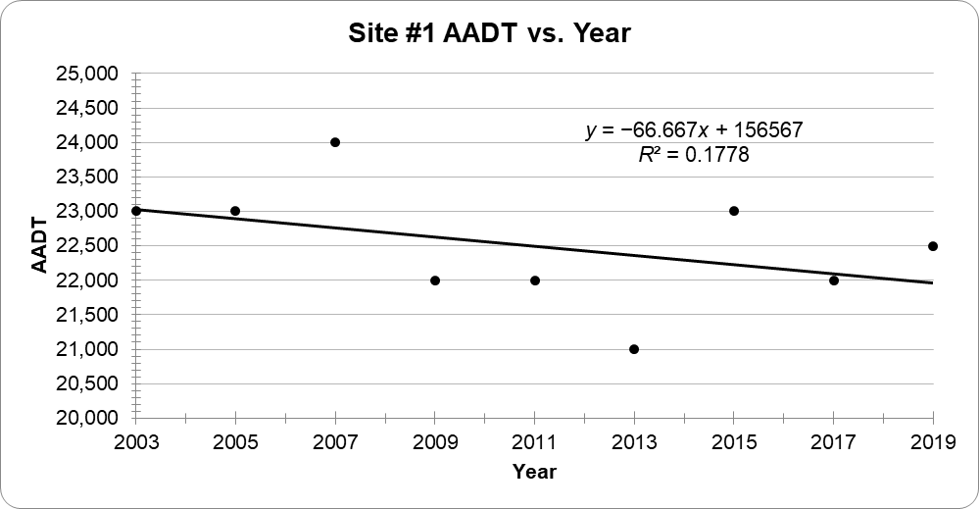
Figure 2. Site #1 AADT vs. Year

Site #2
LocationID: 0920000682
COUNTY: WAKE
RTE_CLS: NC Hwys
ROUTE: NC 54 (CHAPEL HILL RD)
LOCATION: WEST OF TRINITY RD
AADT_2002:
AADT_2003: 20000
AADT_2004:
AADT_2005: 21000
AADT_2006:
AADT_2007: 21000
AADT_2008:
AADT_2009: 29000
AADT_2010:
AADT_2011: 22000
AADT_2012:
AADT_2013: 24000
AADT_2014:
AADT_2015: 29000
AADT_2016:
AADT_2017: 27000
AADT_2018:
AADT_2019:
EST_AADT_2023: 31200
EST_AADT_2043: 42000

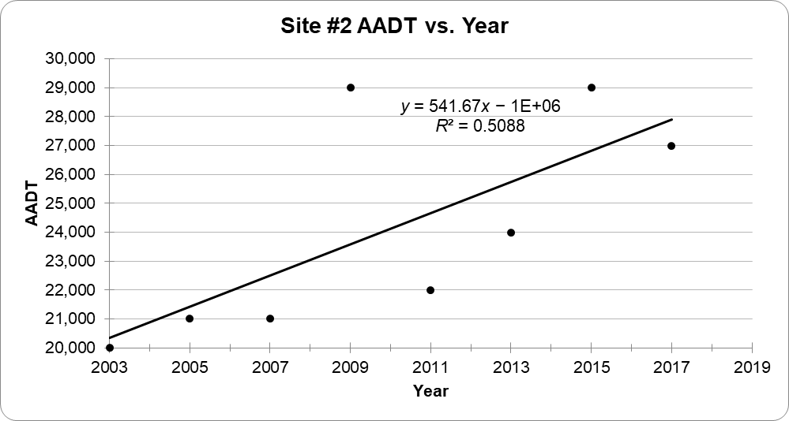
Figure 3. Site #2 AADT vs. Year

Site #3
LocationID: 0320000398
COUNTY: DURHAM
RTE_CLS: Secondary Routes
ROUTE: SR 1999
LOCATION: NORTH OF NC 54
AADT_2002:
AADT_2003: 20000
AADT_2004:
AADT_2005: 19000
AADT_2006:
AADT_2007:
AADT_2008:
AADT_2009:
AADT_2010:
AADT_2011: 20000
AADT_2012:
AADT_2013: 21000
AADT_2014:
AADT_2015: 23000
AADT_2016:
AADT_2017: 23000
AADT_2018:
AADT_2019: 24000
EST_AADT_2023: 24600
EST_AADT_2043: 30300

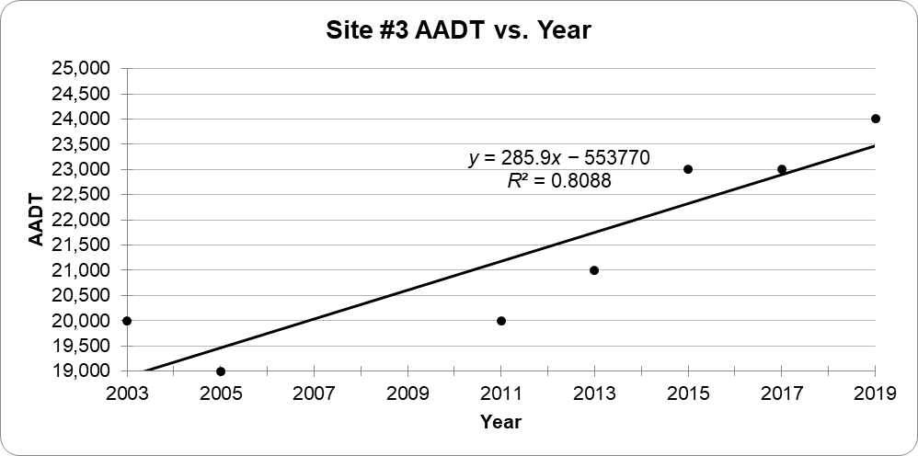
Figure 4. Site #3 AADT vs. Year

Site #4
LocationID: 0920000477
COUNTY: WAKE
RTE_CLS: Secondary Routes
ROUTE: SR 3555 (OLD WAKE FOREST RD)
LOCATION: WEST OF SR 5167
AADT_2002:
AADT_2003: 18000
AADT_2004:
AADT_2005: 19000
AADT_2006:
AADT_2007: 26000
AADT_2008:
AADT_2009: 18000
AADT_2010:
AADT_2011: 27000
AADT_2012:
AADT_2013: 26000
AADT_2014:
AADT_2015: 26000
AADT_2016:
AADT_2017: 23000
AADT_2018:
AADT_2019:
EST_AADT_2023: 29000
EST_AADT_2043: 38400

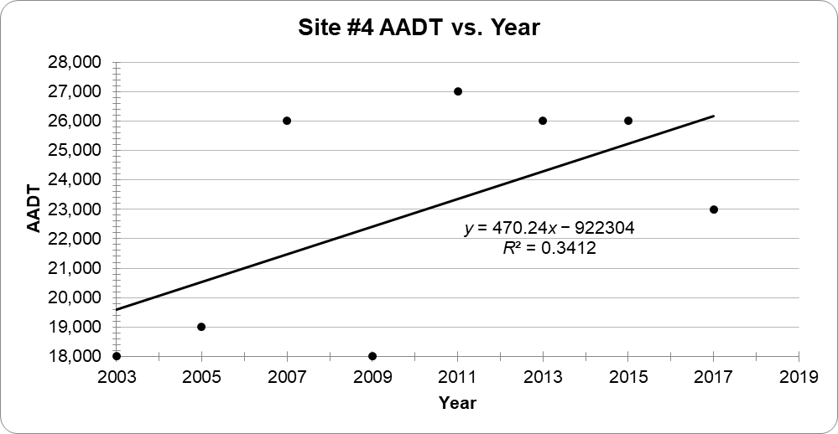
Figure 5. Site #4 AADT vs. Year

Site #5
LocationID: 0920000417
COUNTY: WAKE
RTE_CLS: US Routes
ROUTE: US 1-401
LOCATION: NORTH OF SR 2206 TRAWICK RD
AADT_2002:
AADT_2003: 66000
AADT_2004:
AADT_2005: 80000
AADT_2006:
AADT_2007: 62000
AADT_2008:
AADT_2009: 66000
AADT_2010:
AADT_2011:
AADT_2012:
AADT_2013: 66000
AADT_2014:
AADT_2015: 66000
AADT_2016:
AADT_2017: 69000
AADT_2018:
AADT_2019: 67000
EST_AADT_2023: 65700
EST_AADT_2043: 62200

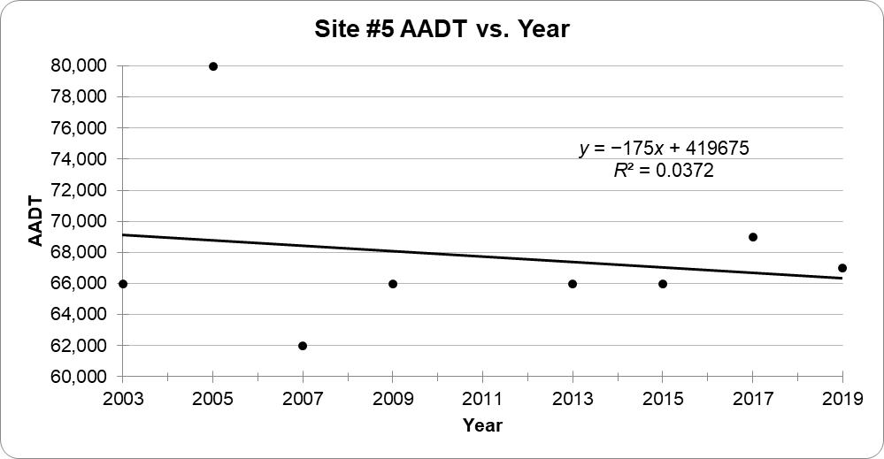
Figure 6. Site #5 AADT vs. Year

Site #6
LocationID: 0920000192
COUNTY: WAKE
RTE_CLS: US Routes
ROUTE: US 1-401
LOCATION: SOUTH OF BRENTWOOD RD
AADT_2002:
AADT_2003: 65000
AADT_2004:
AADT_2005: 72000
AADT_2006:
AADT_2007: 63000
AADT_2008:
AADT_2009: 71000
AADT_2010:
AADT_2011: 61000
AADT_2012:
AADT_2013: 64000
AADT_2014:
AADT_2015: 75000
AADT_2016:
AADT_2017: 72000
AADT_2018:
AADT_2019: 67000
EST_AADT_2023: 70300
EST_AADT_2043: 74400

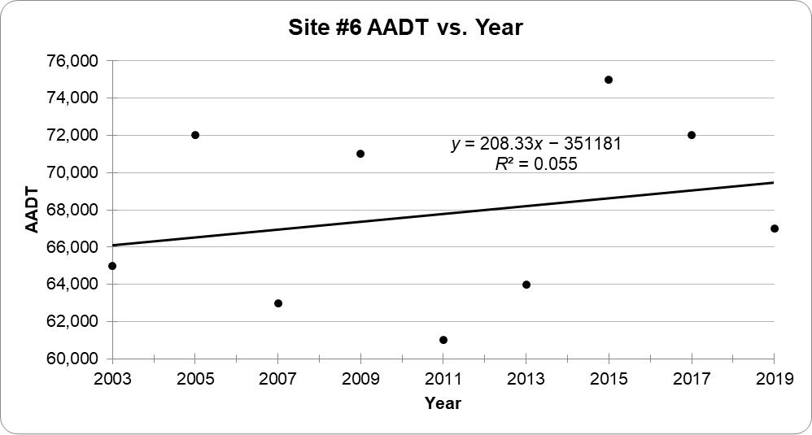
Figure 7. Site #6 AADT vs. Year

Site #7
LocationID: 920001783
COUNTY: WAKE
RTE_CLS: Secondary Routes
ROUTE: SR 3109 (BRIER CREEK PKWY)
LOCATION: SOUTH OF SR 3102
AADT_2002:
AADT_2003:
AADT_2004:
AADT_2005:
AADT_2006:
AADT_2007:
AADT_2008:
AADT_2009:
AADT_2010:
AADT_2011: 22000
AADT_2012:
AADT_2013: 24000
AADT_2014:
AADT_2015: 25000
AADT_2016:
AADT_2017: 28000
AADT_2018:
AADT_2019:
EST_AADT_2023: 33400
EST_AADT_2043: 52400

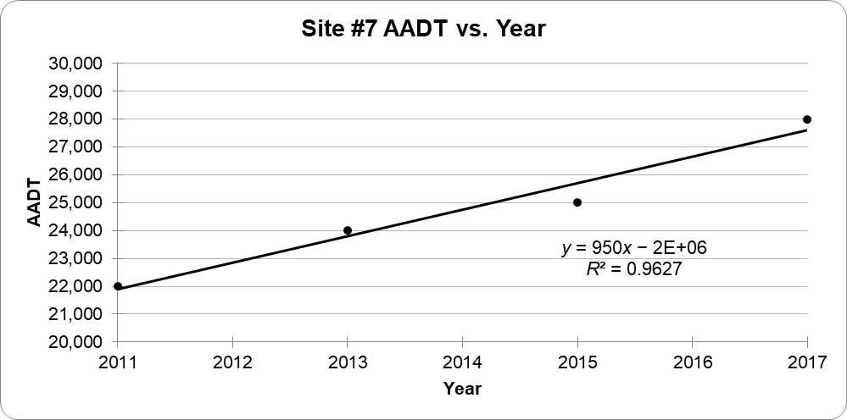
Figure 8. Site #7 AADT vs. Year

Site #8
LocationID: 920001785
COUNTY: WAKE
RTE_CLS: Secondary Routes
ROUTE: SR 1628
LOCATION: WEST OF NC 55
AADT_2002:
AADT_2003:
AADT_2004:
AADT_2005:
AADT_2006:
AADT_2007:
AADT_2008:
AADT_2009:
AADT_2010:
AADT_2011:
AADT_2012:
AADT_2013: 8600
AADT_2014:
AADT_2015: 13000
AADT_2016:
AADT_2017: 15000
AADT_2018:
AADT_2019: 18000
EST_AADT_2023: 24200
EST_AADT_2043: 54400

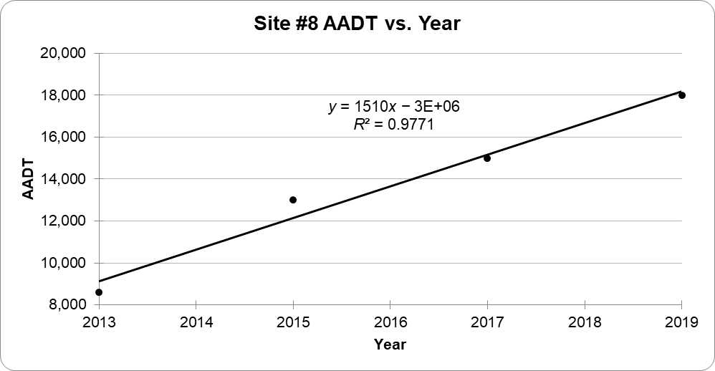
Figure 9. Site #8 AADT vs. Year

