**APPENDIX 5 SSI Analysis**

**Case Study Sites**

**Site 1**

**Table 2. Intersection attributes for existing conventional intersection at site 1**

|  |  |
| --- | --- |
| **Item** | **Input Value** |
| Area type | Sub-Urban |
| Functional classification-major | Arterial |
| Functional Classification-minor | Arterial |
| Design year AADT-major | 24,420 |
| Design year AADT-minor | 711 |
| Number of thru lanes-major | 4 |
| Number of thru lanes-minor | 2 |
| Traffic control type | Signalized |
| Posted speed limit-major | 35 |
| Posted speed limit-minor | 35 |
| Nonmotorized average daily traffic | - |

**Table 3. Ranking of intersections based on SSI score at site 1**

|  |  |  |  |  |  |  |
| --- | --- | --- | --- | --- | --- | --- |
| **Rank** | **Intersection Type** | **Intersection Score** | **Conflict Type SSI Scores** | | | |
| **Non-motorized** | **Diverging** | **Merging** | **Crossing** |
| 1 | Two-phase MUT | 100 | na | 100 | 99 | 100 |
| 2 | Reverse RCI | 100 | na | 100 | 99 | 100 |
| 3 | MUT #1 | 99 | na | 100 | 99 | 99 |
| 4 | CFI/MUT Combo | 99 | na | 100 | 99 | 99 |
| 5 | RCI | 98 | na | 100 | 100 | 94 |
| 6 | Redirect 2L&T | 98 | na | 100 | 100 | 94 |
| 7 | Redirect L&T | 98 | na | 100 | 100 | 94 |
| 8 | Thru-cut | 98 | na | 100 | 100 | 94 |
| 8 | Offset Thru-cut | 98 | na | 100 | 100 | 94 |
| 10 | Offset T | 98 | na | 100 | 100 | 94 |
| 11 | Single Quadrant | 98 | na | 100 | 100 | 94 |
| 12 | Seven Phase | 98 | na | 100 | 100 | 94 |
| 13 | MUT #2 | 97 | na | 100 | 100 | 92 |
| 14 | Conventional | 97 | na | 100 | 100 | 92 |
| 15 | Partial CFI | 97 | na | 100 | 100 | 92 |

**Table 4. Relative exposure, average severity, and average complexity adjustment results at site 1**

|  |  |  |  |  |  |  |  |  |  |  |  |  |  |  |  |  |
| --- | --- | --- | --- | --- | --- | --- | --- | --- | --- | --- | --- | --- | --- | --- | --- | --- |
| **S.N.** | **Intersection Type** | **Relative Exposure** | | | | | **Average Severity, P(FSI)** | | | | | **Average Complexity Adjustment** | | | | |
| **NM\*** | **Diverge** | **Merge** | **Cross** | **NM** | | **Diverge** | **Merge** | **Cross** | **NM** | | **Diverge** | **Merge** | **Cross** |
| 1 | Conventional | na | 1.00 | 1.00 | 1.00 | na | | 0.00 | 0.00 | 0.02 | na | | 1.00 | 1.32 | 1.44 |
| 2 | MUT #1 | na | 1.71 | 3.01 | 0.15 | na | | 0.00 | 0.00 | 0.02 | na | | 1.00 | 1.12 | 1.60 |
| 3 | Partial CFI | na | 1.00 | 1.00 | 1.00 | na | | 0.00 | 0.00 | 0.02 | na | | 1.00 | 1.32 | 1.48 |
| 4 | CFI/MUT Combo | na | 0.40 | 3.57 | 0.18 | na | | 0.00 | 0.00 | 0.02 | na | | 1.00 | 1.22 | 1.53 |
| 5 | Thru-cut | na | 1.07 | 1.19 | 0.92 | na | | 0.00 | 0.00 | 0.03 | na | | 1.00 | 0.84 | 0.98 |
| 6 | Reverse RCI | na | 1.78 | 3.20 | 0.07 | na | | 0.00 | 0.00 | 0.03 | na | | 1.00 | 0.88 | 1.37 |
| 7 | Redirect 2L&T | na | 1.08 | 1.23 | 0.90 | na | | 0.00 | 0.00 | 0.03 | na | | 1.00 | 1.04 | 1.22 |
| 8 | Redirect L&T | na | 1.08 | 1.23 | 0.90 | na | | 0.00 | 0.00 | 0.03 | na | | 1.00 | 1.04 | 1.22 |
| 9 | Seven Phase | na | 1.67 | 1.10 | 0.96 | na | | 0.00 | 0.00 | 0.02 | na | | 1.00 | 1.13 | 1.28 |
| 10 | Offset Thru-cut | na | 1.07 | 1.19 | 0.92 | na | | 0.00 | 0.00 | 0.03 | na | | 1.00 | 0.84 | 0.98 |
| 11 | Offset T | na | 1.03 | 1.10 | 0.97 | na | | 0.00 | 0.00 | 0.03 | na | | 1.00 | 0.91 | 1.06 |
| 12 | MUT #2 | na | 1.06 | 1.16 | 0.93 | na | | 0.00 | 0.00 | 0.02 | na | | 1.00 | 1.05 | 1.46 |
| 13 | Single Quadrant | na | 1.22 | 0.95 | 1.00 | na | | 0.00 | 0.00 | 0.02 | na | | 1.00 | 1.05 | 1.46 |
| 14 | RCI | na | 1.12 | 1.35 | 0.85 | na | | 0.00 | 0.00 | 0.05 | na | | 1.00 | 0.67 | 1.09 |
| 15 | Two-phase MUT | na | 1.77 | 3.17 | 0.08 | na | | 0.00 | 0.00 | 0.02 | na | | 1.00 | 0.91 | 1.46 |

*NM= non-motorized conflict type

**Site 2**

**Table 5. Intersection attributes for the existing conventional intersection at site 2**

|  |  |
| --- | --- |
| **Item** | **Input Value** |
| Area type | Sub-Urban |
| Functional classification-major | Arterial |
| Functional Classification-minor | Arterial |
| Design year AADT-major | 30,978 |
| Design year AADT-minor | 4,983 |
| Number of thru lanes-major | 4 |
| Number of thru lanes-minor | 2 |
| Traffic control type | Signalized |
| Posted speed limit-major | 55 |
| Posted speed limit-minor | 35 |
| Nonmotorized average daily traffic | - |

**Table 6. Ranking of intersections based on SSI score for site 2**

|  |  |  |  |  |  |  |
| --- | --- | --- | --- | --- | --- | --- |
| **Rank** | **Intersection Type** | **Intersection Score** | **Conflict Type SSI Scores** | | | |
| **Non-Motorized** | **Diverging** | **Merging** | **Crossing** |
| 1 | Two-phase MUT | 80 | na | 83 | 76 | 81 |
| 2 | Reverse RCI | 76 | na | 83 | 75 | 70 |
| 3 | RCI | 71 | na | 88 | 82 | 49 |
| 4 | MUT #1 | 70 | na | 86 | 76 | 53 |
| 5 | Thru-cut | 65 | na | 90 | 84 | 36 |
| 5 | Offset Thru-cut | 65 | na | 90 | 84 | 36 |
| 7 | MUT #2 | 63 | na | 90 | 85 | 32 |
| 8 | Single Quadrant | 62 | na | 95 | 85 | 29 |
| 9 | Redirect 2L&T | 61 | na | 91 | 87 | 29 |
| 10 | Redirect L&T | 61 | na | 91 | 85 | 29 |
| 11 | Offset T | 61 | na | 91 | 85 | 29 |
| 12 | Seven Phase | 60 | na | 93 | 83 | 28 |
| 13 | CFI/MUT Combo | 60 | na | 93 | 85 | 27 |
| 14 | Conventional | 56 | na | 92 | 86 | 22 |
| 15 | Partial CFI | 56 | na | 92 | 88 | 21 |

**Table 7. Relative exposure, average severity, and average complexity adjustment results at site 2**

|  |  |  |  |  |  |  |  |  |  |  |  |  |  |
| --- | --- | --- | --- | --- | --- | --- | --- | --- | --- | --- | --- | --- | --- |
| **S.N.** | **Intersection Type** | **Relative Exposure** | | | | **Average Severity, P(FSI)** | | | | **Average Complexity Adjustment** | | | |
| **NM\*** | **Diverge** | **Merge** | **Cross** | **NM** | **Diverge** | **Merge** | **Cross** | **NM** | **Diverge** | **Merge** | **Cross** |
| 1 | Conventional | na | 1.00 | 1.00 | 1.00 | na | 0.01 | 0.01 | 0.06 | na | 1.00 | 1.73 | 1.88 |
| 2 | MUT #1 | na | 1.69 | 1.83 | 0.47 | na | 0.01 | 0.02 | 0.08 | na | 1.00 | 1.46 | 2.09 |
| 3 | Partial CFI | na | 1.00 | 1.00 | 1.01 | na | 0.01 | 0.01 | 0.07 | na | 1.00 | 1.73 | 1.94 |
| 4 | CFI/MUT Combo | na | 0.92 | 1.22 | 0.88 | na | 0.01 | 0.02 | 0.07 | na | 1.00 | 1.59 | 1.99 |
| 5 | Thru-cut | na | 1.22 | 1.27 | 0.81 | na | 0.01 | 0.02 | 0.07 | na | 1.00 | 1.10 | 1.28 |
| 6 | Reverse RCI | na | 1.91 | 2.10 | 0.25 | na | 0.01 | 0.03 | 0.13 | na | 1.00 | 1.15 | 1.79 |
| 7 | Redirect 2L&T | na | 1.17 | 1.20 | 0.87 | na | 0.01 | 0.02 | 0.08 | na | 1.00 | 1.36 | 1.59 |
| 8 | Redirect L&T | na | 1.17 | 1.20 | 0.87 | na | 0.01 | 0.02 | 0.08 | na | 1.00 | 1.36 | 1.59 |
| 9 | Seven Phase | na | 0.99 | 1.14 | 0.90 | na | 0.01 | 0.02 | 0.07 | na | 1.00 | 1.48 | 1.68 |
| 10 | Offset Thru-cut | na | 1.22 | 1.27 | 0.81 | na | 0.01 | 0.02 | 0.08 | na | 1.00 | 1.10 | 1.28 |
| 11 | Offset T | na | 1.14 | 1.17 | 0.96 | na | 0.01 | 0.02 | 0.10 | na | 1.00 | 1.19 | 1.39 |
| 12 | MUT #2 | na | 1.33 | 1.39 | 0.73 | na | 0.01 | 0.02 | 0.08 | na | 1.00 | 1.37 | 1.91 |
| 13 | Single Quadrant | na | 0.63 | 1.09 | 1.04 | na | 0.01 | 0.01 | 0.08 | na | 1.00 | 1.38 | 1.91 |
| 14 | RCI | na | 1.55 | 1.66 | 0.52 | na | 0.02 | 0.02 | 0.16 | na | 1.00 | 0.87 | 1.43 |
| 15 | Two-phase MUT | na | 1.99 | 2.19 | 0.22 | na | 0.01 | 0.02 | 0.08 | na | 1.00 | 1.19 | 1.91 |

*NM= non-motorized conflict type

**Site 4**

**Table 8. Intersection attributes for the existing conventional intersection at site 4**

|  |  |
| --- | --- |
| **Item** | **Input Value** |
| Area type | Sub-Urban |
| Functional classification-major | Arterial |
| Functional Classification-minor | Arterial |
| Design year AADT-major | 83,195 |
| Design year AADT-minor | 34,335 |
| Number of thru lanes-major | 7 |
| Number of thru lanes-minor | 3 |
| Traffic control type | Signalized |
| Posted speed limit-major | 45 |
| Posted speed limit-minor | 35 |
| Nonmotorized average daily traffic | - |

**Table 9. Ranking of intersections based on SSI score for site 4**

|  |  |  |  |  |  |  |
| --- | --- | --- | --- | --- | --- | --- |
| **Rank** | **Intersection Type** | **Intersection Score** | **Conflict Type SSI Scores** | | | |
| **Non-motorized** | **Diverging** | **Merging** | **Crossing** |
| 1 | Reverse RCI | 9 | na | 36 | 8 | 3 |
| 2 | RCI | 5 | na | 51 | 14 | 0 |
| 3 | Two-phase MUT | 3 | na | 52 | 15 | 0 |
| 4 | Offset Thru-cut | 3 | na | 55 | 16 | 0 |
| 5 | Thru-cut | 3 | na | 55 | 16 | 0 |
| 6 | Redirect 2L&T | 1 | na | 62 | 24 | 0 |
| 7 | Redirect L&T | 1 | na | 62 | 22 | 0 |
| 8 | Seven Phase | 1 | na | 59 | 20 | 0 |
| 9 | MUT #1 | 1 | na | 58 | 16 | 0 |
| 10 | CFI/MUT Combo | 1 | na | 82 | 22 | 0 |
| 11 | MUT #2 | 0 | na | 70 | 31 | 0 |
| 12 | Partial CFI | 0 | na | 78 | 40 | 0 |
| 13 | Offset T | 0 | na | 67 | 22 | 0 |
| 14 | Single Quadrant | 0 | na | 74 | 31 | 0 |
| 15 | Conventional | 0 | na | 77 | 33 | 0 |

**Table 10. Relative exposure, average severity, and average complexity adjustment results at site 4**

|  |  |  |  |  |  |  |  |  |  |  |  |  |  |
| --- | --- | --- | --- | --- | --- | --- | --- | --- | --- | --- | --- | --- | --- |
| **S.N.** | **Intersection Type** | **Relative Exposure** | | | | **Average Severity, P(FSI)** | | | | **Average Complexity Adjustment** | | | |
| **NM\*** | **Diverge** | **Merge** | **Cross** | **NM** | **Diverge** | **Merge** | **Cross** | **NM** | **Diverge** | **Merge** | **Cross** |
| 1 | Conventional | na | 1.00 | 1.00 | 1.00 | na | 0.00 | 0.01 | 0.04 | na | 1.00 | 2.53 | 2.76 |
| 2 | MUT #1 | na | 1.67 | 1.62 | 0.74 | na | 0.00 | 0.01 | 0.04 | na | 1.00 | 2.05 | 3.05 |
| 3 | Partial CFI | na | 1.00 | 1.00 | 0.99 | na | 0.00 | 0.01 | 0.04 | na | 1.00 | 2.53 | 2.82 |
| 4 | CFI/MUT Combo | na | 0.71 | 1.36 | 0.81 | na | 0.00 | 0.01 | 0.04 | na | 1.00 | 2.30 | 2.90 |
| 5 | Thru-cut | na | 1.85 | 1.79 | 0.48 | na | 0.00 | 0.01 | 0.05 | na | 1.00 | 1.53 | 1.88 |
| 6 | Reverse RCI | na | 2.51 | 2.42 | 0.19 | na | 0.00 | 0.01 | 0.07 | na | 1.00 | 1.54 | 2.53 |
| 7 | Redirect 2L&T | na | 1.55 | 1.51 | 0.68 | na | 0.00 | 0.01 | 0.05 | na | 1.00 | 1.86 | 2.29 |
| 8 | Redirect L&T | na | 1.55 | 1.51 | 0.68 | na | 0.00 | 0.01 | 0.05 | na | 1.00 | 1.86 | 2.29 |
| 9 | Seven Phase | na | 1.65 | 1.46 | 0.70 | na | 0.00 | 0.01 | 0.04 | na | 1.00 | 2.01 | 2.38 |
| 10 | Offset Thru-cut | na | 1.85 | 1.79 | 0.48 | na | 0.00 | 0.01 | 0.05 | na | 1.00 | 1.50 | 1.88 |
| 11 | Offset T | na | 1.46 | 1.43 | 0.82 | na | 0.00 | 0.01 | 0.06 | na | 1.00 | 1.68 | 2.02 |
| 12 | MUT #2 | na | 1.33 | 1.30 | 0.85 | na | 0.00 | 0.01 | 0.05 | na | 1.00 | 2.00 | 2.88 |
| 13 | Single Quadrant | na | 1.14 | 1.13 | 1.06 | na | 0.00 | 0.01 | 0.04 | na | 1.00 | 1.95 | 2.77 |
| 14 | RCI | na | 2.17 | 2.09 | 0.32 | na | 0.00 | 0.01 | 0.09 | na | 1.00 | 1.19 | 2.05 |
| 15 | Two-phase MUT | na | 2.02 | 1.96 | 0.57 | na | 0.00 | 0.01 | 0.04 | na | 1.00 | 1.68 | 2.95 |

*NM =non-motorized conflict type

**Site 5**

**Table 11. Intersection attributes for the existing conventional intersection at site 5**

|  |  |
| --- | --- |
| **Item** | **Input Value** |
| Area type | Sub-Urban |
| Functional classification-major | Arterial |
| Functional Classification-minor | Arterial |
| Design year AADT-major | 62,151 |
| Design year AADT-minor | 8,004 |
| Number of thru lanes-major | 8 |
| Number of thru lanes-minor | 2 |
| Traffic control type | Signalized |
| Posted speed limit-major | 35 |
| Posted speed limit-minor | 35 |
| Nonmotorized average daily traffic | - |

**Table 12. Ranking of intersection based on SSI score for site 5**

|  |  |  |  |  |  |  |
| --- | --- | --- | --- | --- | --- | --- |
| **Rank** | **Intersection Type** | **Intersection Score** | **Conflict Type SSI Scores** | | | |
| **Non-motorized** | **Diverging** | **Merging** | **Crossing** |
| 1 | RCI | 94 | na | 97 | 92 | 92 |
| 2 | Two-phase MUT | 90 | na | 98 | 94 | 79 |
| 3 | MUT #2 | 87 | na | 99 | 94 | 70 |
| 4 | Reverse RCI | 86 | na | 98 | 93 | 71 |
| 5 | Redirect 2L&T | 86 | na | 99 | 94 | 70 |
| 6 | Redirect L&T | 86 | na | 99 | 94 | 70 |
| 7 | Thru-cut | 84 | na | 98 | 93 | 66 |
| 7 | Offset Thru-cut | 84 | na | 98 | 93 | 66 |
| 9 | Offset T | 80 | na | 99 | 94 | 55 |
| 10 | Seven Phase | 79 | na | 99 | 93 | 54 |
| 11 | MUT #1 | 79 | na | 99 | 94 | 53 |
| 12 | Single Quadrant | 77 | na | 99 | 94 | 50 |
| 13 | CFI/MUT Combo | 77 | na | 99 | 94 | 49 |
| 14 | Conventional | 76 | na | 99 | 94 | 46 |
| 15 | Partial CFI | 75 | na | 99 | 95 | 45 |

**Table 13. Relative exposure, average severity, and average complexity adjustment results at site 5**

|  |  |  |  |  |  |  |  |  |  |  |  |  |  |  |
| --- | --- | --- | --- | --- | --- | --- | --- | --- | --- | --- | --- | --- | --- | --- |
| **S.N.** | **Intersection Type** | **Relative Exposure** | | | | **Average Severity, P(FSI)** | | | | **Average Complexity Adjustment** | | | | |
| **NM\*** | **Diverge** | **Merge** | **Cross** | **NM** | **Diverge** | **Merge** | **Cross** | **NM** | **Diverge** | **Merge** | **Cross** |
| 1 | Conventional | na | 1.00 | 1.00 | 1.00 | na | 0.00 | 0.00 | 0.02 | na | 1.00 | 1.32 | 1.44 |
| 2 | MUT #1 | na | 1.27 | 1.12 | 0.89 | na | 0.00 | 0.00 | 0.02 | na | 1.00 | 1.12 | 1.60 |
| 3 | Partial CFI | na | 0.99 | 1.00 | 0.99 | na | 0.00 | 0.00 | 0.02 | na | 1.00 | 1.32 | 1.48 |
| 4 | CFI/MUT Combo | na | 1.63 | 1.22 | 0.95 | na | 0.00 | 0.00 | 0.02 | na | 1.00 | 1.22 | 1.53 |
| 5 | Thru-cut | na | 2.08 | 1.49 | 0.55 | na | 0.00 | 0.00 | 0.03 | na | 1.00 | 0.84 | 0.98 |
| 6 | Reverse RCI | na | 2.35 | 1.62 | 0.44 | na | 0.00 | 0.00 | 0.03 | na | 1.00 | 0.88 | 1.37 |
| 7 | Redirect 2L&T | na | 2.21 | 1.55 | 0.53 | na | 0.00 | 0.00 | 0.03 | na | 1.00 | 1.04 | 1.22 |
| 8 | Redirect L&T | na | 2.21 | 1.55 | 0.53 | na | 0.00 | 0.00 | 0.03 | na | 1.00 | 1.04 | 1.22 |
| 9 | Seven Phase | na | 1.31 | 1.22 | 0.80 | na | 0.00 | 0.00 | 0.02 | na | 1.00 | 1.13 | 1.28 |
| 10 | Offset Thru-cut | na | 2.08 | 1.49 | 0.55 | na | 0.00 | 0.00 | 0.03 | na | 1.00 | 0.84 | 0.98 |
| 11 | Offset T | na | 1.54 | 1.24 | 0.78 | na | 0.00 | 0.00 | 0.03 | na | 1.00 | 0.91 | 1.06 |
| 12 | MUT #2 | na | 2.16 | 1.53 | 0.56 | na | 0.00 | 0.00 | 0.02 | na | 1.00 | 1.05 | 1.46 |
| 13 | Single Quadrant | na | 1.28 | 1.02 | 0.99 | na | 0.00 | 0.00 | 0.02 | na | 1.00 | 1.05 | 1.46 |
| 14 | RCI | na | 3.25 | 2.02 | 0.11 | na | 0.00 | 0.00 | 0.05 | na | 1.00 | 0.67 | 1.09 |
| 15 | Two-phase MUT | na | 2.44 | 1.65 | 0.46 | na | 0.00 | 0.00 | 0.02 | na | 1.00 | 0.91 | 1.46 |

*NM= non-motorized conflict type

**Site 7**

**Table 14. Intersection attributes for the existing conventional intersection at site 7**

|  |  |
| --- | --- |
| **Item** | **Input Value** |
| Area type | Sub-Urban |
| Functional classification-major | Arterial |
| Functional Classification-minor | Arterial |
| Design year AADT-major | 37,820 |
| Design year AADT-minor | 11,898 |
| Number of thru lanes-major | 4 |
| Number of thru lanes-minor | 2 |
| Traffic control type | Signalized |
| Posted speed limit-major | 35 |
| Posted speed limit-minor | 35 |
| Nonmotorized average daily traffic | - |

**Table 15. Ranking of intersection based on SSI score for site 7**

|  |  |  |  |  |  |  |
| --- | --- | --- | --- | --- | --- | --- |
| **Rank** | **Intersection Type** | **Intersection Score** | **Conflict Type SSI Scores** | | | |
| **Non-motorized** | **Diverging** | **Merging** | **Crossing** |
| 1 | Two-phase MUT | 93 | na | 97 | 92 | 92 |
| 2 | Reverse RCI | 89 | na | 96 | 92 | 80 |
| 3 | MUT #1 | 86 | na | 97 | 92 | 70 |
| 4 | CFI/MUT Combo | 84 | na | 99 | 94 | 64 |
| 5 | RCI | 83 | na | 98 | 95 | 60 |
| 6 | Thru-cut | 80 | na | 99 | 95 | 54 |
| 6 | Offset Thru-cut | 80 | na | 99 | 95 | 54 |
| 8 | Redirect 2L&T | 80 | na | 99 | 96 | 53 |
| 9 | Redirect L&T | 79 | na | 99 | 96 | 53 |
| 10 | Seven Phase | 78 | na | 98 | 95 | 50 |
| 11 | MUT #2 | 77 | na | 99 | 96 | 48 |
| 12 | Offset T | 75 | na | 99 | 95 | 45 |
| 13 | Single Quadrant | 75 | na | 99 | 95 | 45 |
| 14 | Conventional | 73 | na | 99 | 96 | 41 |
| 15 | Partial CFI | 72 | na | 99 | 96 | 38 |

**Table 16. Relative exposure, average severity, and average complexity adjustment results at site 7**

|  |  |  |  |  |  |  |  |  |  |  |  |  |  |
| --- | --- | --- | --- | --- | --- | --- | --- | --- | --- | --- | --- | --- | --- |
| **S.N.** | **Intersection Type** | **Relative Exposure** | | | | **Average Severity, P(FSI)** | | | | **Average Complexity Adjustment** | | | |
| **NM\*** | **Diverge** | **Merge** | **Cross** | **NM** | **Diverge** | **Merge** | **Cross** | **NM** | **Diverge** | **Merge** | **Cross** |
| 1 | Conventional | na | 1.00 | 1.00 | 1.00 | na | 0.00 | 0.00 | 0.02 | na | 1.00 | 1.32 | 1.44 |
| 2 | MUT #1 | na | 2.11 | 2.06 | 0.46 | na | 0.00 | 0.00 | 0.02 | na | 1.00 | 1.12 | 1.60 |
| 3 | Partial CFI | na | 0.99 | 1.00 | 1.00 | na | 0.00 | 0.00 | 0.02 | na | 1.00 | 1.32 | 1.48 |
| 4 | CFI/MUT Combo | na | 0.61 | 1.72 | 0.54 | na | 0.00 | 0.00 | 0.02 | na | 1.00 | 1.22 | 1.53 |
| 5 | Thru-cut | na | 1.19 | 1.19 | 0.85 | na | 0.00 | 0.00 | 0.03 | na | 1.00 | 0.84 | 0.98 |
| 6 | Reverse RCI | na | 2.30 | 2.24 | 0.30 | na | 0.00 | 0.00 | 0.03 | na | 1.00 | 0.88 | 1.37 |
| 7 | Redirect 2L&T | na | 1.25 | 1.24 | 0.83 | na | 0.00 | 0.00 | 0.03 | na | 1.00 | 1.04 | 1.22 |
| 8 | Redirect L&T | na | 1.25 | 1.24 | 0.83 | na | 0.00 | 0.00 | 0.03 | na | 1.00 | 1.04 | 1.22 |
| 9 | Seven Phase | na | 1.65 | 1.11 | 0.91 | na | 0.00 | 0.00 | 0.02 | na | 1.00 | 1.13 | 1.28 |
| 10 | Offset Thru-cut | na | 1.19 | 1.19 | 0.85 | na | 0.00 | 0.00 | 0.03 | na | 1.00 | 0.84 | 0.98 |
| 11 | Offset T | na | 1.34 | 1.34 | 1.01 | na | 0.00 | 0.00 | 0.03 | na | 1.00 | 0.91 | 1.06 |
| 12 | MUT #2 | na | 1.40 | 1.38 | 0.75 | na | 0.00 | 0.00 | 0.02 | na | 1.00 | 1.05 | 1.46 |
| 13 | Single Quadrant | na | 1.42 | 1.29 | 1.02 | na | 0.00 | 0.00 | 0.02 | na | 1.00 | 1.05 | 1.46 |
| 14 | RCI | na | 1.59 | 1.56 | 0.60 | na | 0.00 | 0.00 | 0.05 | na | 1.00 | 0.67 | 1.09 |
| 15 | Two-phase MUT | na | 2.56 | 2.49 | 0.17 | na | 0.00 | 0.00 | 0.02 | na | 1.00 | 0.91 | 1.46 |

*NM= non-motorized conflict type

**Site 8**

**Table 17. Intersection attributes for the existing conventional intersection at site 8**

|  |  |
| --- | --- |
| **Item** | **Input Value** |
| Area type | Sub-Urban |
| Functional classification-major | Arterial |
| Functional Classification-minor | Arterial |
| Design year AADT-major | 36,855 |
| Design year AADT-minor | 35,738 |
| Number of thru lanes-major | 6 |
| Number of thru lanes-minor | 4 |
| Traffic control type | Signalized |
| Posted speed limit-major | 55 |
| Posted speed limit-minor | 45 |
| Nonmotorized average daily traffic | - |

**Table 18. Ranking of intersection based on SSI score for site 8**

|  |  |  |  |  |  |  |
| --- | --- | --- | --- | --- | --- | --- |
| **Rank** | **Intersection Type** | **Intersection Score** | **Conflict Type SSI Scores** | | | |
| **Non-motorized** | **Diverging** | **Merging** | **Crossing** |
| 1 | Reverse RCI | 13 | na | 27 | 9 | 8 |
| 2 | RCI | 12 | na | 31 | 13 | 5 |
| 3 | Thru-cut | 10 | na | 43 | 16 | 1 |
| 4 | Offset Thru-cut | 10 | na | 43 | 16 | 1 |
| 5 | Two-phase MUT | 5 | na | 46 | 20 | 0 |
| 6 | Seven Phase | 4 | na | 59 | 25 | 0 |
| 7 | Redirect 2L&T | 3 | na | 53 | 28 | 0 |
| 8 | Redirect L&T | 3 | na | 52 | 27 | 0 |
| 9 | Single Quadrant | 2 | na | 80 | 34 | 0 |
| 10 | MUT #1 | 2 | na | 60 | 19 | 0 |
| 11 | MUT #2 | 2 | na | 61 | 33 | 0 |
| 12 | Offset T | 2 | na | 61 | 25 | 0 |
| 13 | Conventional | 1 | na | 81 | 36 | 0 |
| 14 | CFI/MUT Combo | 1 | na | 79 | 31 | 0 |
| 15 | Partial CFI | 1 | na | 82 | 41 | 0 |

**Table 19. Relative exposure, average severity P (FSI), and average complexity adjustment results at site 8**

|  |  |  |  |  |  |  |  |  |  |  |  |  |  |
| --- | --- | --- | --- | --- | --- | --- | --- | --- | --- | --- | --- | --- | --- |
| **S.N.** | **Intersection Type** | **Relative Exposure** | | | | **Average Severity, P(FSI)** | | | | **Average Complexity Adjustment** | | | |
| **NM\*** | **Diverge** | **Merge** | **Cross** | **NM** | **Diverge** | **Merge** | **Cross** | **NM** | **Diverge** | **Merge** | **Cross** |
| 1 | Conventional | na | 1.00 | 1.00 | 1.00 | na | 0.01 | 0.01 | 0.06 | na | 1.00 | 1.97 | 2.55 |
| 2 | MUT #1 | na | 1.61 | 1.54 | 0.87 | na | 0.01 | 0.02 | 0.08 | na | 1.00 | 1.70 | 2.56 |
| 3 | Partial CFI | na | 1.06 | 1.00 | 0.99 | na | 0.01 | 0.01 | 0.07 | na | 1.00 | 1.97 | 2.57 |
| 4 | CFI/MUT Combo | na | 1.06 | 1.12 | 0.97 | na | 0.01 | 0.02 | 0.07 | na | 1.00 | 1.83 | 2.57 |
| 5 | Thru-cut | na | 2.18 | 2.04 | 0.39 | na | 0.01 | 0.02 | 0.08 | na | 1.00 | 1.10 | 1.43 |
| 6 | Reverse RCI | na | 2.80 | 2.58 | 0.20 | na | 0.01 | 0.03 | 0.13 | na | 1.00 | 1.15 | 1.79 |
| 7 | Redirect 2L&T | na | 1.75 | 1.66 | 0.67 | na | 0.01 | 0.02 | 0.08 | na | 1.00 | 1.50 | 1.86 |
| 8 | Redirect L&T | na | 1.75 | 1.66 | 0.67 | na | 0.01 | 0.02 | 0.08 | na | 1.00 | 1.50 | 1.86 |
| 9 | Seven Phase | na | 1.57 | 1.44 | 0.70 | na | 0.01 | 0.02 | 0.07 | na | 1.00 | 1.71 | 2.18 |
| 10 | Offset Thru-cut | na | 2.18 | 2.04 | 0.39 | na | 0.01 | 0.02 | 0.08 | na | 1.00 | 1.10 | 1.43 |
| 11 | Offset T | na | 1.59 | 1.51 | 0.81 | na | 0.01 | 0.02 | 0.10 | na | 1.00 | 1.19 | 1.59 |
| 12 | MUT #2 | na | 1.62 | 1.53 | 0.87 | na | 0.01 | 0.02 | 0.08 | na | 1.00 | 1.37 | 2.30 |
| 13 | Single Quadrant | na | 1.18 | 1.27 | 1.08 | na | 0.01 | 0.01 | 0.08 | na | 1.00 | 1.83 | 2.50 |
| 14 | RCI | na | 2.79 | 2.57 | 0.18 | na | 0.02 | 0.02 | 0.16 | na | 1.00 | 0.87 | 2.03 |
| 15 | Two-phase MUT | na | 2.19 | 2.04 | 0.77 | na | 0.01 | 0.02 | 0.08 | na | 1.00 | 1.19 | 1.91 |

*NM= non-motorized conflict type

**Hypothetical Sites**

As anticipated, the reverse RCI and RCI showed a significantly improved SSI score for crossing conflict points. This improvement may be due to both intersections having only two crossing conflict points and a median for left-turn lanes, which facilitates a two-stage crossing. Notably, thirteen (13) alternative intersections outperformed the conventional intersection in terms of crossing conflicts, although the partial CFI was somewhat comparable to the conventional intersection. This is because the rerouting of movements in the alternative intersections eliminates crossing conflicts, reducing the angles at these conflict points and the associated vehicle speeds.

Table 3 and figures 2, 3 and 4 provide a detailed insight into the SSI results, focusing on exposure levels, average severity, and complexity adjustments of conflict points. It highlights a significant decrease in crossing conflict exposure levels across all selected alternatives. Specifically, the reverse RCI exposure levels show a notable reduction in crossing conflicts, decreasing from 1 to 0.18 compared to the conventional intersection. This decrease is attributed to the reduction in crossing conflicts from eight at conventional intersections to two in the RCI. A similar case can be made for the reverse RCI. However, the relative exposure levels for merging and diverging conflicts in the RCI alternatives experienced significant increases of 3.9 and 2.99, respectively. This increase is explained by the conversion of crossing conflicts into merging and diverging conflicts due to rerouted movements at the main intersection.

The average severity index, P(FSI), for diverging conflicts across all selected intersections resulted in a value of 0.00. This may be attributed to the relatively lower collision angles experienced during diverging conflicts, and the lower speeds of 15 mph at signal-controlled near-sides, with significantly fewer occurrences of 25 mph at far-side signal controls at a few alternative intersections. It is also noteworthy that the SSI methodology did not consider rear-end crashes in the assessment of diverging conflicts. The reverse RCI performed relatively better in assessing the average P(FSI) for crossing conflicts across all intersections reviewed. This improvement may again be attributed to the reduced number of crossing conflicts in the reverse RCI, resulting in fewer angular crashes at higher speeds. The average complexity adjustment factor is indicative of the fact that all the alternative intersections have a lower user complexity, especially for crossing conflict points, when compared with the conventional intersection.

**Table 2. Number of conflict points at intersections**

|  |  |  |  |  |  |
| --- | --- | --- | --- | --- | --- |
| **S.N.** | **Intersection Type** | **Diverging** | **Merging** | **Crossing** | **Total** |
| 1 | Conventional | 8 | 8 | 16 | 32 |
| 2 | MUT #1 | 8 | 8 | 8 | 24 |
| 3 | Partial CFI | 8 | 8 | 14 | 30 |
| 4 | CFI/MUT Combo | 8 | 8 | 11 | 27 |
| 5 | Thru-cut | 8 | 8 | 8 | 24 |
| 6 | Reverse RCI | 6 | 6 | 2 | 14 |
| 7 | Redirect 2L&T | 7 | 7 | 8 | 22 |
| 8 | Redirect L&T | 7 | 7 | 8 | 22 |
| 9 | Seven Phase | 8 | 8 | 12 | 28 |
| 10 | Offset Thru-cut | 8 | 8 | 8 | 24 |
| 11 | Offset T | 6 | 6 | 6 | 18 |
| 12 | MUT #2 | 8 | 8 | 8 | 24 |
| 13 | Single Quadrant | 9 | 9 | 10 | 28 |
| 14 | RCI | 6 | 6 | 2 | 14 |
| 15 | Two-phase MUT | 6 | 6 | 4 | 16 |

**Figure 1. Number of conflict points of each intersection**

**Table 3. Relative exposure, average severity P(FSI), and average complexity adjustment results**

|  |  |  |  |  |  |  |  |  |  |  |  |  |  |  |
| --- | --- | --- | --- | --- | --- | --- | --- | --- | --- | --- | --- | --- | --- | --- |
| **S.N.** | **Intersection Type** | **Exposure (Relative to Conventional)** | | | | **Average Severity, P(FSI)** | | | | **Average Complexity Adjustment** | | | | |
| **NM\*** | **Diverge** | **Merge** | **Cross** | **NM** | **Diverge** | **Merge** | **Cross** | **NM** | **Diverge** | **Merge** | **Cross** |
| 1 | Conventional | na | 1.00 | 1.00 | 1.00 | na | 0.00 | 0.00 | 0.02 | na | 1.00 | 1.32 | 1.44 |
| 2 | MUT #1 | na | 1.50 | 1.76 | 0.82 | na | 0.00 | 0.00 | 0.02 | na | 1.00 | 1.12 | 1.60 |
| 3 | Partial CFI | na | 1.00 | 1.00 | 0.95 | na | 0.00 | 0.00 | 0.02 | na | 1.00 | 1.32 | 1.48 |
| 4 | CFI/MUT Combo | na | 0.89 | 1.46 | 0.89 | na | 0.00 | 0.00 | 0.02 | na | 1.00 | 1.22 | 1.53 |
| 5 | Thru-cut | na | 2.64 | 3.48 | 0.27 | na | 0.00 | 0.00 | 0.03 | na | 1.00 | 0.84 | 0.98 |
| 6 | Reverse RCI | na | 3.14 | 4.25 | 0.10 | na | 0.00 | 0.00 | 0.03 | na | 1.00 | 0.88 | 1.37 |
| 7 | Redirect 2L&T | na | 1.95 | 2.44 | 0.57 | na | 0.00 | 0.00 | 0.03 | na | 1.00 | 1.04 | 1.22 |
| 8 | Redirect L&T | na | 1.95 | 2.44 | 0.57 | na | 0.00 | 0.00 | 0.03 | na | 1.00 | 1.04 | 1.22 |
| 9 | Seven Phase | na | 1.83 | 2.28 | 0.61 | na | 0.00 | 0.00 | 0.02 | na | 1.00 | 1.13 | 1.28 |
| 10 | Offset Thru-cut | na | 2.64 | 3.48 | 0.27 | na | 0.00 | 0.00 | 0.03 | na | 1.00 | 0.84 | 0.98 |
| 11 | Offset T | na | 1.77 | 2.17 | 0.67 | na | 0.00 | 0.00 | 0.03 | na | 1.00 | 0.91 | 1.06 |
| 12 | MUT #2 | na | 1.25 | 1.41 | 0.88 | na | 0.00 | 0.00 | 0.02 | na | 1.00 | 1.05 | 1.46 |
| 13 | Single Quadrant | na | 1.08 | 1.14 | 1.01 | na | 0.00 | 0.00 | 0.02 | na | 1.00 | 1.05 | 1.46 |
| 14 | RCI | na | 2.91 | 3.90 | 0.18 | na | 0.00 | 0.00 | 0.05 | na | 1.00 | 0.67 | 1.09 |
| 15 | Two-phase MUT | na | 1.78 | 2.18 | 0.74 | na | 0.00 | 0.00 | 0.02 | na | 1.00 | 0.91 | 1.46 |

*NM=non-motorized conflict type

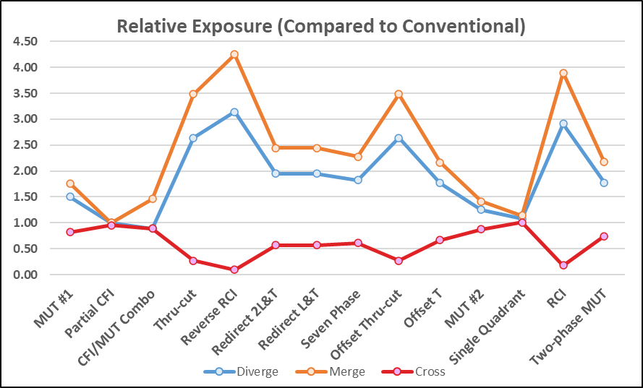

**Figure 2. Exposure levels of the alternative intersections relative to the conventional for each conflict type.**

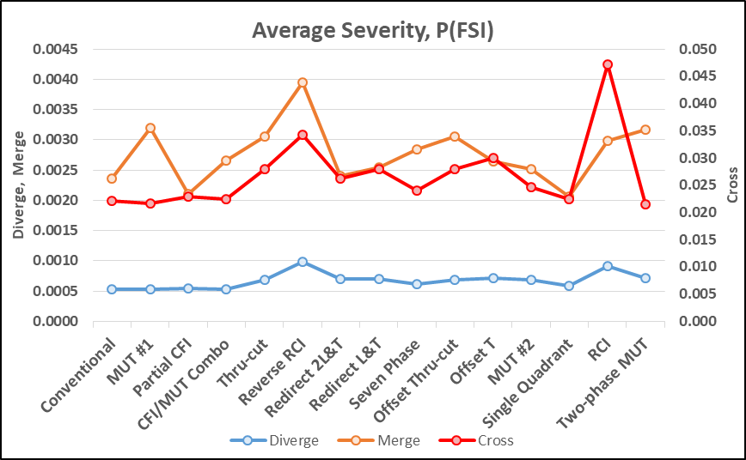

**Figure 3. Average severity of assessed intersections for each conflict type**

**Figure 4. Average complexity adjustment of assessed intersections for each conflict type**

**Table 4. SSI score for intersections and conflict types**

|  |  |  |  |  |  |  |
| --- | --- | --- | --- | --- | --- | --- |
| **S.N.** | **Intersection Type** | **Intersection Score** | **Conflict Type SSI Scores** | | | |
| **Non-motorized** | **Diverging** | **Merging** | **Crossing** |
| 1 | Conventional | 71 | na | 99 | 98 | 36 |
| 2 | MUT #1 | 79 | na | 98 | 96 | 52 |
| 3 | Partial CFI | 70 | na | 99 | 98 | 35 |
| 4 | CFI/MUT Combo | 74 | na | 99 | 97 | 42 |
| 5 | Thru-cut | 87 | na | 97 | 93 | 72 |
| 6 | Reverse RCI | 92 | na | 95 | 92 | 89 |
| 7 | Redirect 2L&T | 80 | na | 98 | 96 | 54 |
| 8 | Redirect L&T | 80 | na | 98 | 96 | 55 |
| 9 | Seven Phase | 79 | na | 98 | 95 | 53 |
| 10 | Offset Thru-cut | 87 | na | 97 | 93 | 72 |
| 11 | Offset T | 74 | na | 98 | 96 | 43 |
| 12 | MUT #2 | 74 | na | 99 | 98 | 42 |
| 13 | Single Quadrant | 74 | na | 99 | 98 | 42 |
| 14 | RCI | 89 | na | 97 | 93 | 79 |
| 15 | Two-phase MUT | 80 | na | 98 | 96 | 55 |

**Figure 5. Overall SSI score of assessed intersections**

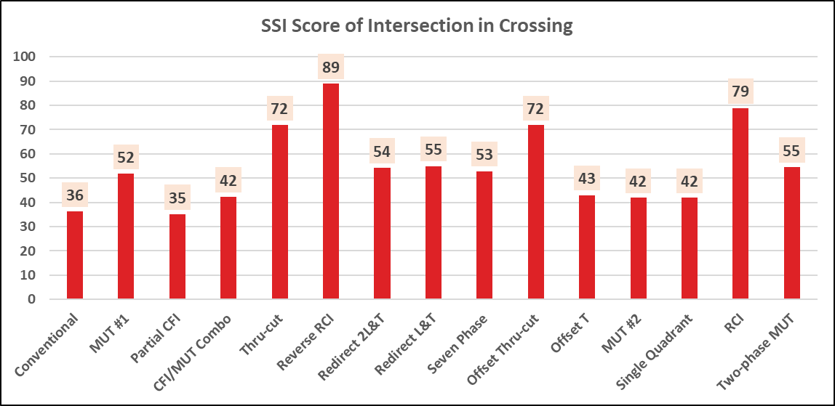

**Figure 6. SSI score for crossing conflicts**