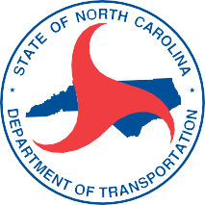



**Phone Number**

For project details, visit:

**project website**

There, you'll find materials such as:

* ***maps • videos • fact sheets***

**Needing Your Input**

**Comment deadline: Aug. 15, 2020**

If you require any accommodations under the Americans with Disabilities Act to participate contact:

# You may submit comments or ask us questions by:

**Contact Email**

**Contact Name**

**Contact Number**

**Contact Email**

X,XXX copies of this public document were printed at a cost of $ x,xxx.xx, or $0.4655 per copy. (MM/20)

Text will go here about the project. Text will go here about the project. Text will go here about the project. Text will go here about the project. Text will go here about the project. Text will go here about the project. Text will go here about the project. Text will go here about the project. Text will go here about the project. Text will go here about the project. Text will go here about the project. Text will go here about the project. Text will go here about the project. Text will go here about the project.

**PROJECT UPDATE MAY AFFECT YOU**

**PROJECT TITLE IN XXXXX COUNTY OR CITY**

State Transportation Improvement Program (STIP) Project No. **I-5XOXO**

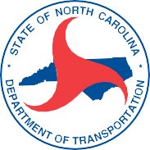

Return Address Line 1

Return Address Line 2

Return Address Line 3

Return Address Line 4

Aquellas personas no hablan inglés, o tienen limitaciones para leer, hablar o entender inglés, podrían recibir servicios de interpretación si los solicitan antes de la reunión llamando al **1-800-481-6494**.