Postcards
Standard and Non-resident owner postcard
5.5 x 8.5 inch – no smaller
Nothing less than 11 pt font anywhere
RTLA on Front where it is quickly seen if needed
Return Address should be person who will take be responsible for updating the project mailing list with returns.
NCDOT person should be contact for questions
In body of postcard – What we are proposing to do and who to contact if they have questions
One contact should be used – Division or Central Contact – if second then consultant can be listed. Better to give one if possible.

RTLA Statement should be easily found, eye catching – not in the paragraph of text if not using double sided /translated

If translated into second language – separate section for that language.
Do no put English/Spanish one above/below in the paragraph or section etc.

NCDOT Mission statement (connecting ………)
MOST IMPORTANT THINGS ARE
  - What are we doing (project title and #)
  - When are we having the meeting (date and time)
  - Where are we having the meeting - DO NOT LIST THE STATE OR ZIP
  - Who to call if they have questions
  - Who to call if they need ADA assistance

Be cognizant of colors – colorblindness issues.

Need to be mailed 2.5 weeks in advance of the meeting – in hands by 2 weeks weeks in advance of meeting.

Note: Nothing should be printed below the address area on the postcard. – Postal Machinery gets confused and cannot process.
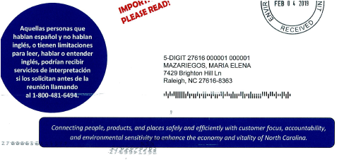
No

Every Door Direct Postcards – EDDM

Every Door Direct Mail – like advertisements from service providers you get in the mail –
Every postal customer with a mail receptacle on a ‘ROUTE’ gets one

Every door direct allows more text – therefore more descriptive information
Ex: Widening of XYZ Rd between A and B. Widening and improvements may include
superstreet elements such as medians and U-turn bulbs along the corridor….. etc.

Map is NOT necessary in most cases – this is going to the people who live along the corridor and/or use it regularly.

EDDM is wonderful if details available or if we need dual language and if we have TIME

NOTE: IF EDDM is used – mailing list is still required (NCDOT pulls mailing list) –
Regular 5.5*8.5 inch postcard MUST still be sent to:
Property owners of Vacant/Raw Parcels
Property owners who do not live at the property address that is along the corridor
(nonresident owners.).

Always – most important things on any postcard are:
NOTHING is less than 11 pt font – Use Times New Roman – Arial - Calibri

What are we doing to need a meeting – adding medians, sidewalks, looking at concepts…..
What is happening – a meeting
When is it happening – date
Where is it happening – location (no state / zip info)
These important things should draw the eye to them…
Be cognizant of color issues – no blue on blue, grey on blue, yellow on green etc.

In body of postcard – What we are proposing to do and who to contact if they have questions
One contact should be used – Division or Central Contact – if second then consultant can be listed. Better to give one if possible.

RTLA Statement should be easily found, eye catching – not in the paragraph of text - if not using double sided /translated

NCDOT statement should be on the card – best on front but can be on back ….. connecting people…..

EDDM must always have the ‘stamps’……. One side only – never an address
MINIMUM: 6.25 INCH
MAXIMUM: 12 INCH
MINIMUM: 9 INCH
MAXIMUM: 17 INCH
PRSRT STD
U.S. POSTAGE
PAID
RALEIGH, NC
PERMIT #XXXX

*********ECRWSSEDDM****
POSTAL CUSTOMER

EDDM continued

EDDM postcards must be separated by Route and delivered to the post office(s) listed on the EDDM site - with sticker stating Route No. No of Postcards in bundle

Ex:

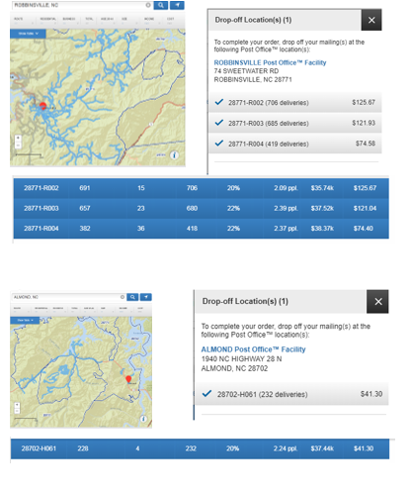
This post office gets one ‘bundle’ delivered to them for distribution
The sticker/bundle label (should state the following:

232 postcards for 28702-H061

This post office gets three ‘bundles’ delivered to them for distribution
The sticker/bundle label (one for each bundle) should state the following:

Bundle 1:
706 postcards for 28771-R002

Bundle 2:
680 postcards for 28771-R003

Bundle 3:
418 postcards for 28771-R004

