PROJECT INTRODUCTION/OVERVIEW EXAMPLE/TEMPLATE
Timeframe: Try to keep to 3-4 min but if needed up to 5 min
Recommendations highlighted in yellow

 | Slide 1 – Title Screen  Intro image can be Title Slide, Project Image (Picture or Visualization)  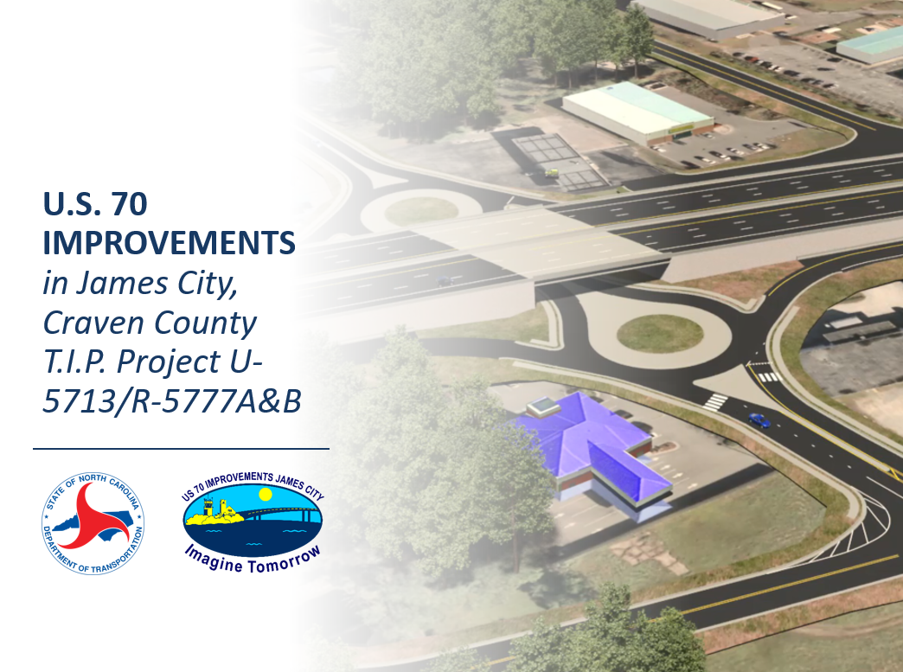  *Images are for example only. They may or may not match the example text. | Example Text - The North Carolina Department of Transportation is working on planning and design efforts for the U.S. 70 Improvement Project R-5777C. The project will upgrade U.S. 70 to interstate standards from the Havelock Bypass to east of Thurman Road. U.S. 70 between Interstate 40 and Morehead City has been designated future Interstate 42. This project is one of several along the U.S. 70 corridor meant to improve safety, enhance regional mobility, benefit military interconnectivity, provide a closer interstate connection to the Port of Morehead City, and assist with economic development in eastern North Carolina.
 | Slide 2 – Project Manager  image of PM example below, include contact information on the right:  Casey Whitley  Project Engineer  NCDOT Highway Division 2  1037 W. H. Smith Boulevard  Greenville, NC 27834  252-439-2811  ckwhitley@ncdot.gov | Example Text - My name is Casey Whitley and I’m the NCDOT Division 2 Project Manager for this project.  This video will provide you with an overview of the project and provide instructional tips on how to read the maps that display preliminary designs for two alternatives being considered.
 | Slide 3 – Context  Project vicinity map with adjacent projects labeled (if any)  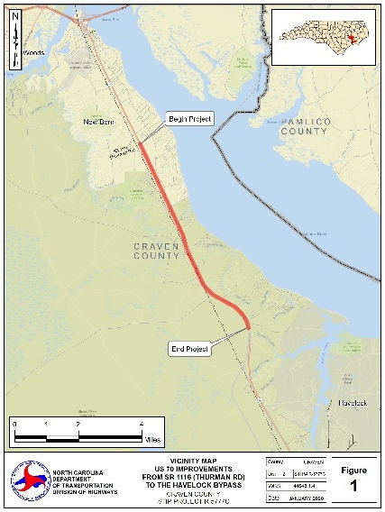 | Example Text - The project is located in Craven County between James City and Havelock, adjacent to the Croatan National Forest, and parallel to the North Carolina Railroad line. The project is a continuation of the Havelock Bypass to the south, which is currently under construction, and the U.S. 70 improvements project in James City, which is slated to begin construction in early 2021.
 | Slide 4 – Project Overview  Study area map with aerial base w/ pertinent design element call outs, example below  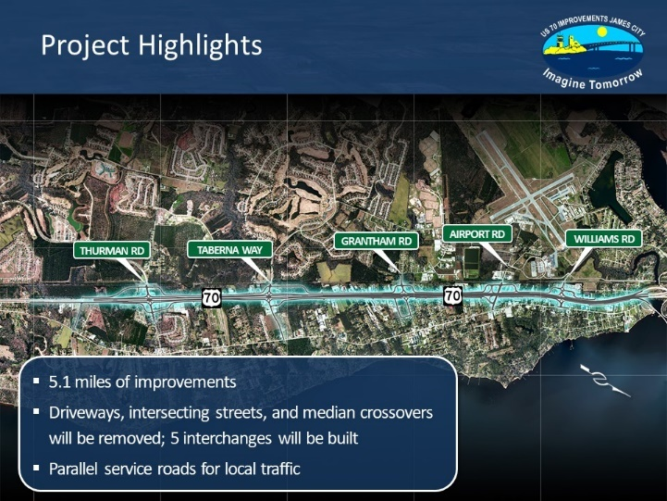 | Example Text - The project will upgrade approximately seven miles of US 70 to interstate standards with elevated interchanges at three intersecting cross streets: Stately Pines Road, Fisher Avenue, and Camp Kiro Road.  NCDOT is considering two design alternatives.  Alternative A would construct interchanges with US 70 passing over these cross streets, while Alternative B would construct interchanges with US 70 passing under these cross streets.  Parallel service roads will be improved and extended to provide access to cross streets and the surrounding community.
 | Slide 5 – Project Impacts  Show tables of Impacts to Human and Natural Resources by Alternative  Show Table of Estimated Costs by Alterative | Example Text - You will find maps and details about the two proposed alternatives on the project webpage, including tables that compare the impacts and cost of each alternative.  Cover the length, relocations, costs and any other pertinent info based on the project
 | Slide 6 – Project Schedule  Pertinent/Important Milestones  *Future dates are preliminary and subject to change based on funding availability.  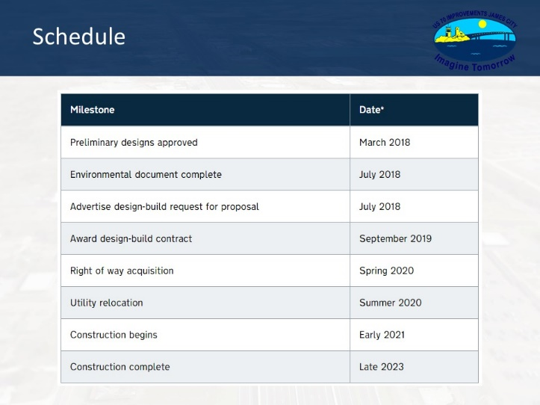 | Example Text - In August 2020, comments from the public and local officials will be collected, evaluated, and considered during the selection of a preferred alternative. The environmental document is expected to be completed in December 2020. The project will then move into the final design and construction phase. Similar to the adjacent U.S. 70 improvement projects in James City, this project will be completed using a design-build contract. The design-build contract is anticipated to be advertised in January 2021. NCDOT will evaluate bids submitted by private contractors and expects to award a contract in the Fall of 2021. Right-of-way acquisition and construction is expected to begin in the winter of 2021/2022.  The design-build process allows NCDOT to contract with a team of designers and contractors that are responsible for the final design, right-of-way acquisition, and construction of a project. Because the Design-Build Team can begin construction while they finish the design and right-of-way acquisition, the project can be completed more quickly than the traditional “design-bid-build” process.

TIME | Mapping  (Written description of visual elements) | NARRATION  (Spoken word)
 | Slide 7 – Insert screen shot of where the project maps are on the webpage, red circle around links  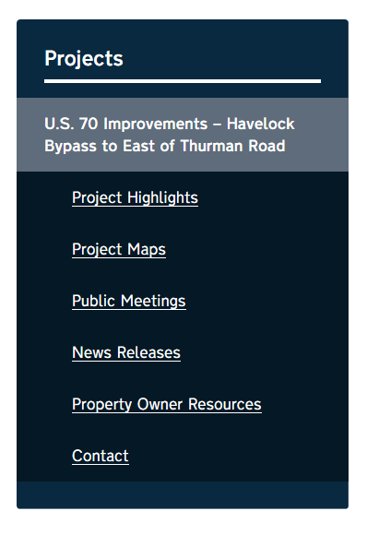 | Example Text - Project materials, including maps and videos, are available online at: [insert NCDOT webpage or Publicinput.com page] Once on this page, look for the project maps tab to the right. The project maps are available for review as PDFs and you can zoom into areas of interest for more detail.  Number of alternatives and maps
 | Slide 8 - Legend  Call out its locations on the maps (transition of the legend being pulled to the center of the screen and zoomed in on from the legend on the map)  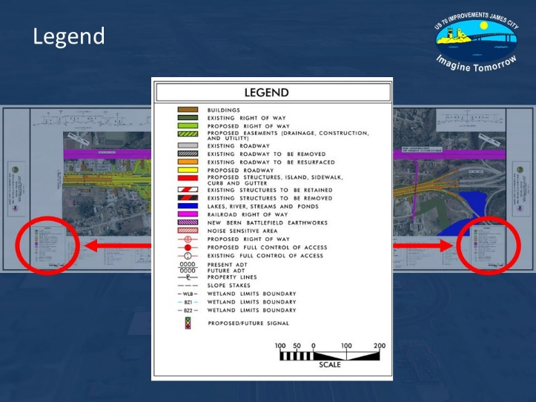 | Example Text - Each map includes a color-coded legend that represents the proposed improvements typically located on the bottom left or right of each map. The legend tells you what each color on the map means. The control bar for viewing the map, including zooming in and out, is located at the top of the webpage. Click the plus sign to zoom in for a better view of the desired area. Click the minus sign to zoom back out.  A video describing how to read these maps is available on our project webpage.
 | Slide 9 – Havelock Bypass to east of Flanners Beach Road  image of roll 1, with text of start and end points (scroll transition to next image for visualization of match line concept)  Similar to example below  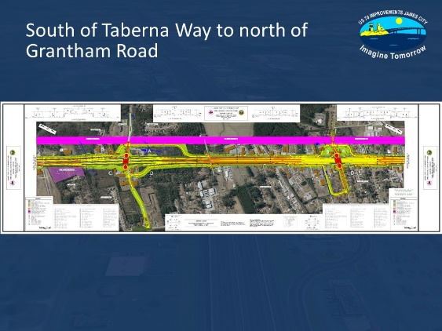 | Example Text - The first map shows the project from the Havelock Bypass to east of Flanners Beach Road.  Identify key design elements on each map
 | Slide 10 – East of Flanner Beach Road to east of Arabica Lane  image of roll 2 (scroll transition to next image for visualization of match line concept)  Similar to example below | Example Text - The second map shows the project from east of Flanners Beach Road to east of Arabica Lane.
 | Slide 11 – East of Arabica Lane to east of Fishers Landing Road and Riverdale Road  image of roll 3 (scroll transition to next image for visualization of match line concept)  Similar to example below | Example Text - The third map shows the project from east of Arabica Lane to east of Fishers Landing Road and Riverdale Road.
 | Slide 12 – East of Fishers Landing Road and Riverdale Road to east of Rivershore Drive  image of roll 4 (scroll transition to next image for visualization of match line concept)  Similar to example below | Example Text - The fourth map shows the project from east of Fishers Landing Road and Riverdale Road to east of Rivershore Drive.
 | Slide 13 – East of Rivershore Drive to east of Thurman Road  image of roll 5 (scroll transition to next image for visualization of match line concept)  Similar to example below | Example Text - The fifth map shows the project from east of Rivershore Drive to east of Thurman Road.
 | Slide 14 – Show image of the 3D perspective Typical section | The roadway cross section for U.S. 70, calls for [insert number of lanes, width and any other pertinent info on proposed cross section. Should reiterate portion of project description]
 | Slide 19 – contact info slide, example below  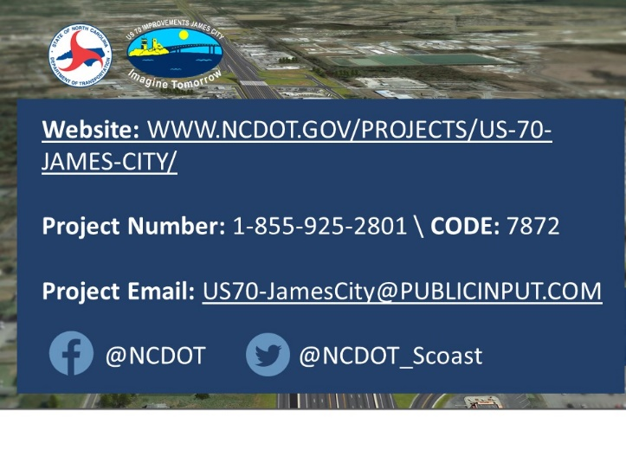  Website: TBD | Example Text - If you have any questions about something that you see on the map, email us70-havelock2thurman@publicinput.com or call 1-855-925-2801, code 4601 to leave a message and someone from the project team will get back to you. Don’t forget to sign-up on the website for project updates and follow us on social media!  ADA Statement

