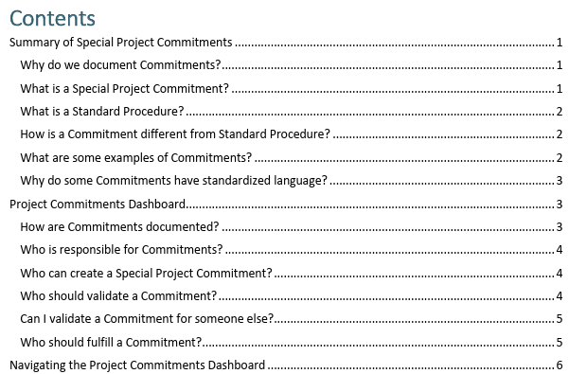
NCDOT Commitments FAQs
Commitments Guidance (see inset)
Overview Video
Chief’s Memo on Special Project Commitments
- document a draft commitment
- provide the reason for the commitment
- validate that the commitment is reasonable and feasible
- assign who will fulfill the commitment
- document the fulfillment of the commitment
- allow applicable consultants and stakeholders to readily view the status of commitments throughout project development, construction, and post-construction.
Who: The project team, led by the NCDOT PM and environmental lead (typically your Consultant NEPA lead)
What: Document special commitments in the Dashboard as they arise and maintain a dialog with the project team on what commitments are being made.
When: Throughout project’s life, as needed for project schedules. Use team meetings and upcoming milestones to check in on commitments that need to be validated, fulfilled, edited, or added.
Where: the Dashboard is a handy, living repository for commitments. The pdf’d green sheets get attached to key deliverables (NEPA docs, Consultations, permits, pre-con meetings, etc.)
Why: Commitments are important to the project, to our stakeholders, to our reputation, and to our public constituents. They are not a box that we check and then forget about – they are promises we’ve made to someone and need to ensure we follow through on their fulfillment.
If we don’t track commitments correctly, then we risk project schedules, regulatory compliance, additional costs, and creating distrust.
Why do we have a Dashboard? Because people retire, files get lost, Word documents get left on consultant servers, etc. Having a Dashboard means the project team has a reliable location to view and edit commitments. These are Commitments we are making to stakeholders and it’s important that we all keep track of them, from the Project Manager to the Resident Engineer and throughout the entire project team.

We don’t want to track commitments that are standard procedures – for instance, Resident’s offices always contact schools and EMS as projects get let, so we don’t need to include a commitment to do that “one month prior to construction” or similar. However, if there is a fire station or a school that would need to significantly change their operations due to our project (perhaps they need 6 months notice to re-rout buses or alter their staffing), then a special commitment is warranted.

