Swiss Hammer (Rebound Hammer) – This is a device used to measure the elastic properties or strength of concrete, mainly surface hardness and penetration resistance.
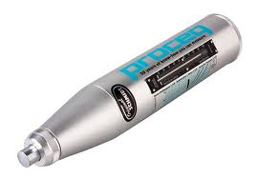

Concrete Vibrator (Motor, hose, head) – This is used to consolidate freshly poured concrete so that trapped air and excess water are released.

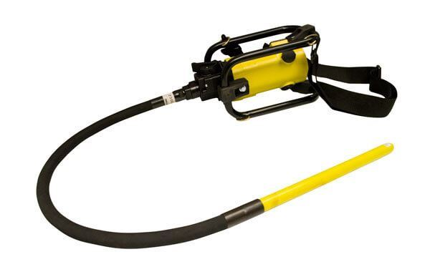

Maturity Meter – A device that shows the relationship between concrete temperature, time and strength gain and represented by an index that can be measured in the field.

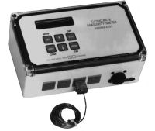

Maturity Probes – Devices that connect to a Maturity Meter to determine the relationship between concrete temperature, time, and strength gain. Usually placed in the concrete pour.
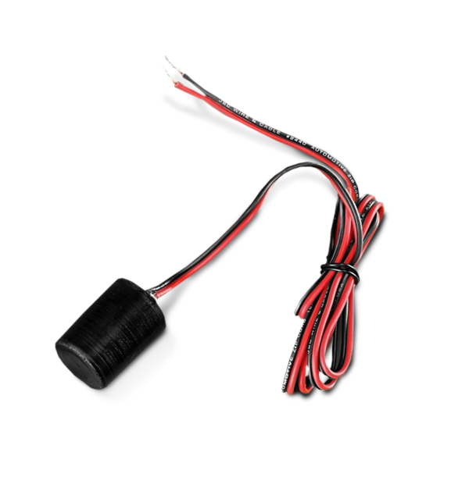

Winsor Probe – This device measures the compressive strength of concrete in the field.
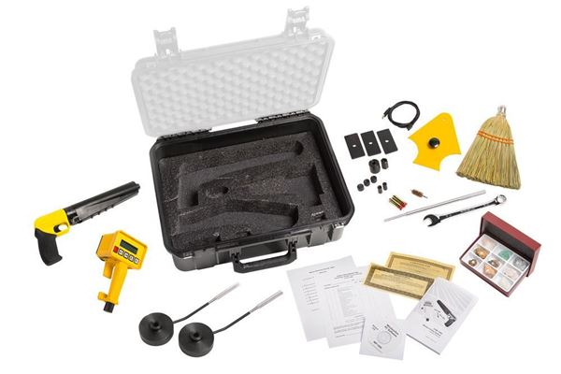

Type B Pressure Meter (Air Pot) – This device measures the amount of air in the concrete.
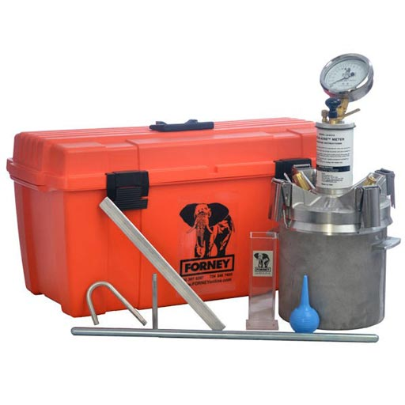

Volumetric meter (Roll-A-Meter) – This device determines the air content in fresh concrete.
