|  |  |  |  |
| --- | --- | --- | --- |
| 26To: | North Carolina Turnpike Authority | From: | Fleur Hartmann, PE Adam Mangano Drenkard, PE |
|  |  |  | Stantec |
| File: | R-2576 | Date: | August 8, 2023 |

Reference: DRAFT: Mid-Currituck Bridge 2023 Shoulder Season Traffic Analysis

# Introduction

NCTA requested that Stantec conduct a Shoulder season traffic data collection program in the Outer Banks in preparation for further traffic and revenue studies of the Mid-Currituck Bridge anticipated to be completed in 2024.

In addition to the Shoulder season data collection, this memorandum also provides summaries and analyses of the traffic crossing the Wright Memorial Bridge (WMB). These data have been continuously analyzed since 2018 and provide an insight to how traffic reacted at the onset of the COVID-19 pandemic and illustrate the “new normal” travel patterns.

Stantec’s review of the 2023 data shows that traffic remains high in the Shoulder season on the Outer Banks and congestion is prevalent on weekends and Fridays, especially along NC-12.

# Shoulder Season Traffic DATA COllection Programs, 2016-2023

As part of the previous Mid-Currituck Bridge studies, Stantec analyzed traffic crossing the WMB and noted three distinct travel seasons in the study area: the Peak season, the Off‑Peak season and the Shoulder season. To assess the conditions within these seasons, a detailed seven- to ten-day traffic data collection program was conducted in each season for each study completed.

The 2023 Shoulder season data collection program discussed herein was conducted from Monday, June 5, 2023 to Sunday, June 11, 2023. Most recently, a Peak season data collection program was conducted in July 2022. Prior to that, Stantec conducted a 2018 data collection program for one week in each season to provide an update to the traffic data previously collected in 2016 (one week in each season) and 2017 (ten days in the Peak season). The 2016, 2017 and 2018 data were collected for the Mid-Currituck Bridge Investment Grade Study (October 2019).

**Table 2-1** summarizes the dates for each data collection program. The Shoulder season data collection dates coincide with the first full week of June for all years. Shoulder season data were collected in 2016, 2018, and 2023 but were not collected in 2017 and 2022.

Table 2-1: Seasonal Data Collection Dates by Year, 2016 – 2023



# Factors Affecting Traffic In The Outer banks

The traffic data collected in June 2023 indicates that traffic volumes are still high, and congestion is still prevalent on the Outer Banks, particularly on Saturdays but also showing increases on Fridays and Sundays. Some trends are different than those in prior data collection programs for reasons discussed below.

## Higher Work-From-home frequency

One of the impacts of the COVID-19 pandemic has been the increased frequency of working from home. According to the US Census, the number of people [primarily working from home](https://www.axios.com/2022/07/12/remote-work-equilibrium-point) tripled in the United States between 2019 (prior to the pandemic) and 2021, increasing from 5.7 percent in 2019 to 17.9 percent in 2021[1]. In North Carolina, the number of people [primarily working from home](https://www.axios.com/2022/07/12/remote-work-equilibrium-point) increased from 6.7 percent in 2019 to 18.8 percent in 2021. The impact of this trend has been later starts to the weekday AM peak period and lower AM peak volumes than before the pandemic.

In addition, flexible work-from-home policies have allowed more “working” vacations, which allow employees to work from vacation locations. People taking these types of vacations are typically working during the weekdays, thereby reducing discretionary recreational trips usually associated with a vacation. Additionally, “working” vacations may allow visitors to extend their stay; conversations with realtors indicate that multi-week rentals are becoming more frequent. This may reduce traffic volumes over the weekend.

## Gas prices

As shown in **Figure 3‑1**, June 2023 gas prices were 26 percent higher than in June 2018 in current (nominal) dollars, and 4 percent higher than in June 2018 in inflation-adjusted dollars[2]. While the higher gas prices likely did not deter people from taking their vacations, they may have impacted the number of vehicles per vacation rental and the number and/or length of discretionary trips taken while on the Outer Banks.

Figure ‑: Average US Gas Prices in June by Year

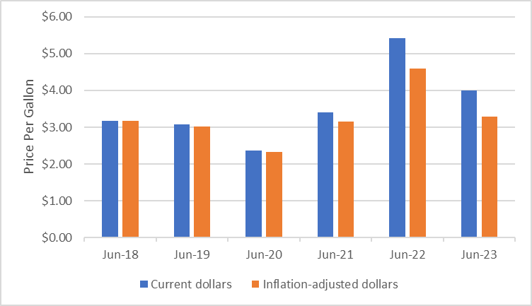

## Rental Contract Opening Dates

In previous years, most rental contracts on the Outer Banks began and ended on Saturdays. Discussions with local realtors indicated that there has been an effort to encourage vacation homeowners to consider changing these start/end rental days to Fridays and Sundays. The effect of this change has been higher traffic volumes on Fridays and Sundays and lower Saturday volumes in some locations than prior years.

# Traffic on the Wright Memorial Bridge

Stantec summarized and analyzed traffic volumes crossing the WMB from 2012 to the present. A NCDOT permanent count station measured WMB traffic volumes in both directions with loop detectors on both spans of the bridge until October 2017 except when construction prevented counts from being collected between October 2013 and April 2014 as well as between October 2014 and May 2015. From October 2017 to May 2018, construction closed both lanes of the westbound bridge span and westbound traffic was re‑routed to the eastbound span which then operated with one travel lane per direction. Permanent station counts after October 22, 2017 were collected from the eastbound span only and could not be broken out by travel direction. On April 30, 2018, the eastbound permanent count station was removed so no permanent count data were available in either direction after that date. In order to gather vehicle volume data, Stantec had a radar count system installed to measure eastbound traffic volumes from late June through early September 2018. The westbound data for that period were estimated based on the eastbound volumes and the historical Peak period directional split. Note that no traffic data in either direction were available for May and most of June in 2018. Radar traffic measurement devices were installed by NCDOT in September 2018 and have continuously been collecting traffic volumes in both directions, except for a short period in the summer of 2021 when the units were out of service.

When summarizing the data, atypically high or low traffic volumes were removed from the dataset to allow for an accurate year-over-year comparison that is not impacted by severe weather, non‑recurring events, or traffic incidents.

Traffic crossing the WMB has been generally trending upward over the past decade as shown in **Figure 4‑1**,from fewer than 900,000 vehicles per month in 2012 to nearly 1,000,000 in 2022. In 2022, July traffic was at its highest level. Peak season traffic was lower in 2018 than 2017. This is likely due to the WMB lane closures on weekdays throughout the summer of 2018 which discouraged discretionary trips across the bridge. In addition to the lane closures, extreme rainfall in late July 2018 impacted travel. The Outer Banks saw more rainfall in July 2018 than any other month in recorded history up to that point in time. The average daily traffic in the first half of the 2023 Shoulder season (May 1st - June 15th) was almost one percent higher than 2022 traffic volumes during the same period.

Figure 4‑1: Total Historical Monthly Traffic Volumes on the Wright Memorial Bridge



**1** No data due to construction.

In general, traffic crossing the WMB recovered to pre-COVID levels quickly. Once local travel restrictions were lifted in May 2020, visitation to the Outer Banks resumed. In 2020 and early 2021, before vaccinations were widely available, international travel was still restricted and people were looking for a way to vacation with the ability to socially distance. In addition to people vacationing on the Outer Banks, work-from-home flexibility afforded people the opportunity to change their work location and renting a house gave people the ability to have “working” vacations more easily. **Figure 4‑2** shows the 7-day moving average of traffic crossing the WMB in both directions from January 2020 to July 2023. As shown by the solid green and purple lines in the figure, traffic has generally exceeded 2019 levels since September 2022.

Figure ‑: 7-Day Moving Average Daily Traffic, Wright Memorial Bridge

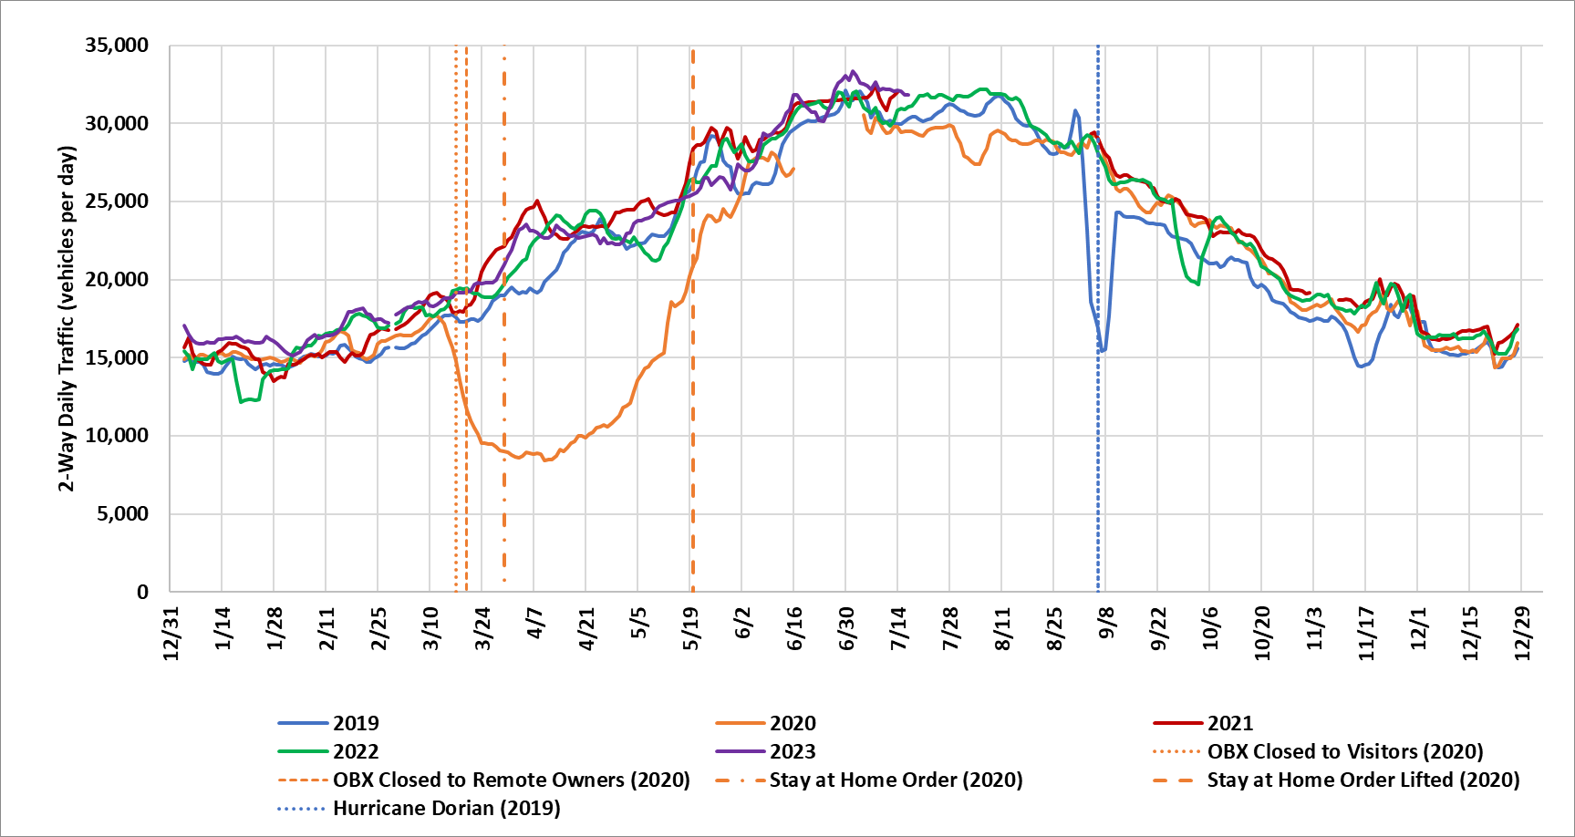

Note: Data were not available from July-August 2021. Major storm warnings (non-Hurricane) were posted for the Outer Banks in November 2019, January 2022, May 2022, and October 2022, causing noticeable dips in traffic crossing the WMB.

**Figure 4‑3** compares the average daily WMB crossing volumes collected from the permanent count stations in the May1st-June 15th portion of the Shoulder season by day type and by year. As shown, weekday travel in 2023 was slightly higher (0.3 percent) than 2018 levels. Volumes crossing the WMB in 2023 grew over 2018 levels on Fridays (1.5 percent), Saturdays (1.9 percent), and Sundays (1.4 percent).

Figure 4‑3: Average Daily Shoulder Season Traffic Across the WMB

First Note: 2018 May 1st to June 15th estimated using the relationship between 2017 and 2018 counts in the late shoulder season (August 15th to September 30th).

Second Note**:** 2016 and 2017 volumes counted with induction loop detector.

# Traffic Volumes at Key Locations

## 2023 Automatic Traffic Recorder Locations

Twenty-three Automatic Traffic Recorder (ATR) counts were collected for 24 hours each day for a continuous 7‑day period during the Shoulder season. Counts began on Monday, June 5 and ended on Sunday, June 11, 2023. Most of the 2023 ATR count locations, shown on a map of the area in **Figure 5‑1** and listed in **Table 5-1**,correspond to the locations counted in July 2022. In July 2022, eight count locations were added to those from the 2018 program to further understand the routes vehicles use to cut through Southern Shores to avoid NC-12 congestion. Because very limited cut-through traffic was observed in the Peak season at ATR 19 and ATR 25 (on Juniper Trail and Ocean Boulevard, respectively), these two locations were eliminated from the 2023 Shoulder season count program. ATR 26 on NC-12 was moved slightly north from North Harbor View to south of Herring Street and is now referred to as ATR 27. There is no data from any year for ATR 11; Stantec is using the same naming convention for its ATR locations as was used in 2016 when ATR 11 was removed from the data collection program prior to its execution. The ATR locations can be grouped into four different areas within the region as follows:

* US-158 and NC-168, North of WMB (Mainland): These five locations (ATRs 10, 12, 13, 14, and 17) on the mainland provide the demand volume, route distribution and arrival profile of the vehicles destined for the Outer Banks.
* NC-12 and US-158, North of WMB (Outer Banks North): Six count locations (ATRs 1, 2, 3, 15, 16, and 27) along the main highway to the northern portion of the Outer Banks provide the distribution of volumes destined for Southern Shores, Duck, Corolla, and areas further north.
* NC-12, US-158 and US-64 South of WMB (Outer Banks South): These six locations (ATRs 4 through 9) provide the volumes and general distribution of traffic in areas south of the bridge such as Kitty Hawk, Kill Devil Hills, and Nags Head. Counts on US-64 provide volumes for the Washington Baum Bridge which connects the Outer Banks to Roanoke Island and the mainland south of Albemarle Sound.
* South Dogwood Trail and Southern Shores (Backroads): These locations (ATRs 18, 20 through 24) identify how many vehicles attempt to circumvent the NC-12 congestion by cutting through the local neighborhood and also the paths these vehicles take through the neighborhood. One of these locations, South Dogwood Trail north of Tall Pine Lane (ATR 18) was counted in count programs from previous years; the other locations were added in 2022 or 2023 and provide additional insight on the travel patterns in the area.

Figure ‑: 2023 Shoulder ATR Count Locations

Table -: 2023 Shoulder ATR Count Locations



*New location added to the 2022 count program.

+ATR 27 added in 2023.

## Hourly Traffic Volumes

### 2023 Shoulder Season Hourly Traffic Volumes to the Outer Banks

The Shoulder season weekday hourly traffic profile from US-158 at Aydlett on the mainland to NC-12 in Duck follows a steady trend throughout the day at all locations, as shown in **Figure 5‑2**. Counts from key locations are shown in the figure to illustrate the general traffic patterns through each area. The 2018 volumes are also included for comparison. Note that the backroad parallel to NC-12, South Dogwood Trail, experiences fewer than 100 vehicles per hour during a typical Shoulder season weekday. The total volume counted on this backroad location along South Dogwood trail was about 9 percent higher than that counted in 2018. As shown in the graph, traffic on the mainland, as shown by the US 158 southbound in Aydlett hourly distribution, has increased since 2018 on weekdays. The 2023 traffic volumes along NC-12 were about 5 percent lower than the 2018 traffic volumes.

Figure 5‑2: Stantec ATR Weekday Shoulder Season Hourly Volumes from Aydlett to Duck



Source: Stantec ATR Counts, June 2018 and 2023.

**Figure 5‑3** shows that the Shoulder Saturday volumes are much greater than those on a Shoulder weekday. The US-158 peak hour volumes on Saturday are two to three times higher as those during the weekday. The 2023 traffic volumes at this location were also greater than those counted in the 2018 Shoulder season.

South Dogwood Trail experiences a much higher volume during a Shoulder Saturday than a Shoulder weekday; on a Shoulder season Saturday in 2023, an hourly volume of over 100 vehicles on South Dogwood Trail is sustained from about 1 PM to 7 PM, with the highest volumes, greater than 300 vehicles per hour, occurring between 2 PM and 6 PM. Field observations revealed the vehicles using this route are a major contributor to the congestion experienced on northbound NC‑12 approaching Duck on a Shoulder season Saturday. While there has been an effort to reduce the number of vehicles that use this backroad route through the use of variable message signs along US 158 and at the turn‑off onto South Dogwood Trail, Google Maps still sends people on this route. The friction added by the left turn volumes from eastbound traffic on Sea Oats Trail, 11th Avenue, Hillcrest Drive, Hickory Trail, and East Dogwood Trail onto northbound NC-12 worsens the delays on NC-12. **Figure 5‑4** shows the typical route taken from the Mainland to Duck along US‑158 and NC-12 compared to the alternative route along South Dogwood Trail and subsequent local roads most utilized during the Shoulder season weekends.

Figure 5‑3: Stantec ATR Saturday Shoulder Season Hourly Volumes from Aydlett to Duck



Note: 2018 counts adjusted to account for weather effects. Source: Stantec ATR Counts, 2018 and 2023.

Figure ‑: US 158/NC 12 Route to Duck compared to South Dogwood Trail Route

In 2023, hourly volumes over 400 vehicles begin at 7 AM on Saturdays on northbound NC-12 in Southern Shores. Throughput increases throughout the morning, reaching a peak at noon and then begins to decrease to about 500 vehicles at 7 PM, which corresponds to the timespan in which the South Dogwood Trail volumes show increased volumes. The decrease in hourly volumes on NC-12 northbound during the PM period is due in part to substantial congestion; the travel time runs conducted show average speeds along NC-12, south of Sea Oats Trail that were slower than 10 mph between 3 PM and 5 PM. Stantec’s monitoring of traffic conditions on Google Maps corroborates the increased congestion. On a total daily basis, the 2023 Saturday count volumes on NC-12 and the back roads were about 15 percent higher as compared to 2018.

**Figure 5‑5** shows that the 2022 Sunday hourly volumes on NC-12 are greater than in 2018; a peak is clearly visible in the afternoon from 3 PM to 5 PM that did not occur as prominently in 2022. In prior years, almost all rental contracts began on and ended on Saturdays. There has been an increased effort to spread arrivals over the entire weekend with more contracts beginning on Fridays and Sundays. The Sunday afternoon peak corresponds to the afternoon check-in times. The 2023 data collection program traffic shows that travelers do not use South Dogwood Trail to get to their destinations in Duck and north of Duck on Sundays. Because vehicles do not use the back roads, and then need to turn left onto NC-12, there is less friction on NC-12 approaching Duck, resulting in higher speeds that were observed on Saturday (discussed in Section 6.0).

Figure 5‑5: Stantec ATR Sunday Shoulder Season Hourly Volumes from Aydlett to Duck



Source: Stantec ATR Counts, 2018 and 2023.

## 2018 and 2023 Daily Volume Comparison

### Shoulder Season Daily Volumes

**Table 5-2**, **Table 5-3**, **Table 5-4**, and **Table 5-5** show the changes in Shoulder season daily traffic volumes between 2018 and 2023 for representative count locations in the study area for weekdays (Monday-Thursday), Fridays, Saturdays, and Sundays, respectively. On NC-12, the 2023 weekday daily volumes were lower than in 2018. This was likely due to a variety of factors including more work-from-home activity. On Fridays, the collected volumes on NC-12 were higher, and speeds on NC-12 were slower in the PM peak period (discussed in Section 6.0), indicating congestion. Friday volumes on the “shortcut” along South Dogwood Trail in the midday and PM peak period were higher. Saturday volumes on NC-12 decreased, likely due to the effort to change rental start dates to Fridays and Sundays, and also because vehicles used the South Dogwood Trail to avoid NC‑12, something they had not done in 2018 Shoulder season. Sundays showed increased volumes on NC-12 as compared to 2018, likely a result of the effort to move some rental start dates to Sunday.

Table 5-2: 2018 and 2023 Shoulder Season Weekday (Monday-Thursday) Daily Volumes



Note: Stantec ATR Counts, 2018 and 2023.

Table 5-3: 2018 and 2023 Shoulder Season Friday Daily Volumes



Note: Stantec ATR Counts, 2018 and 2023.

Table -: 2018 and 2023 Shoulder Season Saturday Daily Volumes



Note: Stantec ATR Counts, 2018 and 2023.

Table -: 2018 and 2023 Shoulder Season Sunday Daily Volumes



Note: Stantec ATR Counts, 2018 and 2023.

### South Dogwood Trail Volumes

Traffic was recorded on South Dogwood Trail, the alternative route to NC-12 through Southern Shores from the eastern side of the WMB, during the 2018 and 2023 Shoulder seasons. Use of this alternative route occurs when congestion on NC‑12 is substantial, making travel times on South Dogwood Trail comparable to, or lower than, NC‑12. Smartphone guidance apps such as Google Maps direct vehicles to this alternative route when there is even a one-minute time benefit. While there has been an effort to reduce the number of vehicles that use this back road route through the use of variable message signs along US 158 and at the turn-off onto South Dogwood Trail, Google Maps still sends people on this route when there is a time benefit. It should be noted that when travel time runs along the back roads were completed on a Shoulder Saturday, the estimated travel time was considerably understated in the Google Maps app, indicating that the route’s travel time benefit over NC-12 was overstated. **Figure 5‑6** shows the variation in traffic volumes on South Dogwood Trail across days of the week and for each season in 2018 and in 2023. Northbound traffic reaches over 2,500 daily vehicles on Saturdays in the Shoulder season in 2023, about twice the daily volume that used this route in 2018. Total daily volumes increased between 2018 and 2023 on all days and directions except for southbound on Fridays and northbound on Sundays.

Figure ‑: South Dogwood Trail Daily Volumes, 2018 vs. 2023

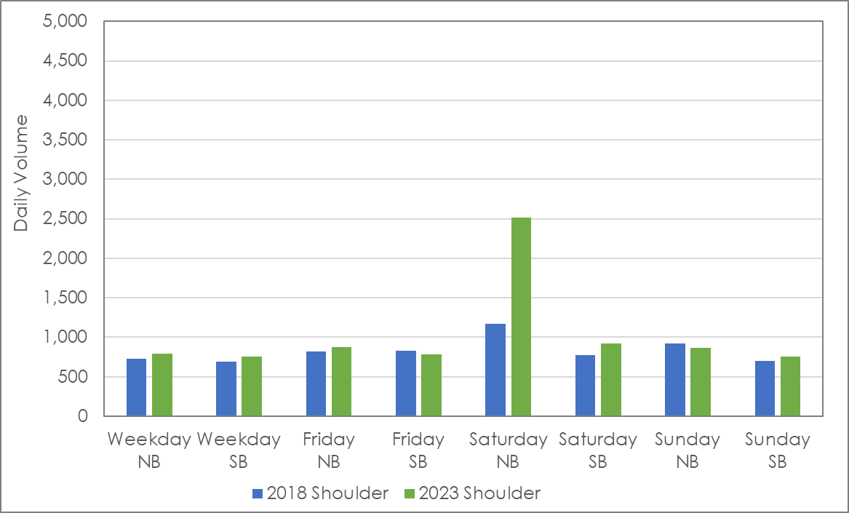

Source: Stantec ATR Counts, 2018 and 2023.

# Travel Times

Travel times were collected between US-158 in Aydlett and NC-12 north of Duck during the 2023 Shoulder season count program. Data were collected between 6 AM and 7 PM on a Monday (6/5), Friday (6/9), Saturday (6/10), and Sunday (6/11).

## 2023 Travel Times

The average Shoulder season Saturday travel times from US-158 (at Marshall Grandy Lane) in Aydlett on the mainland through the town of Duck during the AM, midday, and PM time periods in 2023 are shown in **Figure 6‑1**. During the PM peak congestion period, the average traveler drives for 77 minutes to get from Aydlett through the town of Duck. Under free-flow conditions, this trip takes 36 minutes. For visitors staying in Sanderling, Corolla, and Carova, this equates to about 41 minutes in congestion. During the AM period, travel time from Aydlett through Duck is generally free flow with a travel time of 40 minutes. During the midday period, travel time is just about 49 with about 13 minutes of added congestion.

Figure 6‑1: 2023 Shoulder Season Saturday Travel Time from Aydlett to locations north of Duck



Source: Stantec 2023 travel time surveys over the WMB.

## 2018 to 2023 Shoulder Season Comparison

From US-158 at NC-136 on the mainland to NC-12 north of Duck, average weekday travel time was generally slower in 2023 compared to 2018, as shown in **Figure 6‑2**. Travel times increased in all periods except Sunday midday. Friday and Sunday evening increases are likely a result of more rentals starting on Fridays and Sundays than in past years. Saturday PM travel times were very slow in 2023, increasing by about 70 percent. Most of this increase was due to very heavy congestion south of Duck where the backroad volumes merge into NC-12. Sub-10 mph speeds were observed along NC-12, south of Sea Oats Trail.

Westbound travel times during 2023 were also generally slower than that in 2018. Travel time increases ranged from three percent to about sixteen percent of 2018 travel times. Midday Saturday and midday Sunday showed improvements in travel times. The increased congestion on Fridays and Sundays is likely related to the changes in rental day arrivals and departures. Westbound travel times are shown in **Figure 6‑3**.

Figure 6‑2: Eastbound Shoulder Season Travel Time from Aydlett to North of Duck via WMB, 2018 and 2023



Source: Stantec 2018 and 2023 travel time surveys.

Figure 6‑3: Westbound Shoulder Season Travel Time from North of Duck to Aydlett via WMB, 2018 and 2023



Source: Stantec 2018 and 2023 travel time surveys.

1. https://www.census.gov/newsroom/press-releases/2022/people-working-from-home.html
2. https://www.eia.gov/dnav/pet/hist/LeafHandler.ashx?n=PET&s=EMM_EPM0R_PTE_NUS_DPG&f=M