**Adding Table of Contents (TOC) and Top of Page links to the Specifications Manual (using to HTML)**

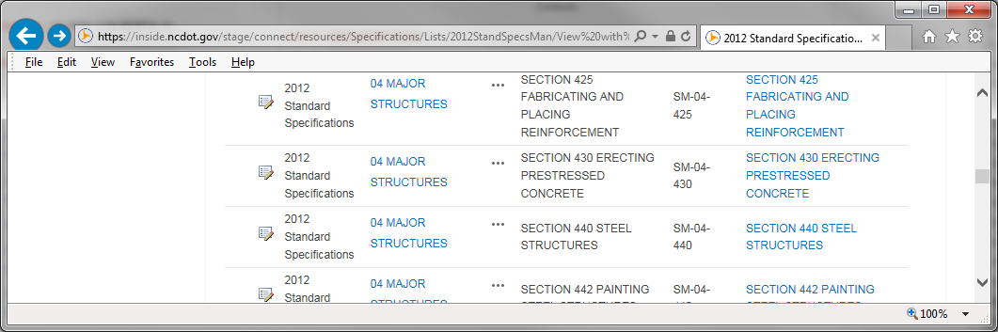

1. **Click on the Edit button.**

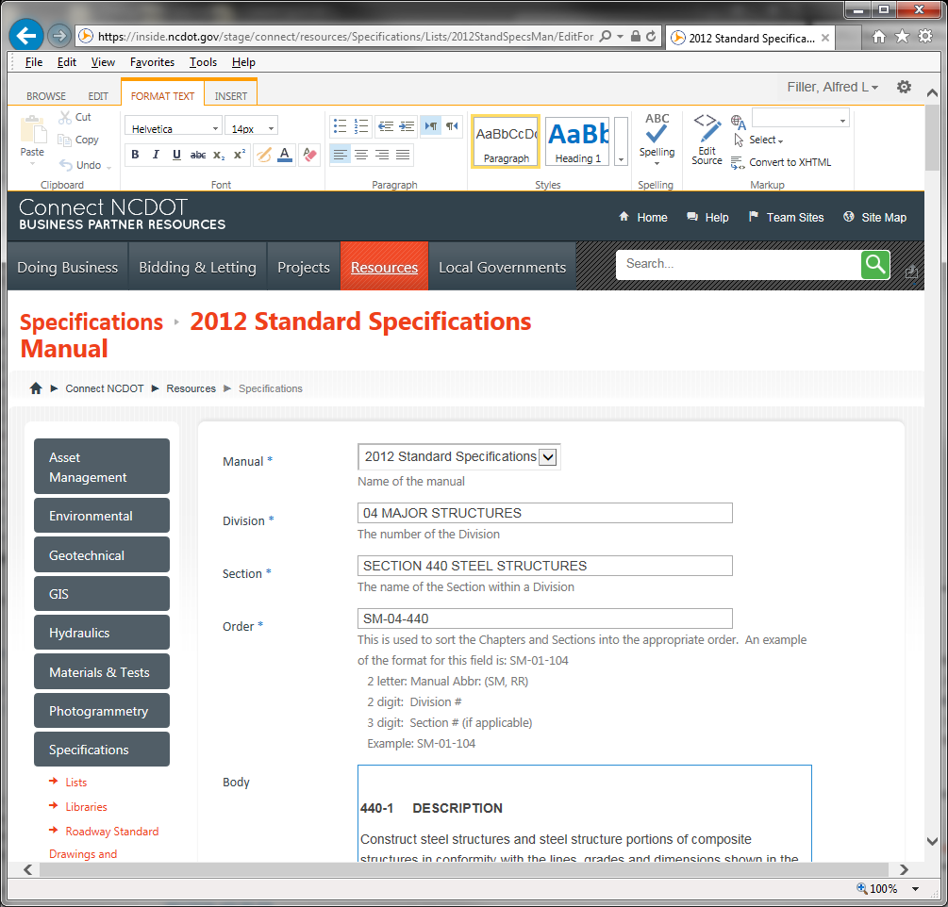

1. **Place you mouse at the top of the edit screen.**
2. **Click on the Edit Source button.**
3. **Place you mouse at the top of the edit screen and paste the TOC HTML code in.**

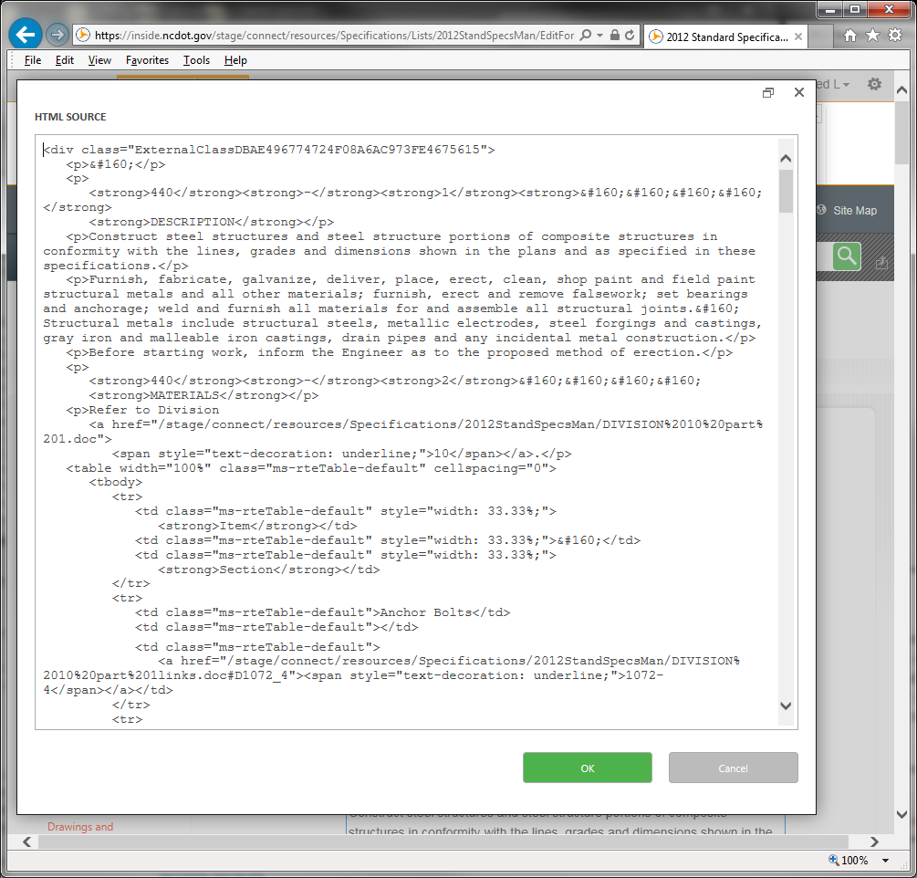

1. **You will see the HTML at the top of the screen.**

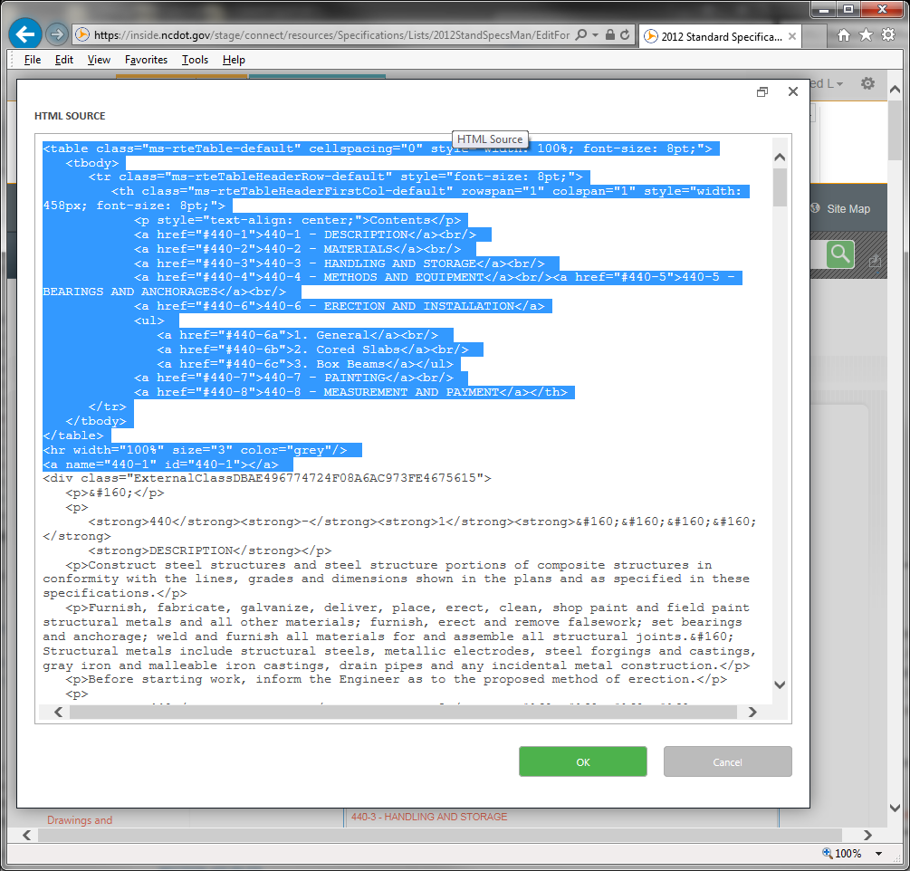

1. **Click the OK button.**
2. **You will see the TOC at the top of the column.**

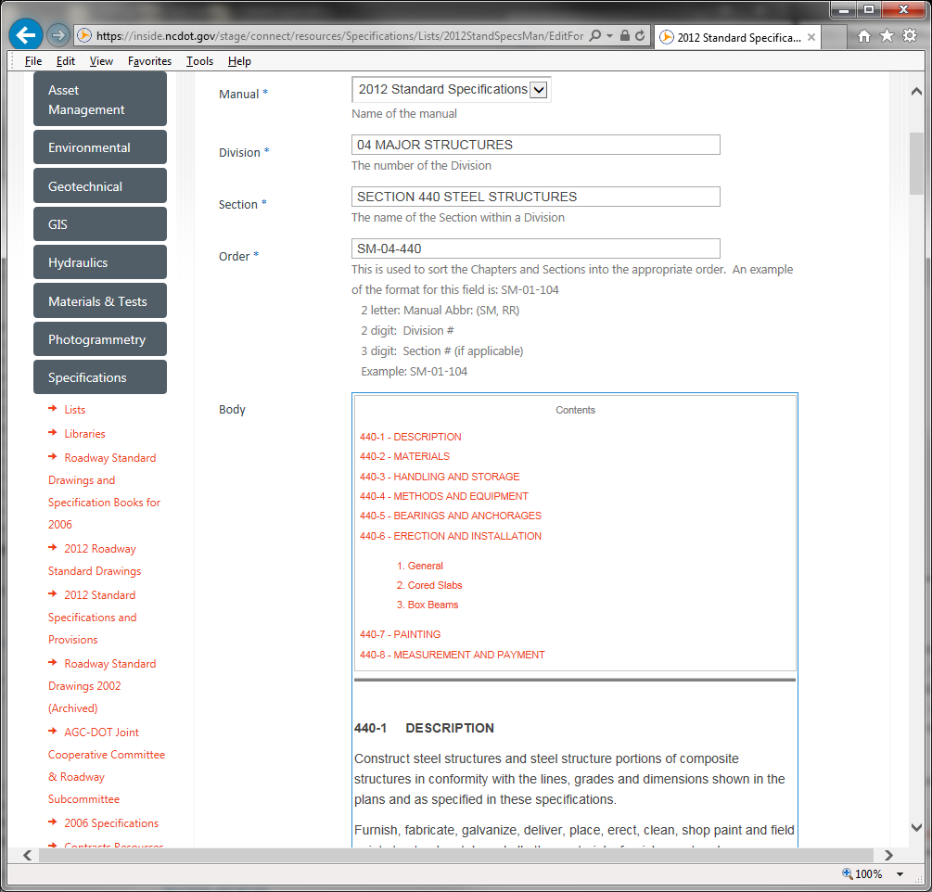

1. **Select one of the Headers to add the anchor HTML**

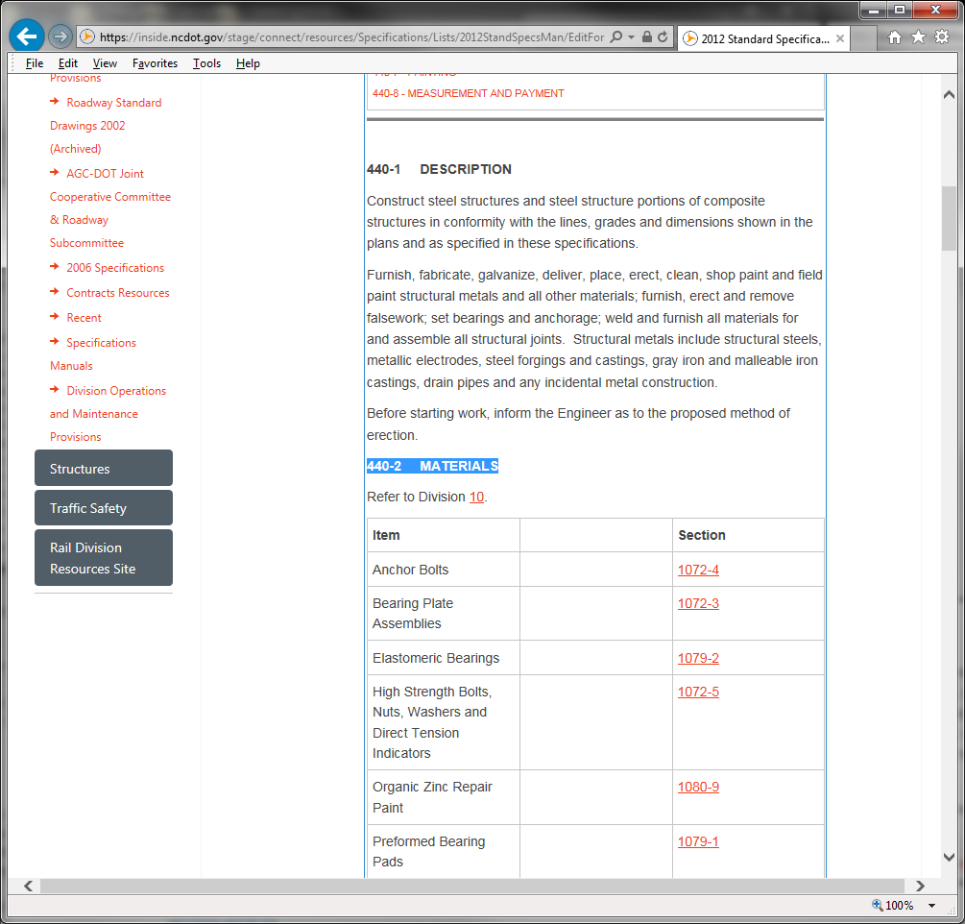

1. **You will see the header highlighted.**

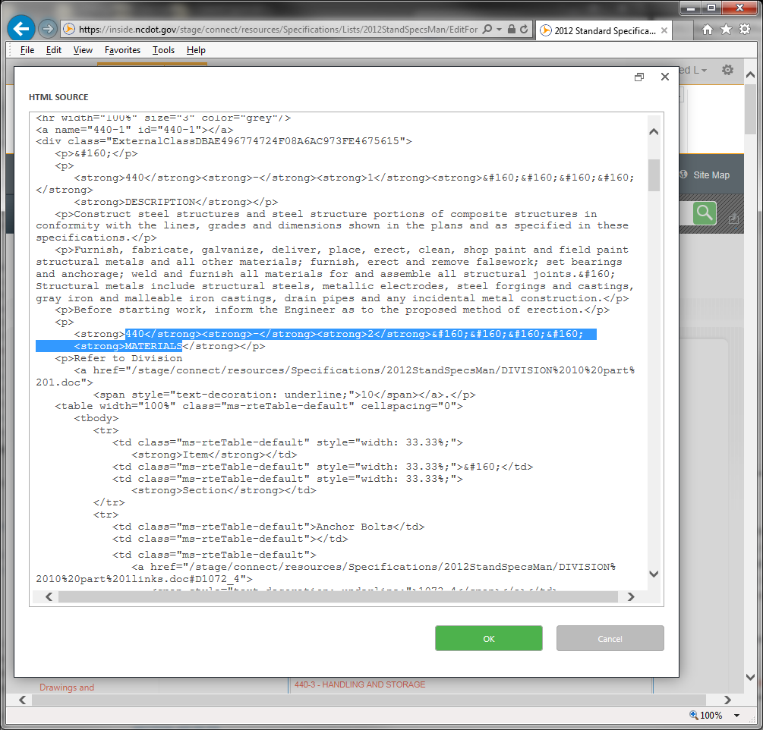

1. **Paste the Anchor and Top of Page HTML just above the Header Text.**
2. **Click the OK button.**

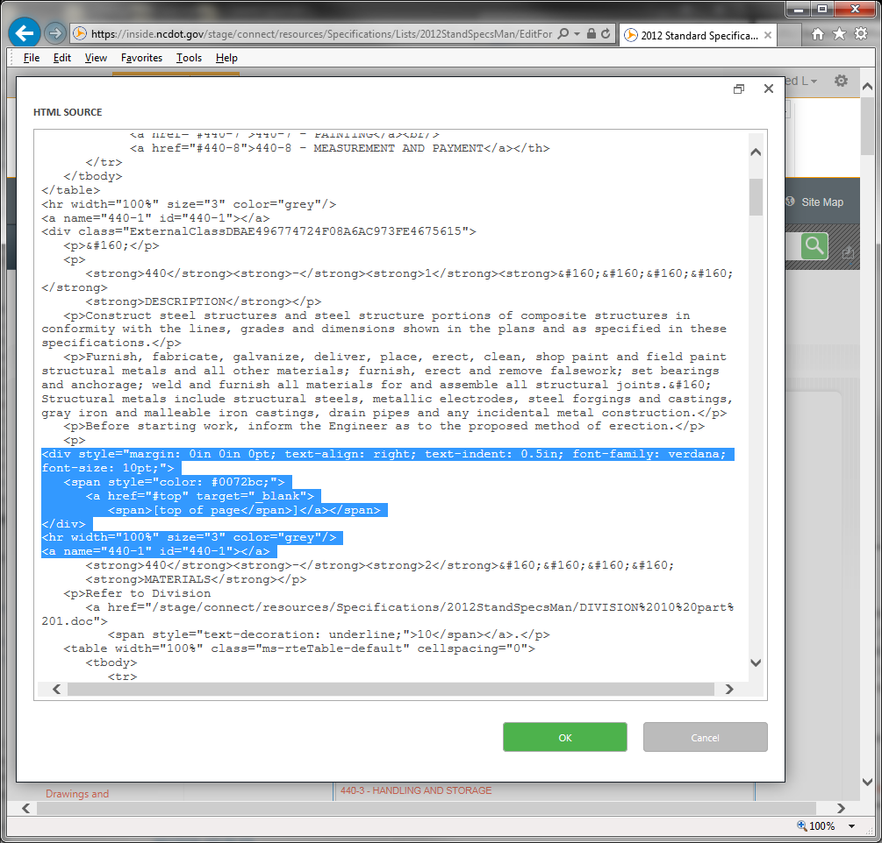

1. **You will see the top of page and the Gray Line which holds the Anchor tag.**

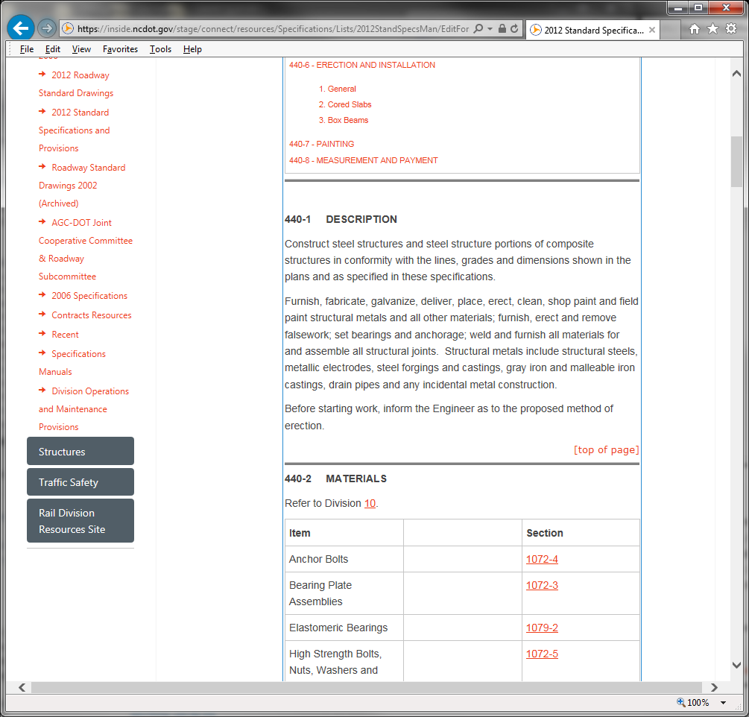

1. **Continue to add Anchor Tags and Click the SAVE button.**

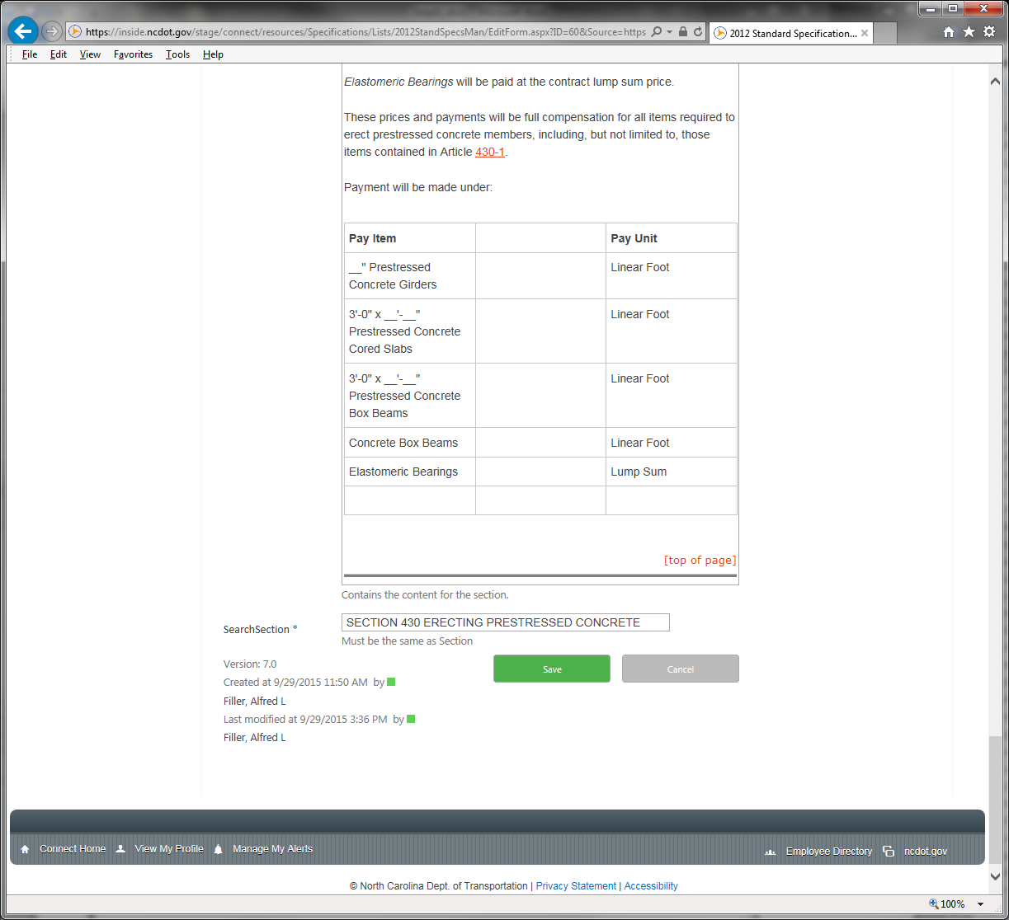

1. **Click on the SearchLink to view the Section you worked on.**

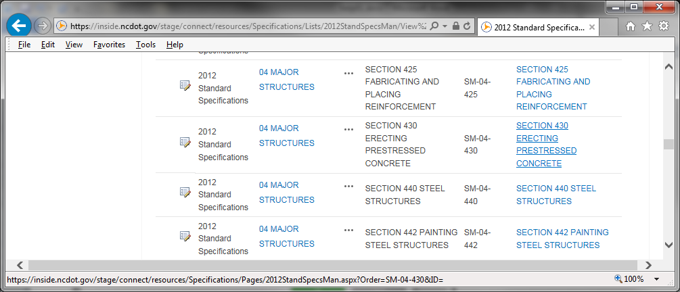

1. **You can see the section and TOC. Test the links to see if it worked.**

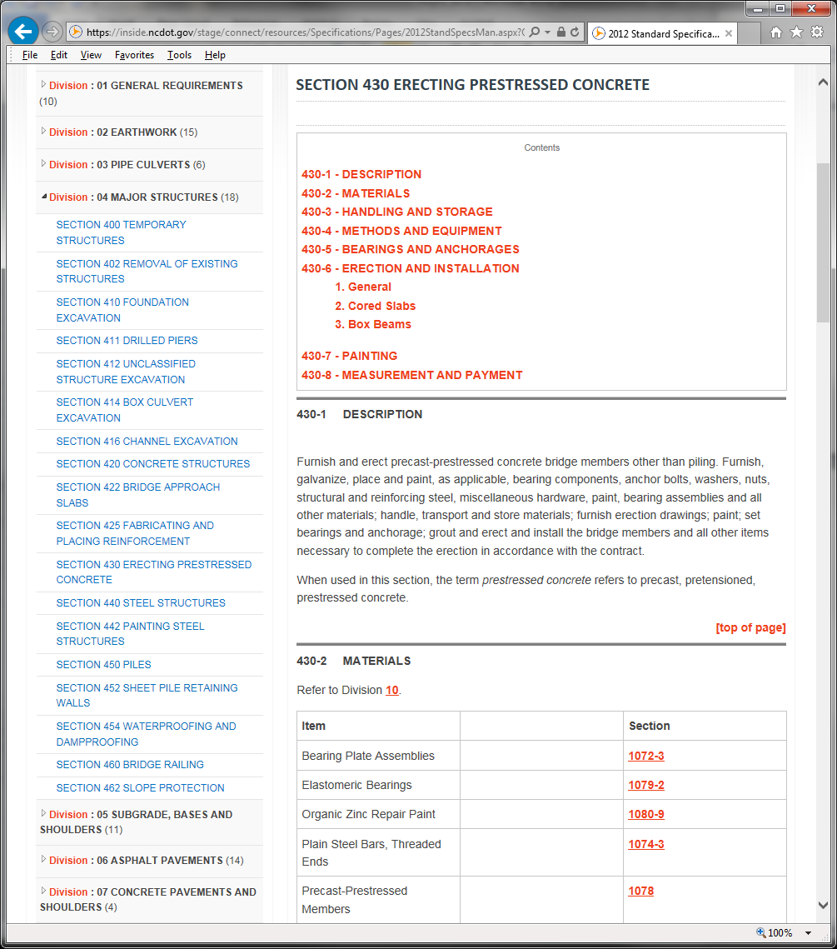

HTML TOC and Anchor Tags

===============

SAMPLE

DIVISON 4

SECTION 430

===============

<table class="ms-rteTable-default" cellspacing="0" style="width: 100%; font-size: 8pt;">

<tbody>

<tr class="ms-rteTableHeaderRow-default" style="font-size: 8pt;">

<th class="ms-rteTableHeaderFirstCol-default" rowspan="1" colspan="1" style="width: 458px; font-size: 8pt;">

<p style="text-align: center;">Contents</p>

<a href="#430-1">430-1 - DESCRIPTION</a><br/>

<a href="#430-2">430-2 - MATERIALS</a><br/>

<a href="#430-3">430-3 - HANDLING AND STORAGE</a><br/>

<a href="#430-4">430-4 - METHODS AND EQUIPMENT</a><br/>

<a href="#430-5">430-5 - BEARINGS AND ANCHORAGES</a><br/>

<a href="#430-6">430-6 - ERECTION AND INSTALLATION</a>

<ul>

<a href="#430-6a">(A) General</a><br/>

<a href="#430-6b">(B) Cored Slabs</a><br/> **These can be Numbers or Letters.**

<a href="#430-6c">(C) Box Beams</a>

</ul>

<a href="#430-7">430-7 - PAINTING</a><br/>

<a href="#430-8">430-8 - MEASUREMENT AND PAYMENT</a>

</th>

</tr>

</tbody>

</table>

<hr width="100%" size="3" color="grey"/>

<a name="430-1" id="430-1"></a>

===============

Back to Top goes at the bottom of each Sub-section.

===============

<div style="margin: 0in 0in 0pt; text-align: right; text-indent: 0.5in; font-family: verdana; font-size: 10pt;">

<span style="color: #0072bc;">

<a href="#top" target="_blank">

<span>[top of page</span>]</a></span>

</div>

<hr width="100%" size="3" color="grey"/>

<a name="440-1" id="440-1"></a>

**Change to match each of the content links.**