optional PRECAST REINFORCED CONCRETE (10-31-24)

BOX CULVERT AT STATION

General
This Special Provision covers the design, fabrication and construction of precast reinforced concrete box culverts intended for the conveyance of storm water.
The option for a precast reinforced box culvert, in lieu of a cast-in-place culvert, is permitted only when indicated on the plans. When the precast option is selected, provide the size and number of barrels as indicated on the plans. Detail the culvert with cast-in-place wings walls and footings. Precast wing walls and footings will not be allowed. Provide a precast box culvert that meets the requirements of Section 1077 and any other applicable parts of the Standard Specifications.
The Contractor shall be responsible for the design and load rating of the precast culverts, as well necessary cast-in-place elements. Design the precast culvert sections in accordance with ASTM C1577 or the current edition of the AASHTO LRFD Bridge Design Specifications. Regardless of size, load rate precast reinforced concrete box culverts in accordance with the current edition of the AASHTO Manual for Bridge Evaluation for the AASHTO design load, the applicable North Carolina legal loads, and Fixing America's Surface Transportation (FAST) Act’s emergency vehicles (EV). Refer to the section on North Carolina’s Legal Loads for the load rating vehicle configurations.
Submit, to the Engineer, a set of detailed plans and load rating sheets for review and approval. Show all structural details in the plans, including the size and spacing of the required reinforcement necessary to build the precast box and cast-in-place members. The plans, load rating sheets, and design calculations shall be sealed by a North Carolina Registered Professional Engineer.
If the span, rise and design earth cover for the precast reinforced concrete box culvert are identical to a previously approved submittal, the Contractor may request the previously approved design calculations and plans be considered as the submittal for review and approval. However, a set of plans and rating sheets will need to be submitted to become part of the contract plans.
After the plans, rating sheets and design calculations are approved, submit a finalized complete set of plans, including the load rating sheets in 22" x 34" (ANSI D) format plan sheets to incorporate into the contract plans.

North Carolina’s Legal Loads

Legal loads for structures carrying interstate traffic:
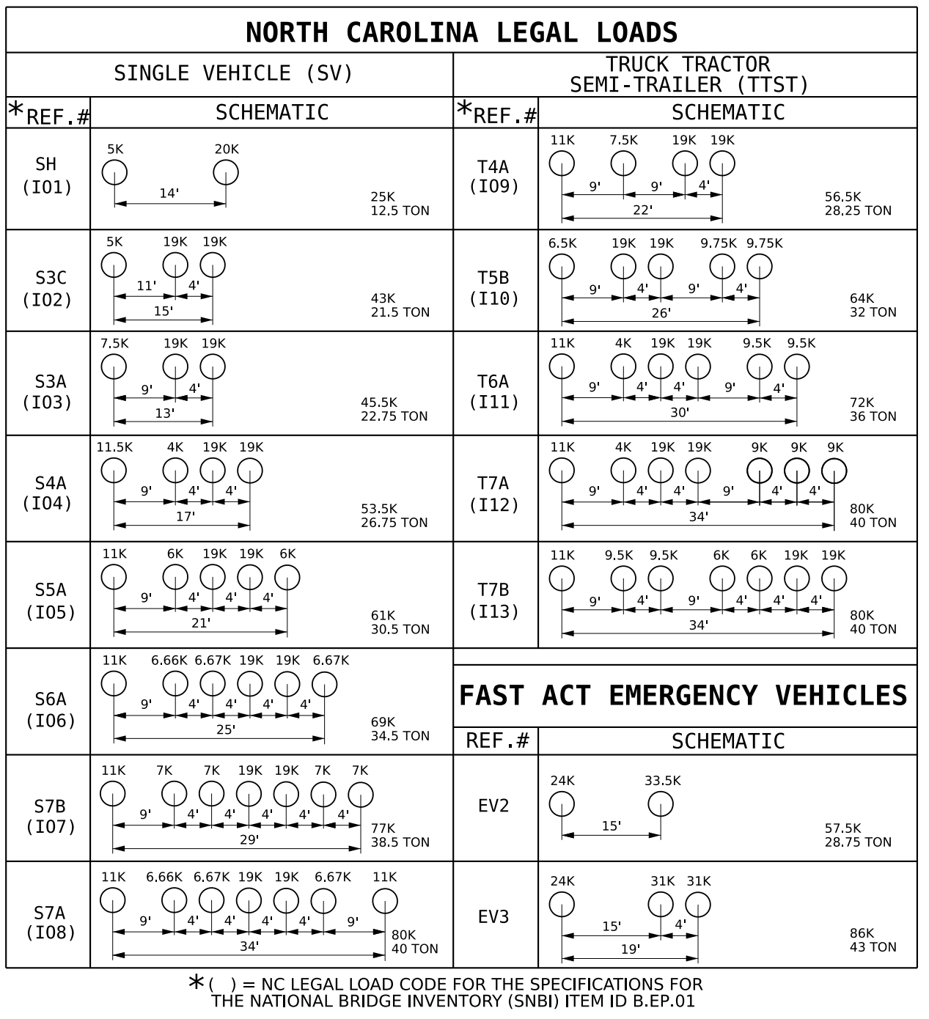

Legal loads for structures carrying non-interstate traffic:
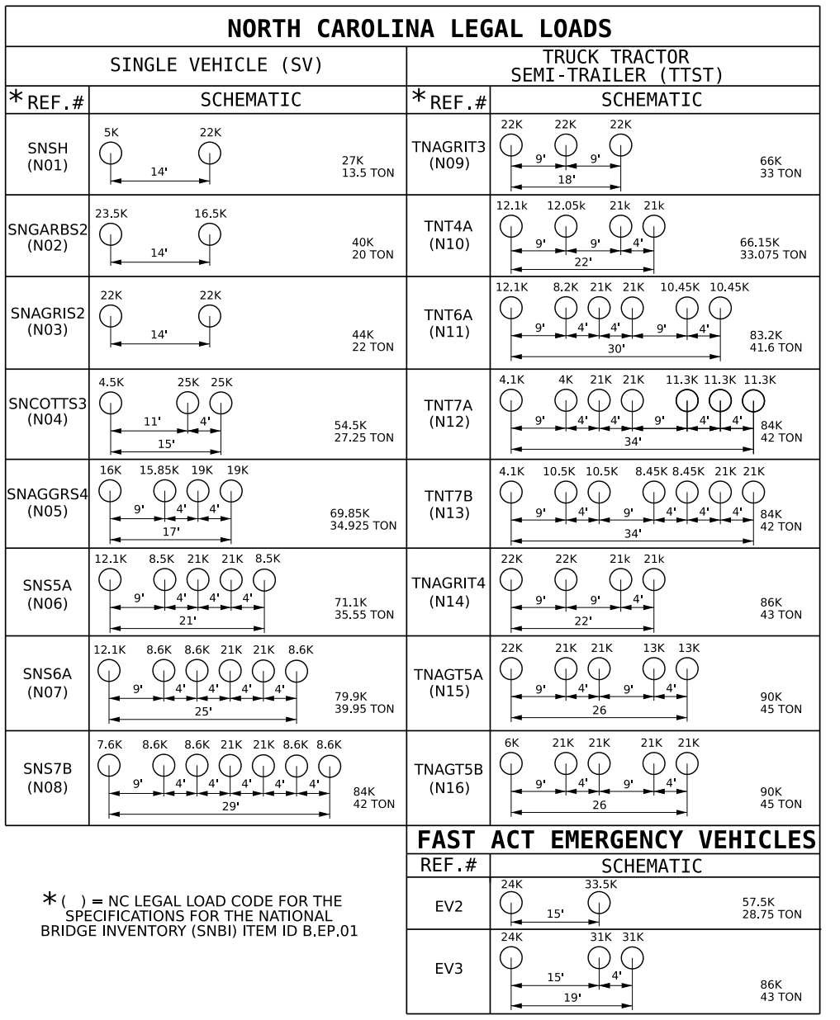

Precast Reinforced Concrete Box Sections
The precast reinforced concrete box culvert sections shall match the size and hydraulic opening indicated in the contract plans.

Design

Design Fill – The design earth cover is reported on the plans as the elevation difference between the point of maximum fill and the bottom of the top slab.

Placement of Reinforcement – Provide a 1-inch concrete cover over the reinforcement subject to the provisions of Section E. Extend the inside reinforcement into the tongue portion of the joint and the outside reinforcement into the groove portion of the joint. Detail the clear distance of the end wires so it is not less than ½ inch or more than two (2) inches from the ends of the box section. Assemble reinforcement per the requirements of ASTM C1577 or the approved design. The exposure of the ends of the wires used to position the reinforcement is not a cause for rejection.

Laps and Spacing – Use lap splices for the transverse reinforcement. Detail the transverse wires so that the center to center spacing is not less than two (2) inches or more than four (4) inches. Do not detail the longitudinal wires with a center to center spacing of more than 8 inches.

Joints

Produce the precast reinforced concrete box section with tongue and groove ends. Design and form these ends of the box section so, when the sections are laid together, they make a continuous line of box sections with a smooth interior free of appreciable irregularities in the flowline, all compatible with the permissible variations given in Section F. The internal joint formed at the tongue and groove ends of the precast units shall be sealed with either bitumen/butyl sealant or closed-cell neoprene material. The internal joint material shall be installed in accordance with the manufacturer's recommendations. The material shall be shown on the shop drawings when they are submitted for review.

Seal the external joint with an outside sealer wrap conforming to ASTM C877 that is at least 12 inches wide and covers the joint on both the sides and the top of the box section. Use ConWrap CS-212 from Concrete Sealants, Inc., EZ-Wrap from Press-Seal Gasket Corporation, Seal Wrap from Mar-Mac Manufacturing Co., Inc., Cadilloc External Pipe Joint from Cadilloc, or an approved equal for the outside sealer wrap. If the outside sealer wrap is not applied in a continuous strip along the entire joint, a 12 inch minimum lap of the outside sealer wrap is permitted. Before placing the outside sealer wrap, clean and prime the area receiving the outside sealer wrap in accordance with the sealer wrap manufacturer recommendations. The joint wrap manufacturer installation recommendations shall be included with shop drawings submitted for review. The external joint wrap shall be installed in pieces, as indicated on Figure 1 below:

3 5

1 2 3 1 2 4

Figure 1

Cover the external joint sealer with a 3 foot strip of filter fabric conforming to Type 4 requirements in Section 1056 of the Standard Specifications.

Place multiple lines of a precast reinforced concrete box culvert such that the longitudinal joint between the sections has a minimum width of three (3) inches. Fill the joint between multiple lines of precast box sections with Class A concrete. Use Class A concrete that meets the requirements listed in the Standard Specifications except that Field Compressive Strength Specimens are not required.

Manufacture

Manufacture precast reinforced concrete box culvert sections by either the wet cast method or dry cast method.

Mixture – In addition to the requirements of Section 1077 of the Standard Specifications, do not proportion the mix with less than 564 lb/yd³ of Portland cement. When a flowable concrete consistency is required, refer to Section 1077-5(B) of the Standard Specifications for the use of Self-Consolidating Concrete (SCC) and Intermediate Flow Concrete.

Strength – Concrete shall develop a minimum 28-day compressive strength of 5,000 psi. Movement of the precast sections should be minimized during the initial curing period. Any damage caused by moving or handling during the initial curing phase will be grounds for rejection of that precast section.

Air Entrainment – Air entrain the concrete in accordance with Section 1077 – 5(A) of the Standard Specifications. For dry cast manufacturing, air entrainment is not required.

Testing − Test the concrete in accordance with the requirements of Section 1077 – 5( C) of the Standard Specifications.

Handling – Handling devices or holes are permitted in each box section for the purpose of handling and placing. Submit details of handling devices or holes for approval and do not cast any concrete until approval is granted. Remove all handling devices flush with concrete surfaces as directed. Fill holes in a neat and workmanlike manner with an approved non-metallic non-shrink grout, concrete, or hole plug.

Physical Requirements
Acceptability of precast culvert sections is based on concrete cylinders made and tested in accordance with ASTM C31 and ASTM C39.

Permissible Variations

Flatness − All external surfaces shall be flat, true, and plumb. Irregularities, depressions, or high spots on all external surfaces shall not exceed ½ inch in 8 feet.

Internal Dimensions – Produce sections so that the internal and haunch dimensions do not vary more than ¼ inch from the plan dimensions.

Adjacent Sections - Internal, external, and haunch dimensions for connecting sections shall not vary more than ½ inch.

Length of Tongue and Groove − The minimum length of the tongue shall be four (4) inches. The minimum length of the groove shall be four (4) inches. The dimensions of the tongue and groove shall not vary more than ¼ inch from the plan dimensions.

Slab and Wall Thickness – Produce sections so that the slab and wall thickness are not less than that shown on the plans by more than 5% or inch, whichever is greater. A thickness more than that required on the plans is not a cause for rejection.

Length of Opposite Surfaces – Produce sections so that variations in laying lengths of two (2) opposite surfaces of the box section meet the requirements of ASTM C1577, Section 11.3.

Length of Section – Produce sections so that the underrun in length of a section is not more than ½ inch in any box section.

Position of Reinforcement – Produce sections so that the maximum variation in the position of the reinforcement is ± ⅜ inch for slab and wall thicknesses of five (5) inches or less and ± ½ inch for slab and wall thicknesses greater than five (5) inches. Produce sections so that the concrete cover is never less than ⅝ inch as measured to the internal surface or the external surface. The preceding minimum cover limitations do not apply at the mating surfaces of the joint.

Area of Reinforcement – Use the design steel shown on the plans for the steel reinforcement. Steel areas greater than those required are not cause for rejection. The permissible variation in diameter of any wire in finished fabric is prescribed for the wire before fabrication by either AASHTO M32 or M225.

Marking

Each section shall be match-marked in order of intended installation as indicated on the approved shop drawings. Ensure that pieces fit together neatly and in a workmanlike manner. In order to ensure a good, neat field fit, the Department will verify assembly of the first five (5) adjacent sections or 20% of the total culvert length, whichever is greater, at the producer's facility and match-mark the pieces. This will require that a minimum of three (3) adjacent sections of the culvert be fitted at the production yard at a time and then match-marked. Once three (3) sections have been match-marked, the first section may be removed for shipment and a fourth section set for marking. Continue in a progressive manner until all sections have been properly match-marked. The producer shall document the GO-NO-GO dimensional measurements of each box culvert section produced through the post-pour inspection process.

Clearly mark each section of the box culvert in accordance with ASTM C1577, Section 15. The information requirements of Section 15.1 shall be clearly marked on the inner surface of each section.

Construction

Pre-installation Meeting − A pre-installation meeting is required prior to installation. Representatives from the Contractor, the precast box manufacturer, and the Department should attend this meeting. The precast box manufacturer’s representative shall be on site during installation.

Foundation − Foundation for precast box culvert shall meet the requirements of Section 414 of the Standard Specifications. In addition, Type VI foundation material shall be encapsulated in filter fabric conforming to Type 4 requirements in Section 1056 of the Standard Specifications. The filter fabric shall be placed perpendicular to the culvert barrel. Provide sufficient overhang beyond the excavation to allow a minimum lap of three (3) feet when the foundation material is placed, and fabric wrapped on top. Perpendicular sections of fabric shall be continuous. A minimum lap of two (2) feet shall be provided between sections of fabric.

Installation − Sections shall be placed at the beginning of the outlet end of the culvert with the groove end being laid upgrade. Tongue sections shall be laid into the groove sections. Positive means shall be provided to pull each section firmly into the previously placed section so that the joints are tightly homed. Use a "come-along" box pullers or other approved methods to create a positive means of joining box sections. Construction equipment shall not have direct contact with the box section. The load of the box shall be suspended by lifting device during joining procedure.

Backfill − Complete backfill in accordance with Section 414 of the Standard Specifications.

Measurement and Payment
Payment for the Precast Reinforced Concrete Box Culvert will be a lump sum amount equal to the payment that would be allowed for construction of a Cast-in-Place Box Culvert, except for Foundation Conditioning Material and Culvert Excavation. Plan quantities and unit bid prices will be used to compute the lump sum amount. Such price and payment will be full compensation for all work covered by this Special Provision, the plans and applicable parts of the Standard Specifications and will include, but not be limited to, furnishing all labor, materials (including all filter fabric), equipment and other incidentals necessary to complete this work. Such price and payment will also be full compensation for concrete, reinforcing steel, labor, equipment, and all other related materials necessary for the completion of the barrel section, and the construction of the headwalls, leveling pad, end curtain walls, wings, and wing footings. The cost of designing, load rating, and plan preparation for the optional Precast Reinforced Concrete Box Culvert will be paid for by the Contractor and will not be reimbursed by the Department.

