**North Carolina Department of Transportation**

**Division of Highways**

**Transportation Mobility and Safety Division**

**DRAFT GUIDELINES**

**for**

**Traffic Signal and Hybrid Beacon Recommendations for Transportation Improvement Projects**

**A. TOPIC OWNER**

Traffic Safety Unit (Unit Head: Brian K. Mayhew, PE)

**B. PURPOSE**

Describes the guidelines and responsibility for recommending new traffic signals and hybrid beacons, and for revising existing traffic signals as part of all Transportation Improvement Program (TIP) projects.

**C. OVERVIEW**

The decision to install a traffic signal or hybrid beacon must be made with careful consideration of expected traffic operations as well as the expected needs of pedestrians and bicyclists. NCDOT follows the standards in Part Four of the Federal Highway Administration’s *Manual on Uniform Traffic Control Devices*. Traffic Signal recommendations for TIP projects are made utilizing traffic forecast data and with consideration to expected roadway, traffic, and other conditions. For intersections with fewer than four legs that involve merging or crossing two lanes of traffic (may be referred to as reduced conflict intersection, r-cut, superstreet, synchronized street), NCDOT’s *Guidelines for Signalization of Intersections with Two or Three Approaches* should be used.

It has been the standard practice of NCDOT for signal recommendations (new and revised) to be the responsibility of the Regional Traffic Engineering Staff of the Transportation Mobility and Safety Division. This practice has been in place for in excess of 20 years.

**D. CRITERIA**

Recommendations to install new traffic signals and/or to revise existing traffic signals as part of the scope of any NCDOT project are the responsibility of the appropriate Regional Traffic Engineer. Traditional intersections are evaluated using 8-hour warrants only (Warrant 1A, Warrant 1B) in the *Manual on Uniform Traffic Control Devices*. Traffic Forecast data are used to interpolate expected traffic volumes at each intersection evaluated. Volume data is interpolated to 5 years past the construction let date for the project and compared to the appropriate minimum volumes in the tables for Warrant 1A and Warrant 1B.

For reduced conflict intersections (may be referred to as r-cut, superstreet, synchronized street), the process, guidance and associated charts contained in the *Guidelines for Signalization of Intersections with Two or Three Approaches* should be used. These guidelines are based on gap acceptance and can be used to determine if a signal is needed for left turns, U-turns, and right turns opposing two lanes of opposing through traffic. This guidance uses **design hour** volume data only. As with full movement intersections, the traffic forecast should be used to interpolate peak hour movements 5 years past the construction let date of the project.

The decision to install a pedestrian hybrid beacon should be based on guidance found in section 4F of the *Manual on Uniform Traffic Control Devices*. Criteria for the installation of emergency vehicle hybrid beacons are found in chapter 4G of the *Manual on Uniform Traffic Control Devices.*

In addition to recommending new signals or revisions to existing signals, the following information is provided to the signal designer for each project (see memo template):

* TIP Project Number
* WBS
* County
* Description
* Project Design Speed
* Recommended Future Speed Limit
* Distance to Adjacent Signalized Intersections off Project
* Existing System and Type of Equipment Used
* Type of Poles
* Recommendation for Interconnection to an Existing System
* Special Requests such as Pedestrian Accommodations, Out of Street Detection or Others
* Any Additional Comments

**E. GUIDELINES**

The appropriate Regional Traffic Engineer (RTE) should be notified as soon as possible that traffic signal recommendations are needed for a given project. The RTE should be provided with the most recent set of available roadway plans. The plans should include traffic forecast data for each intersection. The forecast data is displayed on a Traffic Diagram and includes the base year (No-Build Condition) and the horizon year (**Build** Condition).

**Interpolation**

The first step is to estimate the traffic forecast to 5 years beyond the construction let date for the project for the movements at each location analyzed. This is done by applying the method of linear interpolation to the existing base-year volume and the horizon year build-condition volume. The formula is:

*y = y0(x1 - x) + y1(x-x0)*

*x1-x0*

where:

*y* = desired year volume

y0 = base-year volume

*y1*= horizon year build-condition volume

and

*x* = desired volume year

*x0* = base year

*x1* = horizon year

Example:

13,000 Year 2020

20,000 Year 2040

Desired Year is 2025

*y* = 13,000(2040-2025) + 20,000(2025-2020)

2040-2020

=14,750

**Estimate of 8th Highest Daily Hour**

The next step is to estimate the 8th highest daily hour of volume entering the intersection. This estimate is then compared to the minimum vehicular volumes for Warrant 1A and 1B in the MUTCD. If the 8th highest daily hour exceeds the minimum requirements, then the intersection will meet the 8-hour warrant for signalization. To estimate the 8th daily highest hour, 5% of the ADT values are used.

Example

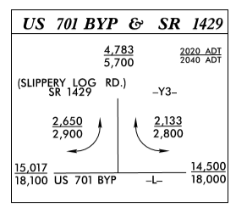

Assume that the let date for this project is 2020. So, we will need the estimated volumes for 2025 (5 years past let):

5,012

2025 Estimated Volumes SR 1429 (Slippery Log Road)

(using linear interpolation)

2,712 2,300

15,788 15,375

US 701 Bypass

Warrant 1 uses the higher volume side street. Since this is a three-leg intersection, the volumes on SR 1429 (Slippery Log Road) are used. Next, the 8th highest daily hour directional volumes are calculated. For the 8th highest daily hour, a 50% split in the volumes is assumed. Do not use the peak hour directional split (D), which may be different. It is assumed that 5% of the volume occurs during the 8th highest daily hour. Again, do **not** use the design hour factor (K) which will likely be higher.

SR 1429 (Slippery Log Road)

68 58

394.5 779 384.5

US 701 Bypass

**Traditional Intersection**

The estimates for the 8th highest daily hour volumes are now compared to the appropriate values in Table 4C-1 of the MUTCD to determine if condition 1A and/or condition 1B are met. In this case, US 701 is being constructed as a 4-lane divided facility. Slippery Log Road will have more than 2 approach lanes. The speed limit will be 45 mph. So, the values in column c (70%) column are used for a major street with two or more lanes and a minor street with two or more lanes.

SR 1429 (Slippery Log Road)

126 (total entering volume)

394.5 779 384.5

US 701 Bypass

The intersection does not meet condition A. However, it does meet condition B. Additionally, the intersection meets the combination of conditions A and B requirement. In this example, the values in column d (56%) are used for the combination requirement since the speed limit is greater than 40 mph.

|  |  |  |  |  |  |  |  |  |  |
| --- | --- | --- | --- | --- | --- | --- | --- | --- | --- |
| **Table 4C-1. Warrant 1, Eight-Hour Vehicular Volume** | | | | | | | | | |
| **Condition A—Minimum Vehicular Volume** | | | | | | | | | |
| **Number of lanes for moving traffic on each approach** | | **Vehicles per hour on major street (total of both approaches)** | | | | **Vehicles per hour on higher-volume minor-street approach (one direction only)** | | | |
| Major Street | Minor Street | 100%a | 80%b | 70%c | 56%d | 100%a | 80%b | 70%c | 56%d |
| 1 | 1 | 500 | 400 | 350 | 280 | 150 | 120 | 105 | 84 |
| 2 or more | 1 | 600 | 480 | 420 | 336 | 150 | 120 | 105 | 84 |
| 2 or more | 2 or more | 600 | 480 | 420 | 336 | 200 | 160 | 140 | 112 |
| 1 | 2 or more | 500 | 400 | 350 | 280 | 200 | 160 | 140 | 112 |
|  |  |  |  |  |  |  |  |  |  |
| empty cell | | | | | | | | | |
| **Condition B—Interruption of Continuous Traffic** | | | | | | | | | |
| **Number of lanes for moving traffic on each approach** | | **Vehicles per hour on major street (total of both approaches)** | | | | **Vehicles per hour on higher-volume minor-street approach (one direction only)** | | | |
| Major Street | Minor Street | 100%a | 80%b | 70%c | 56%d | 100%a | 80%b | 70%c | 56%d |
| 1 | 1 | 750 | 600 | 525 | 420 | 75 | 60 | 53 | 42 |
| 2 or more | 1 | 900 | 720 | 630 | 504 | 75 | 60 | 53 | 42 |
| 2 or more | 2 or more | 900 | 720 | 630 | 504 | 100 | 80 | 70 | 56 |
| 1 | 2 or more | 750 | 600 | 525 | 420 | 100 | 80 | 70 | 56 |

*a Basic minimum hourly volume*

*b Used for combination of Conditions A and B after adequate trial of other remedial measures*

*c May be used when the major-street speed exceeds 40 mph or in an isolated community with a population of less than 10,000*

*d May be used for combination of Conditions A and B after adequate trial of other remedial measures when the major-street speed exceeds 40 mph or in an isolated community with a population of less than 10,000*

Since the estimated 8th highest daily hour meets the minimums defined in Warrant 1, the intersection meets the 8-hour warrant and a signal should be recommended.

**Reduced Conflict Intersection (Superstreet)**

Now using the same example, assume the intersection will be constructed as a reduced conflict intersection (superstreet). This means that there will be left and right turns from the mainline, but only right turns from the side street. In this example the left turns from US 701 onto SR 1429 (Slippery Log Road) and the right turns from SR 1429 (Slippery Log Road) onto US 701 will need to be evaluated for potential signalization.



Assume the same let date for this project (2020) as before. So, we will need the estimated volumes for 2025 (5 years past let):

5,012

2025 Estimated Volumes SR 1429 (Slippery Log Road)

(using linear interpolation)

2,712 2,300

15,788 15,375

US 701 Bypass

For this situation, the peak hour directional splits (D) and design hour volume (DHV) are used to estimate the volumes. Assume for this example that D = 50% and K = 10%.

SR 1429 (Slippery Log Road)

251 (all traffic turns right) 115

789 115 136 654 769

US 701 Bypass

The left turns and right turns at the main intersection as well as the U-turns need to be evaluated for potential signalization. To do this, NCDOT’s *Guidelines for Signalization of Intersections with Two or Three Approaches* is used. Note that the guidelines are intended for left turns, right turns, and U turns crossing or merging with two lanes of conflicting traffic with posted a posted speed limit (or 85th percentile speed) of 45 or 55 mph.

The intersection of US 701 at SR 1429 (Slippery Log Road) will be analyzed first. For this example, assume that there are no upstream signals (isolated). Therefore, it will not be necessary to determine the Conflicting Volume Adjustment Factor (CVAF). The CVAF = 1.0.

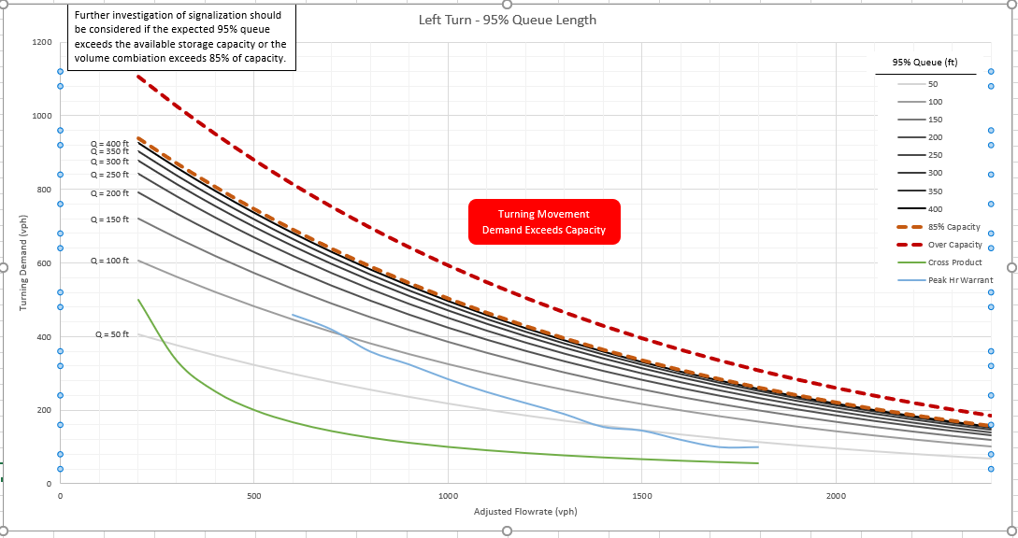

The plotted point on the graph (red dot) indicates that the expected 95th percentile queue length is less than 50 feet, and the left turn is well below capacity. Further investigation of signalization of the left turn should not be considered. Next the right turns at the main intersection are evaluated.

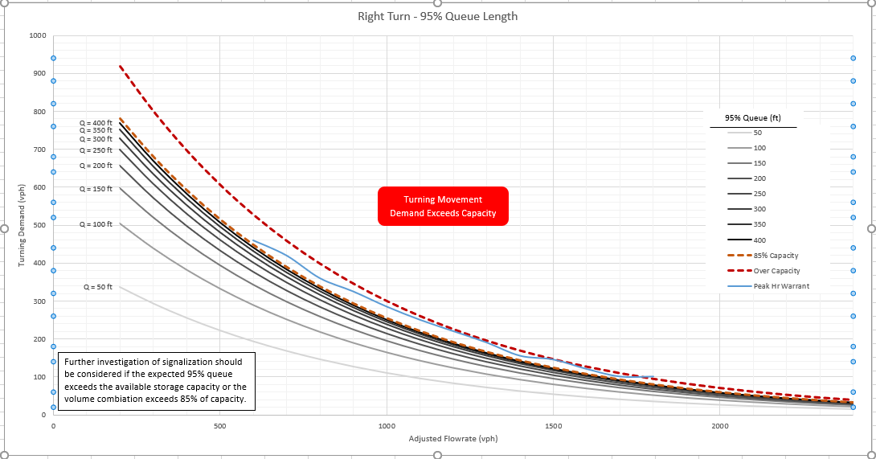

For this example, we will assume that no mainline right turn lane is provided. Both the mainline through vehicles and right turns are considered in conflict with the side street right turns. Drivers on the side street will not be able to determine with certainty whether a vehicle is truly turning until it reaches the intersection. If a mainline right turn lane were present, then only the mainline through vehicles are considered in conflict. The plotted point indicates that a 95th percentile queue length of between 100 and 150 feet is expected. Further investigation of signalization should be considered if the left turn lane is less than 150 feet.

Next the U-turn is investigated. We will assume that there no upstream traffic signal, so the U-turn movement is also analyzed as an isolated location.

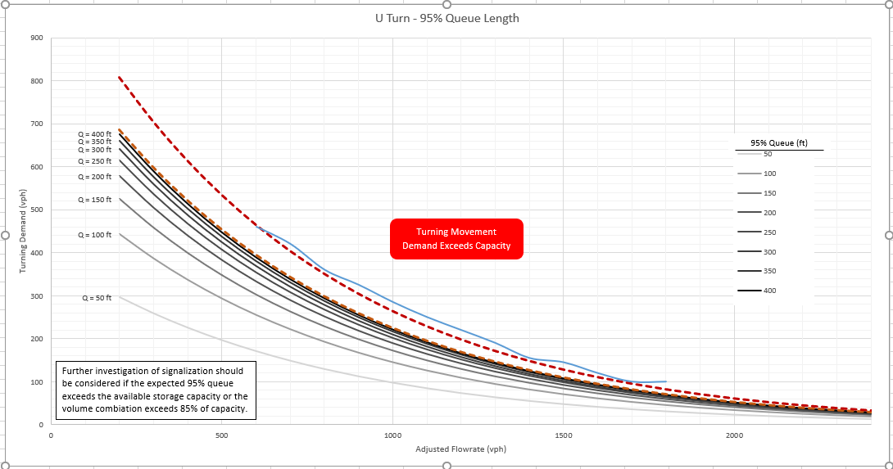

The plotted point indicates that a 95th percentile queue length of less than 50 feet is expected for the U-turn movement. Further investigation of signalization should not be required.

For locations that have an existing upstream traffic signal, a conflicting volume adjustment factor (CVAF) must be determined. That process is explained in detail in the *Guidelines for Signalization with Two or Three Approaches*, beginning on page 27.

Other locations with two or three approaches such as some ramp terminals or one-way streets can also be evaluated using the guidelines.

**Design Hour Factor (K) and Peak Hour Directional Split (D)**

The appropriate values for Design Hour Factor (K) and Peak Hour Directional Split (D) may be provided on the roadway plan sheets for a given project. If not, they can be found in the traffic forecast document. For reference, mean and median values by North Carolina roadway type can be found in the following charts from the *NCLOS Program 2010 Update*:

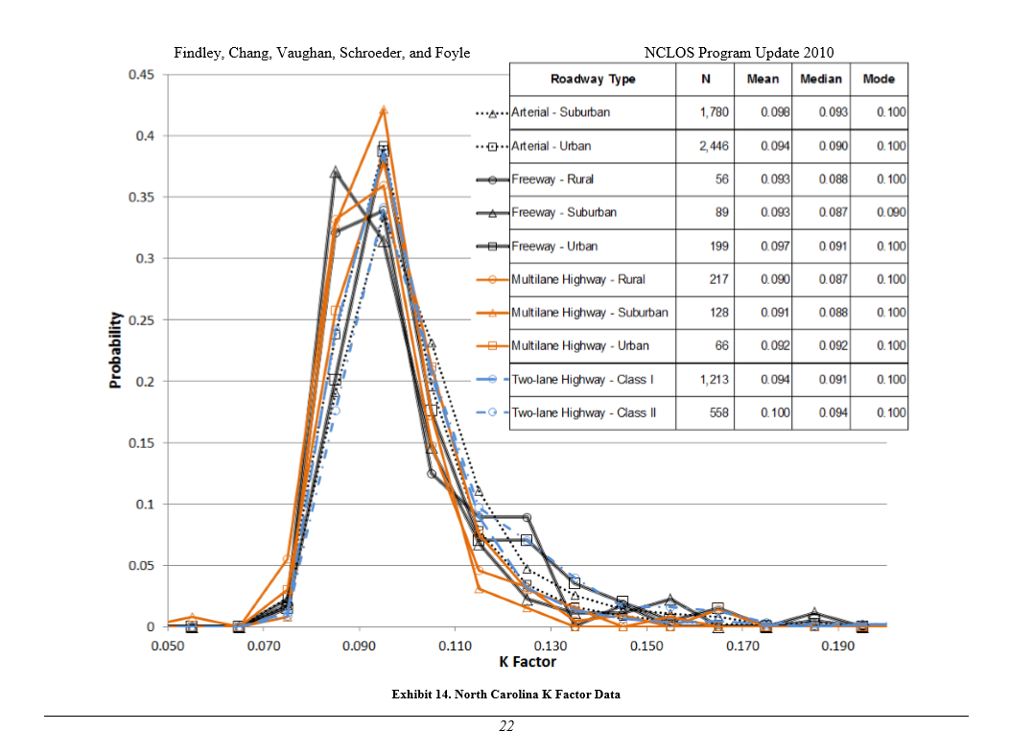

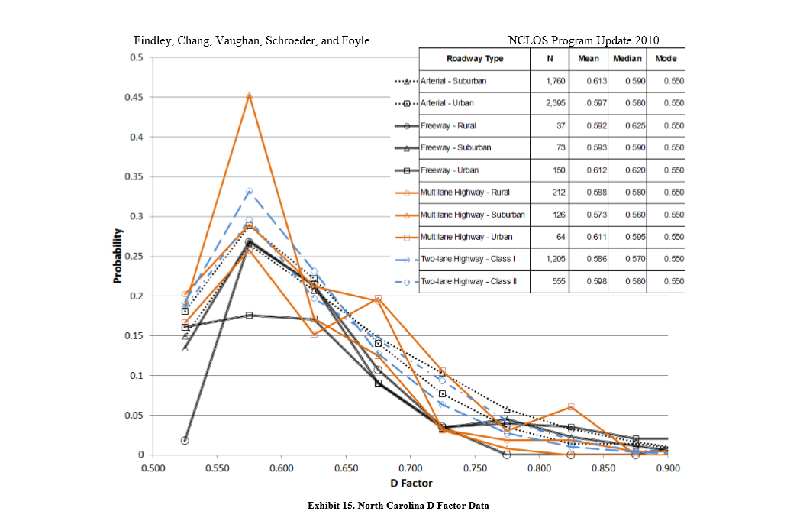

**Signal Spacing**

When recommending traffic signals along a corridor it is important to consider the spacing between signalized intersections. Well-spaced signals promote progression, which reduces delay and crashes. If a review is done early enough in the project development process it may be possible to adjust the location of proposed signalized intersections or driveways to improve progression. If relocation is not feasible, then alternative intersection designs that utilize half signals can be used to improve progression. An example of this is a reduced conflict intersection (superstreet) design. Good signal spacing and progression can also be used to control speeds along a corridor.

The guidance below should be used to evaluate the signal spacing along a corridor. This is taken from the *Best Practices for Driveways* manual by Dr. Joe Hummer:

The spacing between signals is critical in the safe and efficient operation of highway corridors. Signals that are well-spaced promote progression, which is the ability of a driver to make his or her way through two or more signals in a row without stopping. Even with the most modern signal hardware available, progression cannot be established between consecutive signals if they are poorly spaced. Progression means large reductions in delay and travel time, fewer crashes, reductions in harmful emissions, and reduction in fuel consumption. Progression on a main street also creates larger gaps in the traffic stream for minor street and driveway vehicles to use safely, which helps them.

Progression, and therefore signal spacing, matters on main highways when signals are one mile apart or closer. Beyond one mile downstream from a signal, vehicle flows become virtually random. However, within a mile downstream from a signal, vehicles stay relatively bunched together, or platooned, so a second signal if spaced well can take advantage of that and provide green time when the platoon arrives.

There is one important exception to the above paragraph on when signal spacing matters, and that is in the case of “half-signals.” Most signals are “full signals” which turn red for both directions of the main street at some point during the cycle. In contrast, a half-signal is a signal that only turns red for one direction of the main highway; if the main highway is a two-way street, at the half-signal location the second direction is either not signalized or has a separate half-signal. A reduced conflict intersection (superstreet), a one-way street, and a few other specialized street and interchange designs use half-signals. With half-signals, progression can be established at any signal spacing, so the location of half-signals is only constrained by the need to keep new ones out of the functional areas of existing signals.

Two types of progression are feasible through a series of full signals. One type of progression, simultaneous, occurs when two or more signals turn green for the main street at the same time. The second type of progression occurs when the main street green for one signal begins one-half cycle before the start of the green at the next signal; this allows vehicles to drive from one signal to the next in half the cycle. Applying well-known equations for vehicle movement to these two types of progression produces the signal spacing chart in Table b. Knowing the desired speed on the main street, usually the speed limit, and the signal cycle length, one can see the signal spacing limits within which good progression will be possible in both directions on the main street. Cycle length can be approximated even early in project development using about 80 sec for a cycle with two critical phases (no protected left turns), 120 sec for a cycle with three critical phases (a protected left turn on one street), and 150 sec for a cycle with four critical phases (protected left turns on both streets). The chart in Table b is set up for 40 percent two-way progression efficiency, which is a reasonable expectation on North Carolina roadways. The chart also presumes that random flow begins one-half mile downstream of a signal for speeds of 25 or 30 mph, three-quarters of a mile downstream of a signal for speeds of 35 or 40 mph, and one mile downstream of a signal for speeds above 40 mph. Note that in Table b many of the distances that encourage simultaneous progression are very short and a new signal installed that close to an existing signal would likely fall within the functional area of the existing signal.

Progression and signal spacing can also help control speeds. Most drivers would prefer to keep moving through several nearby signals on green at a steady pace, even if below their desired free-flow speed, rather than accelerating to free-flow speed and then stopping at red at each signal. Progression speeds with wide bands set below the free-flow speed but at the speed that the residents, businesses, pedestrians, police, or local politicians would prefer could be a great compromise in a contentious project development process. Speed control through progression is easier with half-signals, but in rare cases can be arranged with full signals at the right spacing.

Table b. Signal spacing guidance based on progression through full signals.



**Pedestrian Signal Heads and Marked Crosswalks**

If sidewalk exists, pedestrian signal heads and crosswalks should be installed. Recommendations for pedestrian accommodations at new or existing signals warranted based on vehicular traffic should be included in the traffic signal memorandum. The decision to install marked crosswalks and pedestrian signal heads at a signalized location should follow the process in the *NCDOT Pedestrian Crossing Treatment Evaluation Guidance* flowchart. The chart requires that an ADA compliant path be present or planned and follows the standard in section 4E.03 *Application of Pedestrian* Signal *Heads* in the *MUTCD*:

**Section 4E.03 Application of Pedestrian Signal Heads**

**Standard:**  
01 **Pedestrian signal heads shall be used in conjunction with vehicular traffic control signals under any of the following conditions:**

1. **If a traffic control signal is justified by an engineering study and meets either Warrant 4, Pedestrian Volume or Warrant 5, School Crossing (see** [**Chapter 4C**](https://mutcd.fhwa.dot.gov/htm/2009/part4/part4c.htm)**);**
2. **If an exclusive signal phase is provided or made available for pedestrian movements in one or more directions, with all conflicting vehicular movements being stopped;**
3. **At an established school crossing at any signalized location; or**
4. **Where engineering judgment determines that multi-phase signal indications (as with split-phase timing) would tend to confuse or cause conflicts with pedestrians using a crosswalk guided only by vehicular signal indications.**

*Guidance:*  
02 *Pedestrian signal heads should be used under any of the following conditions:*

1. *If it is necessary to assist pedestrians in deciding when to begin crossing the roadway in the chosen direction or if engineering judgment determines that pedestrian signal heads are justified to minimize vehicle-pedestrian conflicts;*
2. *If pedestrians are permitted to cross a portion of a street, such as to or from a median of sufficient width for pedestrians to wait, during a particular interval but are not permitted to cross the remainder of the street during any part of the same interval; and/or*
3. *If no vehicular signal indications are visible to pedestrians, or if the vehicular signal indications that are visible to pedestrians starting a crossing provide insufficient guidance for them to decide when to begin crossing the roadway in the chosen direction, such as on one-way streets, at T-intersections, or at multi-phase signal operations.*

Option:  
03 Pedestrian signal heads may be used under other conditions based on engineering judgment.

Beyond the standards in section 4E.03, the chart recommends that pedestrian signal heads and crosswalks should be considered at locations with *high* estimated pedestrian volumes. Judgement must be used to determine the appropriate values for low or high pedestrian volume. The guidance recommends the following for consideration (see page 11):

* Does the crossing have more or less than 25 pedestrians per pedestrian peak hour OR more or less than 100 pedestrians per day?
* Is the crossing area near high pedestrian trip generators?
* Does the crossing area connect complementary land uses?

The guidance also recommends that a lower threshold be considered based on the presence of a special population, such as children or the elderly.

Pedestrian volume data may not be available. It may be necessary to collect pedestrian data independently through the NCDOT count program (or other sources) and/or make estimations based upon the expected land uses and socioeconomic conditions and apply good engineering judgement.

The guidance indicates that no action is **required** when the estimated pedestrian activity is low. However, if an ADA compliant path is present or planned, there should be a careful evaluation of whether marked crosswalks and pedestrian signal heads **should** be installed. Refer to the *guidance* in Section 4E.03 of the MUTCD.

**Pedestrian Traffic Signals, Hybrid Beacons and Rectangular Rapid Flashing Beacons**

The need for pedestrian facilities should be evaluated as part of the traffic signal recommendation process. Mid-block locations and intersections that do not meet vehicle traffic warrants may require crosswalks and supplemental traffic control devices to accommodate existing or expected pedestrian crossing activity. Factors that should be considered include expected pedestrian and vehicular volume, roadway cross section (crossing distance), geometric features, vehicle speeds, and pedestrian crash history. When feasible, land use and socioeconomic conditions should be considered. For example, the presence of neighborhoods, schools, apartment complexes, public housing, transit, greenways or multi-use pathways, and large event centers such as arenas or civic centers will generate pedestrian activity. Socioeconomic factors such as household income and the percentage of zero car households can be used to gauge pedestrian demand.

The use of pedestrian hybrid beacons at crossings that are near side streets or driveways that are controlled by stop or yield signs requires special consideration. The MUTCD states that the PHB should be installed at least 100 feet from these types of intersections. An assessment should be made to determine if the pedestrian and motor vehicle traffic would be better served by a traditional signal at the intersection.

Potential crossing locations should be evaluated using the *North Carolina Pedestrian Crossing Guidance* and the associated crosswalk assessment flowchart tool.

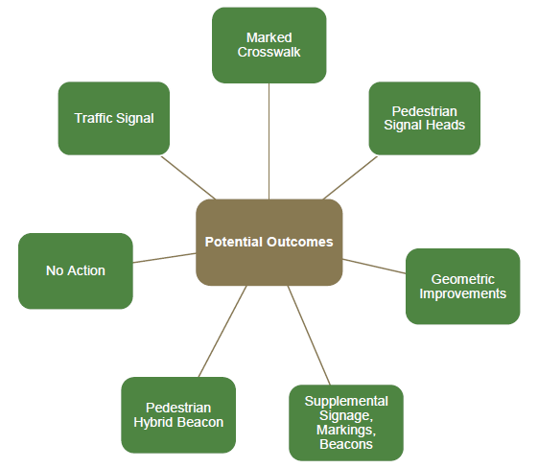

The crossing guidance compares existing conditions to requirements in the MUTCD sections *4C.05 Warrant 4, Pedestrian Volume*, *4C.06 Warrant 5, School Crossing*, and *4F.01 Application of Pedestrian Hybrid Beacons*.

Data needed for the crossing assessment includes (from page 7 of the guidance):

* Distance to adjacent crossing
* Vehicle Traffic Volume
* Speed limit and/or operating speed
* Pedestrian volume
* Number of lanes and/or crossing distance
* Total pedestrian delay

Pedestrian volume and delay data are typically not available for TIP projects. It may be necessary to collect pedestrian data independently through the NCDOT count program and/or make estimations based upon the expected land uses and socioeconomic conditions described above and apply good engineering judgement.

Recommendations for independent pedestrian crossings should be included in the signal recommendation memorandum.

**Traffic Signals and Safety**

When considering signalization, engineers should consider what feasible options are available that would produce fewer crashes on average. Table c shows signal-related crash modification factor (CMF) values. A CMF is the ratio of the estimated crash frequency after an intervention to the crash frequency before the intervention. A CMF below one thus means the intervention helped. The values in Table c are from a website called the “Crash Modification Factors Clearinghouse” maintained for the FHWA by the University of North Carolina Highway Safety Research Center (HSRC). The Clearinghouse contains thousands of CMFs for many countermeasures. The safety researchers at the HSRC have rated the quality of each of the studies in the Clearinghouse on a scale of zero stars (poor or unknown quality, result should not be trusted) to five stars (excellent quality, trustworthy result); Table c shows averages of all of the signal-related studies in the Clearinghouse that rated at three stars or better. References for each value in Table c are contained in a paper posted on TEPPL at: <https://connect.ncdot.gov/resources/safety/teppl/_layouts/15/osssearchresults.aspx?u=https://connect.ncdot.gov/resources/safety/teppl&k=s86>.

Table c. Signal-related CMF values.

|  |  |  |  |
| --- | --- | --- | --- |
| Changing from… | Changing to… | All crashes | Injury crashes |
| Two-way stop control | Conventional signal | 0.81 | 0.74 |
| All-way stop control | 0.32 | 0.28 |
| One-lane roundabout | 0.51 | 0.16 |
| Unsignalized RCI | 0.58 | 0.42 |
| Conventional signal | One-lane roundabout | 0.74 | 0.45 |
| Two-lane roundabout | 0.89 | 0.54 |
| Signalized RCI | 0.85 | 0.78 |

The top row of Table c shows that changing from two-way stop control to a conventional traffic signal saves an average of 19 percent of all crashes and 26 percent of injury crashes at the intersection. However, Table c also shows that changing from two-way stop control to all-way stop control, to a one-lane roundabout, or to an unsignalized RCI would save considerably more overall crashes and injury crashes on average. The lower portion of Table c shows likewise that replacing a conventional signal with a one-lane roundabout, a two-lane roundabout, or a signalized RCI would reduce overall crashes and injury crashes.

**G. REQUIREMENTS**

A signal recommendation memorandum should be provided by the appropriate Regional Traffic Engineer for all NCDOT Transportation Improvement Program projects where new traffic signals are being considered and/or existing signals are being modified. The contents of the memorandum should include locations of new and revised traffic signals as well as the following:

* TIP Project Number
* WBS
* County
* Description
* Project Design Speed
* Recommended Future Speed Limit
* Distance to Adjacent Signalized Intersections off Project
* Existing System and Type of Equipment Used
* Type of Poles
* Recommendation for Interconnection to an Existing System
* Special Requests such as Pedestrian Accommodations, Out of Street Detection or Others
* Any Additional Comments

Please refer to the TIP signal recommendations template. The memorandum should be sent to the Regional Signal Design Engineer with a copy to the following:

* Division Engineer
* Division Traffic Engineer
* Division Construction Engineer
* Division Project Engineer
* Signing and Delineation Regional Engineer
* Congestion Management Regional Engineer
* Work Zone Traffic Control Regional Engineer
* Senior Project Manager
* Project Manager

Traffic signals should not be recommended based solely on the traffic capacity analysis alone and should not be shown on hearing maps unless a recommendation following this standard practice has been made. The capacity analysis and other factors such as bicycle and pedestrian activity, geometric conditions, crash history, expected delay, left turn cross product, and peak hour volumes should be considered in applying good engineering judgement when making these recommendations.