# Emergency Traffic Control

*Emergency Traffic Control is a traffic control strategy used by NCDOT for an immediate response to unplanned events. It is intended to be deployed quickly with the expectation that it will be transitioned to proper temporary traffic control as defined in the Manual on Uniform Traffic Control Devices (MUTCD) Chapter 6. It is important to understand when and where emergency traffic control can be used and what role NCDOT has when implementing.*

**Purpose:**

Understand when Emergency Traffic Control is necessary

Understand the difference between Emergency Traffic Control and Temporary Traffic Control

Understand when to transition from Emergency Traffic Control to Temporary Traffic Control

## Overview

Incident types can require a variation of responses, which necessitate a range of traffic control strategies. Unplanned incidents (i.e. crash, debris in the roadway) require a quick response to mitigate the possibility of secondary crashes, expedite clearing of the incident, and minimize the overall threat and impact to traffic. Unplanned incidents can vary greatly in duration based on their severity and this duration directly correlates to the decision around the appropriate traffic control strategy applied. Most incidents require the immediate implementation of emergency traffic control (*referred to as* ETC) to protect emergency responders on the scene and provide guidance to motorist. ETC is often appropriate for incidents with a short duration; however, when ETC has been implemented and the incident duration is expected to be extended, it is necessary to transition from ETC to temporary traffic control (*referred to as* TTC).

Important:

Emergency Traffic Control *is referred to as* **ETC**

Temporary Traffic Control *is referred to as* **TTC**

The quantity and scale of traffic control equipment necessary to deploy proper TTC, as defined in Chapter 6 of the Manual on Uniform Traffic Control Devices (MUTCD) and the NCDOT Roadway Standard Drawings, can be impractical for unplanned incidents with shorter durations. In addition, equipment needs of TTC exceed the capabilities and resources of those who are often first to respond to an incident (i.e. law enforcement, fire, or NCDOT Incident Management Assistance Patrol (IMAP). NCDOT has defined ETC applications based on the principles of the MUTCD but using the quantity of traffic control devices readily available to an IMAP responder. The ability to quickly implement the ETC improves the safety of on-scene management during a shorter incident or during the initial phase of a longer duration incident, until TTC can be deployed.

## Traffic Control Methods – Temporary Traffic Control and Emergency Traffic Control

Temporary Traffic Control (TTC) is the deployment of traffic control devices to delineate a temporary work area (zone). TTC is used for planned events or longer duration incidents to maintain the flow of traffic and provide safety to workers. TTC, as defined within Chapter 6 of the MUTCD, includes the use of advance warning, defined tapers and buffers using cones or drums, and signs to direct motorists. It is the required traffic control treatment for safely and effectively managing traffic patterns through planned construction and maintenance activities or for an extended duration incident.

Emergency Traffic Control (ETC) is the deployment of a smaller footprint of traffic control devices. Like TTC, ETC is intended to improve the flow of traffic around the scene while providing protection to the scene and incident responders. It can be deployed quickly with devices that are immediately available on IMAP responder vehicles. TTC requires coordination, planning, and resources that are not practical for an emergency response. ETC allows incident responders to quickly mitigate risks introduced by an incident. Lastly, ETC shall never be used for planned work zone activities or planned events.

## Roles and Responsibilities

In Divisions where IMAP is present, IMAP responders may be the first to arrive on scene, assess the incident, and establish the necessary traffic control. IMAP responders are equipped with the resources and training to implement emergency traffic control (ETC). In Divisions without IMAP, Maintenance and Traffic Services personnel typically have the primary responsibility for deploying traffic control devices. If conditions permit, and staff have successfully completed ETC training, Maintenance and Traffic Services personnel can deploy ETC.

### Divisions with IMAP

#### IMAP Responders Role

IMAP responders are responsible for the following roles relative to emergency traffic control (ETC):

* Assess incident scene needs to determine initial traffic control strategy
* Establish ETC in accordance with protocols defined within the **IMAP Field Training Manual for Drivers** to promote safety of the scene, responders, and drivers near the incident
* Continuously reassess the incident scene needs and adjust ETC accordingly and in coordination with other responders, including accommodations for towing/recovery
* Coordinate with IME/CME/Traffic Services if the ETC needs to be transitioned to TTC
* Support IME/CME/Traffic Services with TTC implementation

#### Incident Management Engineer Role

In Divisions with IMAP resources, properly trained Incident Management Engineers (IME’s) have the following responsibilities relative to emergency traffic control (ETC) when they arrive on scene.

**If IMAP is On-Scene upon arrival:**

* Assess the ETC implementation as they approach the incident scene; coordinate with IMAP, and rectify any issues observed once on scene
* Coordinate with the Incident Commander (IC) regarding the anticipated duration of the incident
* If needed, coordinate with other NCDOT staff to transition the ETC to TTC

**If IMAP is not On-Scene upon arrival:**

* Assess incident scene needs to determine initial traffic control strategy
* Coordinate with IMAP to establish ETC in accordance with protocols defined within the **IMAP Field Training Manual for Drivers** to promote safety of the scene, responders, and drivers near the incident
* Coordinate with the IC regarding the anticipated duration of the incident
* If needed, coordinate with other NCDOT staff to transition the ETC to TTC

### Divisions without IMAP

In Divisions that do NOT have IMAP resources, the following are typical responses.

#### Incident Management Engineer Role

Only properly trained Incident Management Engineers (IME’s) would implement emergency traffic control (ETC) with the following responsibilities.

* Assess incident scene needs to determine initial traffic control strategy
* Coordinate with NCDOT staff to establish ETC in accordance with protocols defined within the **IMAP Field Training Manual for Drivers** to promote safety of the scene, responders, and drivers near the incident
* Coordinate with the IC regarding the anticipated duration of the incident
* If needed, coordinate with other NCDOT staff to transition the ETC to TTC

If the Incident Management Engineer has not been trained, they should not implement ETC; rather they should coordinate with the IC and other on-scene personnel to implement TTC.

#### Maintenance and Traffic Services Role

Typically, Maintenance/Traffic Services personnel are not immediately on scene after an incident occurs. ETC would be deployed by on-scene law enforcement or fire. If it is determined the incident clearance will be extended, law enforcement or the Incident Command (IC) will contact NCDOT for Maintenance/Traffic Services to implement on-scene TTC.

On rare instances, Maintenance/Traffic Services personnel may arrive on scene immediately after an incident occurs. In these cases, Maintenance/Traffic Services should coordinate with the IC regarding the anticipated duration of the incident. If it is concluded TTC is needed, Maintenance/Traffic Services can coordinate to implement TTC. When ETC is needed, only those properly trained to deploy ETC should implement.

## Emergency Traffic Control Considerations

There are several factors that should be considered during the implementation and monitoring of ETC. In all cases, safety is paramount in establishing traffic control that directs motorists and protects the scene. Effective set-up will protect the incident scene while also supporting better mobility of the existing traffic. Mitigating impacts to traffic flow through the incident scene helps to reduce the likelihood of secondary crashes.

### Regional Differences

In certain scenarios, IMAP has been trained on how ETC can be adjusted to accommodate local conditions, such as variations in geography and different roadway cross-sections. This example scenario demonstrates how an ETC implementation can vary between an urban and rural area for a crash in the center lane. IMAP should refer to the **IMAP Field Training Manual for Drivers** for proper set up in either of the cases noted below.

**Urban Area** – Since congestion levels are typically higher and speeds are lower, it may be possible for an IMAP responder to close a center lane and allow traffic to pass on either side of the incident.

**Rural Area** – Since congestion levels are often lower and speeds are higher, it may be too dangerous to apply the same center lane closure and allow traffic to pass on both sides of an incident. Instead, all lanes from the shoulder to the blocked lane should be closed to more safely manage the impact to traffic.

Terrain and topography of the incident location can also influence the application of ETC. Sight distance in the mountains can be limited due to hills or curves. In these scenarios, the necessary ETC may be a variation of typical ETC. The variation is likely to include longer tapers and additional warning signs in order to provide an appropriate level of safety. IMAP responders should be fully aware of the acceptable flexibility and safety needs based on the on-scene conditions.

### Extending Lane Closures when Speeds Increase

The **IMAP Field Training Manual for Drivers** provides guidance for standard configuration and ETC set-up. The MUTCD formula is intended to calculate a taper length for TTC, but for ETC implementation the full taper length includes both a buffer area and a taper area. Since IMAP vehicles are not equipped with crash attenuators, this delineation is provided to shift over oncoming traffic sooner and provide a buffer area to the IMAP vehicle/responder.

ETC guidelines should be deployed based on the observed conditions upon on-scene arrival (e.g. speed, volume of traffic, roadway geometrics, etc.). Standard ETC configuration is applicable if vehicle speeds through the incident area are below 40 mph. As conditions change and speeds begin to increase, the ETC should be modified to accommodate the higher speeds and maintain the safety of the of roadway.

When traffic speeds increase above 40 mph and begin to approach the posted speed limit, the length of the lane closure needs to be extended to provide a greater transition and buffer area. For speeds above 40 mph, the ETC guidance is based on a set speed of 60 mph. While speeds may sometimes exceed this limit, responders equipped for ETC, do not typically have access to resources that would support tapers or buffers defined for TTC.

The formula for calculating the taper length when speeds are over 40 mph is as follows:

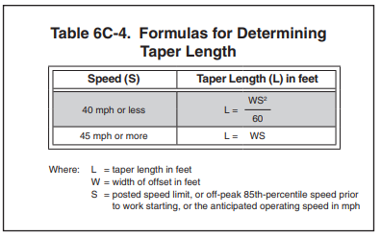

Figure 1. Formulas for Determining Taper Length (source: MUTCD Table 6C-4)

### Closing the Shoulder

When setting up the initial ETC for a single or multiple lane closure and traffic speeds are less than 40 mph, the shoulder is not to be closed for the following reasons:

1. To allow scene access for additional responders that may arrive on-scene
2. To allow the IMAP vehicle’s flashing arrow panel (FAP) to be easily visible to motorists
3. To potentially use the shoulder to move traffic around the incident.

If speeds increase above 40 mph, it is important to close the shoulder with the assumption that all responders are on-scene and the shoulder is no longer being used to access the incident or to move traffic.

## Transitioning from Emergency Traffic Control to Temporary Traffic Control

During the timeline of the incident, it is important to continually monitor both the incident scene and the traffic impacted. Some conditions warrant the need to transition the initially deployed ETC to a TTC implementation to provide enhanced safety and better traffic flow. If responders anticipate the incident timeline will extend longer than 2 hours, a transition to TTC would be appropriate. Secondly, revisions to the ETC should be assessed based on the prevailing **speed** in the vicinity of the incident. If speeds increase and become higher than 40 mph, the ETC should be adjusted to TTC to enhance the safety of both the responders and motorists.

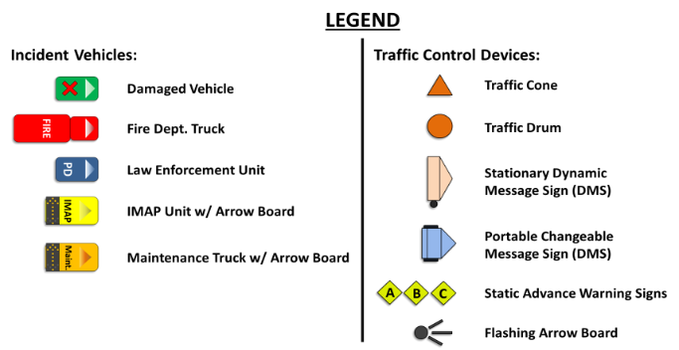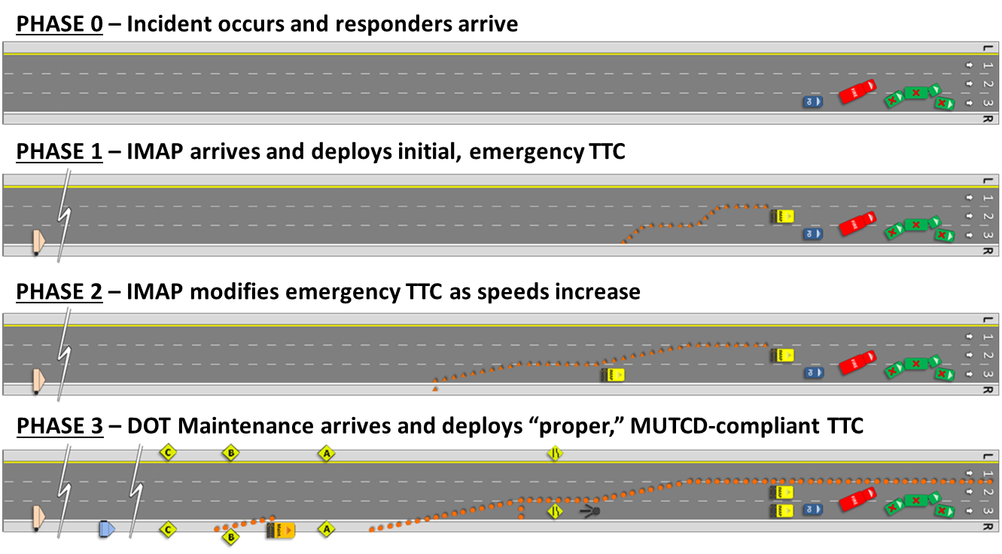

**PHASE 3 – DOT Maintenance arrives and deploys “proper” MUTCD-compliant TTC**

**PHASE 0 – Incident occurs and responders arrive**

**PHASE 1 – IMAP arrives and deploys initial ETC**

**PHASE 2 – IMAP modifies ETC as speeds increase**

Figure 2. Transition of an ETC to TTC (source: NCDOT Training Materials)

Since IMAP responders are not equipped with enough devices and signs to install a proper TTC, the Maintenance/Traffic Services would be asked to provide the appropriate equipment and set-up. However, this process takes time (*notification, mobilization, and installation*); therefore, IMAP responders should be continuously assessing the situation to determine if the durations anticipated to exceed the 2-hour threshold. If so, the IMAP responder and Maintenance/Traffic Services should take steps to establish the proper TTC as soon as possible, not waiting until the 2-hour threshold has been reached to initiate this process.