Queue Management for Incidents

*Queue management is utilizing proactive strategies to manage existing queues and to prevent or minimize additional traffic queues from forming on the roadway and. Some strategies include advance warning on dynamic message signs (DMS), using Incident Management Assistance Patrol (IMAP) for minor incidents, rerouting or detouring traffic at locations upstream of an incident location, and quick clearance strategies.*

**Purpose:**

Understand the causes of queue formation and identify queue elements

Understand how queue management relates to Emergency Traffic Control and Quick Clearance Strategies

Understand the channels of communication necessary for effective queue management

A **queue** (or congestion) is a grouping of stopped or slow-moving vehicles whose normal traveling speed is limited by peak travel periods, planned events, or unplanned events. Queues are caused when the **traffic volume** (the number of vehicles on a roadway) exceeds the **roadway capacity** (the maximum number of vehicles a roadway is designed to handle).

# Overview

Queue management **refers** to the coordinated efforts of NCDOT and other emergency responders to limit the overall impact of an incident by preventing queues from forming, decreasing queues once formed, and using appropriate traffic control to keep traffic flowing safely.

The **purpose** of queue management is to reduce secondary crashes, provide a safer work area for first responders, and facilitate the movement of traffic past an incident. One of the primary tools for queue management is traffic control; however, queue management extends beyond simply deploying emergency traffic control (ETC) or temporary traffic control (TTC) measures outlined in the ***Emergency Traffic Control*** chapter. Queue management requires adjusting traffic control measures in response to changing queue lengths, traffic speeds, and motorist reactions in addition to continual monitoring of traffic control efficacy by Incident Management Assistant Patrol (IMAP) responders, transportation management center (TMC) operators, incident management engineer (IME), and county maintenance engineer (CME). For non-incident situations or long duration incidents, refer to the Roadway Standard Drawings for proper set-up of Advance warning and traffic control.

During an incident, the queue length may increase over time. As the incident duration increases, secondary crashes are more likely to occur. Research supports that secondary crashes can be more severe and fatal than the initial incident. Therefore, effective queue management strategies increase safety for motorists passing by the incident, as well as on-scene first responders working to clear the roadway.

This section will provide a common language for queue characteristics to facilitate communication between IMAP responders, TMC operators, IME/CME/traffic services, and first responders, identify the tools available, outline common strategies to decrease volume and increase capacity, and provide guidance for partner agencies.

# Queue Identification

A traffic queue forms from various reasons such as when traffic slows or stops due to an incident, roadway geometry (bottlenecks, horizontal and vertical curves), weather, and even motorist behavior (i.e., (on-lookers”). The ability to identify different characteristics of a queue is necessary for recognizing secondary crash hot spots, setting up traffic control, assessing the effectiveness of traffic control, and placing advanced warning in the appropriate location. In addition, being able to communicate queue characteristics to the TMC operator is necessary for effective dynamic message signs (DMS) messages and establishing alternate routes.

## Queue Theory

From the 2009 FHWA’s *Focus States Initiative: Traffic Incident Management Performance Measures Final Report* **secondary crashes** is defined as "Unplanned incidents (starting at the time of detection) for which a response or intervention is taken, where a collision occurs either a) within the incident scene or b) within the queue (which could include the opposite direction) resulting from the original incidents."

The study of queue theory or ‘queuing’ is studying the behavior of traffic at a location where demand exceeds available capacity. When there is poor management of the queue, the result can be congestion or ‘gridlock’ conditions. This in turn increases time delay and decreases highway performance.

There is a direct correlation between the incident clearance time and the length of queue – the longer a lane blocking incident stays in the roadway, the longer the resulting queue. This makes the duration of an incident a critical factor in how responding agencies manage the queue and deploy of proper strategies. There is a need for strategies at the incident itself to ensure on‑scene safety while also deploying strategies prior to and at the end of the queue to minimize the likelihood of secondary crashes.

If there is a short queue, motorists approaching the scene may see the incident and take appropriate measures. If there is a longer queue, especially along rural interstates, motorists may be surprised by the stopped traffic or the slowing of traffic. Motorists not expecting the stopped traffic are then required to perform defensive maneuvers, such as sudden braking, which can increase the likelihood of secondary crashes.

### Performance Changes due to Queuing during an Incident

Congestion resulting from incidents can severely reduce the transportation network performance. Proper monitoring of traffic conditions is the first step to building an effective queue management approach. Performance metrics for queue management exist, both for TMC and IMAP operations, to quantify the impacts on quicker incident notification, verification, dispatch, and lane clearance. These personnel, along with IME/CME and first responders, must work continually and collectively to not only safely reduce incident duration time, but mitigate prolonged queue development. Performance of the roadway is directly proportional to performance of those both monitoring and on site at the incident. All must be properly trained and meet required performance metrics and objectives, especially during an incident, to prolong roadway service life.

## Queue Elements

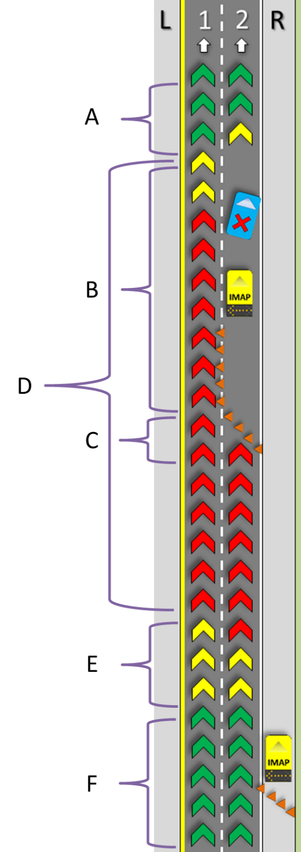**A.** **Front of Queue**

* Downstream of the incident
* Vehicles may collide as traffic returns to normal speeds
* Downstream buffer and taper may help to mitigate secondary crashes

**B.** **Activity Area**

* Within the queue, beginning after the transition area and typically ending at the incident when traffic begins to return to normal speeds
* Can be volatile area as motorists may be abruptly braking in the vicinity of the incident

**C.** **Transition Area**

* Transition length is determined by traffic speed (ex. 120-foot taper for 40 mph or less)
* Bottlenecks may occur if traffic control tapers are not placed properly, and vehicles may collide with traffic control measures if traffic control is not visible in time

**D.** **Queue**

* Main body of congestion
* Motorists often drive erratically in stop-and-go traffic

**E. End of Queue**

* Upstream of the incident where traffic speeds decrease significantly as vehicles enter the queue
* Hot spot for secondary crashes due to sudden unexpected change in traffic speeds

**F. Before Queue**

* Traffic speeds are normal
* Advanced Warning (AW) should be placed here
* AW must be adjusted to stay before End of Queue

Figure Queue Elements

**Queue length** is measured as the distance from the Front of Queue (A) to End of Queue (E)

**Traffic Speed** is the speed of traffic traveling through the Activity Area (B)

# Queue Management Applications and Strategies

Queue management strategies should be focused on increasing capacity, decreasing volume, and preventing secondary crashes.

The most effective solution to increasing the capacity of the route is to clear the incident and restore traffic to all available lanes. The **Quick Clearance** chapter outlines the laws and policies that facilitate clearing roads quickly and safely.

Properly deployed traffic control supports queue management by giving responders room to clear lanes quickly and safely, guiding vehicles around incidents, diverting excess volume to alternate routes, and increasing capacity by creating temporary travel lanes.

The tools, data, and strategies outlined below work to meet the goals of decreasing volume, increasing capacity, and prioritizing safety.

## Traffic Control Applications for Queue Management

* **Cones:** Used to set up a lane closure taper, a temporary travel lane, or divert traffic to a Return Access Detour. Cones should not be used as an end of queue strategy unless in combination with IMAP and/or portable CMS.
* **Flashing Arrow Panels:** These devices provide higher visibility in advance of a lane closure so that motorists can plan ahead for their merge. This advanced warning can decrease the volatility of the traffic and minimize unnecessary fluctuations in the queue development. These devices are installed on IMAP trucks and can be deployed at the most critical locations of the incident. If additional IMAP vehicles arrive on-scene, they can be placed near the end of queue for better advanced warning.
* **Changeable Message Signs (CMS):** Portable CMS are used to support traffic control during significant incidents with a longer duration. CMS allow agencies to provide advanced warning messages and additional context of downstream traffic conditions. They can also be placed at critical locations to help guide motorists along a designated detour route.
* **Dynamic Message Signs (DMS):** Fixed DMS can be utilized by TMC operators to provide motorists with advanced warning about lane closures, travel times, and alternate routes.
* **CCTV Cameras:** TMC operators should utilize CCTV cameras in the vicinity of the incident to monitor traffic speeds and queue length to communicate with IMAP responders and Incident Commanders about queue characteristics. Additional incident-monitoring options being explored by NCDOT include portable CCTV cameras, including pole-mounted cameras or tethered unmanned aerial vehicles (UAV).
* **Drones**: During large incidents, the TMC can coordinate with North Carolina State Highway Patrol (NCSHP) to request their drone team to be onsite and provide additional situational awareness to the TMC. This is especially true in locations with minimal CCTV camera coverage.
* **HAWKS:** The HAWKS (Helping All Work Zones Keep Safe) Program uses off-duty NCSHP to increase enforcement in high-risk work zones. This additional enforcement increases compliance with speed limits and other laws within these work zones; decreases the response time of first responders if there is a crash or incident; and their presence can normalize traffic conditions in the transition and work area, thereby minimizing the queue volatility.

## Data Applications to Support Queue Management

* **TIMS:** The Traveler Information Management System (TIMS) is a backend data warehouse that provides real-time traffic information to the traveling public (through DriveNC.gov), media, and to third party navigation companies. TMC operators enter in incidents when they are reported, thus alerting motorists using navigation tools about the upcoming incident and provide faster alternative routes. The data functions both as advance warning for motorists and provides alternate routes to decrease the volume passing the incident.
* **Probe Data:** Probe data displayed on the heat maps provides the TMC operators with real time congestion information. Operators utilize the heat maps as an indication of queue length, especially in areas with limited or no CCTV camera coverage. Operators may dispatch an IMAP responder to confirm back of queue in applicable areas – to confirm congestion or incident.
* **Smart Work Zone Sensor Data**: Congestion data within and approaching work zones is collected in real time and messaged to motorists to warn about possible stopped traffic and queueing. TMC operators can use this data to confirm real time congestion impacts from those work zones and place messages on DMS based on the magnitude of the queueing and anticipated impacts.

## Strategies for Queue Management during Incidents

### Reassess Traffic Control Measures

* Watch for vehicles suddenly stopping or swerving as approaching traffic control or attempting to bypass traffic control by driving on the shoulder.
* Refine signage or traffic control based on observed conditions.

### Utilize Advanced Warning

* DMS should be used as appropriate based on their location relative to the End of Queue.
* Effective Advance Warning should be at least 1.5 miles from the Transition Area. Depending on the severity of the incident and/or anticipated duration of the event, DMS should be utilized on all upstream feeder roadways to facilitate motorist re-routing and queue avoidance.
* Portable CMS also can be used to provide advance warning, especially during incidents that have longer durations.

### Alternate Routes

* Divisions have pre-planned alternate routes that can be used to detour traffic around an incident. The routes should be updated as needed.
* IMAP should coordinate with the TMC on when to implement an alternate route based on queue length, time of day, number of lanes closed, and incident type.
* The TMC should utilize DMS, CMS, DriveNC.gov, and media to communicate alternate route to motorists.
* Traffic control can be used to divert traffic to an alternate route *only* if the route is a Return Access Detour.

### Temporary Travel Lanes during incidents

* Traffic can be diverted onto paved shoulders as space permits.
* Narrow shoulders can be combined with an available travel lane to create additional capacity.
* Tapers (see Cones, 3.1) must be utilized to shift traffic in and out of temporary lanes and the lanes must be separated with a buffer.

### On-Ramp Closures

* On-Ramp Closures prevent additional traffic from entering the roadway and further increasing the queue length.
* 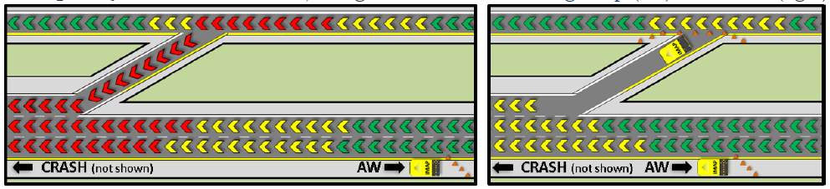Closed ramps provide additional access to emergency responders.

Figure 2. On-Ramp Closure Configuration (Source: IMAP Field Training Manual)

### Return Access Detour

* For use when all or most of the travel lanes are blocked between the exit and entrance ramps of the same exit where the exit has return access to the roadway.
* Traffic control may be used to redirect traffic to the off ramp.
* Law enforcement and IMAP can provide traffic control at interchanges to improve traffic flow.

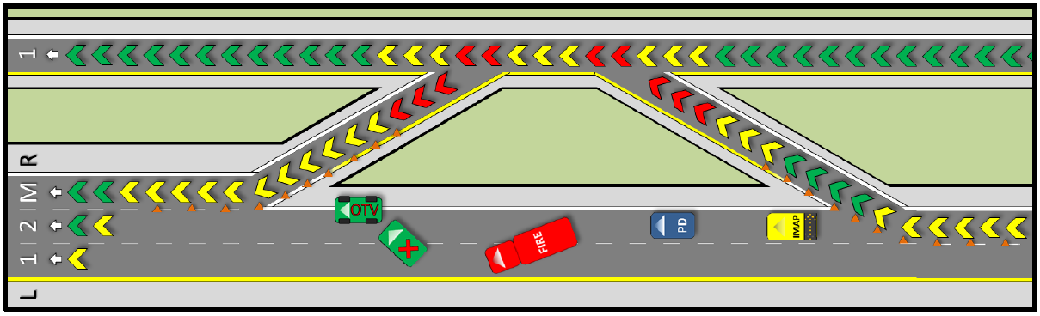

Figure 3. Return Access Detour Configuration (Source: IMAP Field Training Manual)

## Training to Support Queue Management

**SHRP2**

The Second Strategic Highway Research Program (SHRP2) (2006-2015) was created as a partnership to find strategic solutions for improving highway safety, reducing congestion, and improving methods for renewing roads and bridges. One of the SHRP2 trainings includes the Federal Highway Administration’s (FHWA) Every Day Counts initiative (<https://www.fhwa.dot.gov/innovation/everydaycounts/>) which provides national traffic incident management (TIM) training. The TIM training provides an opportunity for all emergency responder agencies to learn together using the same language.

**Field Training Manual for IMAP Responders**

The Field Training Manual outlines standard and critical knowledge for IMAP responders, including on-scene responsibilities, traffic control set-up in various situations, and other duties of an IMAP responder.

# Roles and Responsibilities

For quick reference, here is a summary of the roles and responsibilities of the responding agencies. IMAP responders, TMC operators, IME/CME, and first responders should remain in communication to continually assess queue conditions and adjust queue management techniques throughout the duration of an incident.

## IMAP Responders

* Communicate estimated incident duration to TMC upon initial arrival.
* Set-up initial traffic control using cones and IMAP truck with arrow board.
* Monitor queue length and speeds and report to TMC.
* Adjust traffic control measures based on motorists’ response, traffic speeds, and queue lengths.
* Play an active role in incident command by relaying up-to-date queue information to first responders.
* Communicate actions being used to minimize congestion to the TMC.
* Coordinate with back-up IMAP units to place Advanced Warning at End of Queue.

## TMC Operators

* Monitor queue length and traffic speeds using CCTV cameras and probe data and report to IMAP.
* Recommend detours and alternate routes based on queue information.
* Continually assess the effectiveness of the response and modify as needed.
* Post DMS messages based on appropriate incident manage response plan.
* Use DMS to provide Advance Warning and traffic diversion messaging.

## Incident Management Engineers/County Maintenance Engineers or their designee

* Provide support to and collaborate with IMAP responders currently on-scene.
* Improve traffic control measures from initial Emergency Traffic Control (ETC) to Temporary Traffic Control (TTC).
* Provide updates to TMC operators about traffic control measures and queue characteristics.

## First Responders

* Communicate to IMAP responder any variables that would affect incident duration.
* Work with IMAP responder and TMC to deploy most effective traffic control to manage the queue.
* In the case of Return Access Detour, law enforcement can control traffic at the interchange.