Use the Inside NCDOT Site Map
The site map gives a one-page overview of all content on Inside NCDOT. A link to the site map appears on all pages.
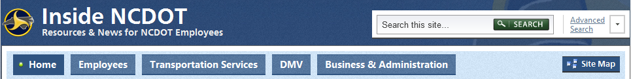
The left column lists content for each of the top-level tabs. The right column gives links to the team and project sites that you have permissions to use.
