CTP-ICE Screening for Indirect Effects
TECHNICAL MEMORANDUM
(CTP-ICE Product 3 – Part 1)
Date: | Revision: Date:  Date of Original Version:
To: | NCDOT Transportation Planning Branch Regional Unit Head, TPB  NCDOT Community Studies Team Leader, HES
From: | Staff, TPB/MPO/RPO
Subject: | CTP-ICE Screening for Indirect Effects for the XXXX CTP
This Technical Memorandum template provides instruction for documenting Part 1 of the Product 3 Comprehensive Transportation Plan-Indirect and Cumulative Effects (CTP-ICE) –Screening for Indirect Effects of the CTP Alternatives. Part 1 documents the alternatives screening for indirect effects. In Part 1, a separate matrix and technical memorandum are prepared for each alternative whereas in Part 2, only one matrix and technical memo are prepared for assessing cumulative effects at the CTP level.
The Metropolitan Planning Organization (MPO), Rural Planning Organization (RPO), and/or Transportation Planning Branch staff will conduct the Indirect Effects Screening of alternatives and draft the Technical Memorandum summarizing the results. The NCDOT Human Environment Section-Community Studies (HES-CS) staff will review the Indirect Effects Screening Technical Memorandum and Screening Matrices and provide comments to the MPO/RPO and Transportation Planning Branch (TPB) Staff to ensure consistency between long-range planning and the National Environmental Policy Act (NEPA) process during project development.

CTP-ICE Plan-Level Screening: XXXX CTP Study Area

CTP-ICE Plan-Level Screening Results for the XXXX CTP Study Area
Summarize the results of the screening matrix. Highlight the primary factors that affected the result.
The following sections of the Technical Memorandum will contain an overview of the TPB Alternatives, followed by sections that correspond to the categories within the matrix. These sections will contain brief paragraphs documenting the important variables which have been assessed, using the staff’s best professional judgment, to qualitatively rank categories.

CTP-ICE Screening Matrix for Indirect Effects, Plan-Level: XXXX CTP Study Area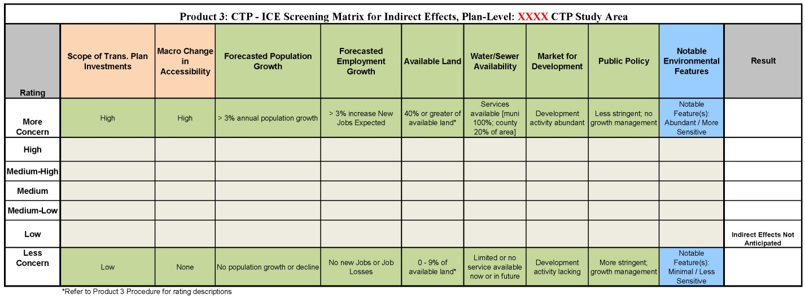Figure 1 – See attached matrix for larger image

CTP Project Proposals

Briefly describe the highway, public transportation, rail, pedestrian, and bicycle project proposals contained in the CTP. The CTP-ICE Screening for Indirect Effects will be based on these proposals. Distinguish between proposals to upgrade existing facilities and those projects that would be on new location.

Scope of Transportation Plan Investments
Provide a written description of the ranking provided in the matrix that addresses the Scope of the Transportation Investments. The planner will describe the ranking of the alternative, that includes new location bypass, major roadway widening, and new rail service. The alternatives that will result in greater capacity and travel speed will have higher rankings within the matrix.

Macro Change in Accessibility
Provide a written description of the ranking of the change in accessibility qualitatively considering overall macro changes in access likely to result from the alternative. The documentation will be based on best professional judgment to qualitatively rank the category. A high ranking would include a major roadway widening with less access control, higher frequency of new interchanges/intersections, and new location highways or freeways, with resulting changes in accessibility.

Forecasted Population Growth
Provide a written description of the ranking of the population growth or decline expected in the CTP Study Area, and why the rating of more concern, or less concern was selected. The documentation will be based on best professional judgment of growth and planned development, as well as data and projections contained in Community Understanding Report (CUR) report and elsewhere within the CTP dataset. Any methodology used to create a more localized or regional population rate should be provided.

Forecasted Employment Growth
Provide a written description of the ranking of the growth expected in the CTP Study Area, and why the rating of more concern, or less concern was selected. The documentation will be based on best professional judgment of the CTP Study Area trends, as well as data and projections contained in CUR report and elsewhere within the CTP dataset. Any methodology used to create a more localized, or regional employment rate should be provided.

Available Land
Document and describe the quantitative (GIS) or qualitative methodology used to estimate the amount of land available for development contained in the identified CTP Study Area. If a GIS quantitative methodology was used, note the amount of land that is already developed, how this acreage was calculated, and how the ranking of the matrix was determined. Describe the qualitative methodology for assessing available land, how staff estimated percentages of land available for development, and how a ranking of more concern or less concern of the matrix was determined.

Water and Sewer Availability
Describe the ranking of the availability of water and sewer service in the CTP Study Area by the time horizon. This narrative will describe the general location of existing service areas, and the areas where extension of service is planned under capital programs (G.SSS. 153A-82(5) for counties, and G.SS. 160A-148(5) for cities).

Market for Development
Document and describe the current development pressures occurring in the CTP Study Area. Describe how a ranking was selected; for example, a high ranking would denote abundant development activity, while a low ranking would indicate development activity is lacking, and note development trends or characteristics.

Public Policy
Document and describe the prevalence and applicability of the development policies and regulations in the jurisdictions contained in the CTP Study Area. The summary will note that less stringent policies and regulations would be ranked as high, whereas more stringent regulations and growth management policies would be ranked low.

Notable Environmental Features
Document and describe the sensitivity and abundance of notable environmental features in the CTP Study Area. Examples of sensitive environmental features would include, but are not limited to: major waterways, significant natural heritage areas, important habitat areas, land designated for conservation/preservation, water supply watershed areas, 303 (d) listed streams, high quality waters, outstanding resource waters, trout streams, etc... The ranking will relate to the sensitivity and abundance of these resources. A high ranking would constitute several environmental features that are more sensitive, and a low ranking would indicate that there are very few environmental features that are less sensitive.

CTP-ICE Project-Level Screening: XXXX Project
XXXX Project
Provide a brief overview of the project and explain why it was selected for a Project-Level Screening. Refer to the results from the Product 2 Future Growth Potential Assessment as reason for the screening. Reasons for a second-screening may include but are not limited to: major project, high priority, close to implementation, new location, available land, and water and sewer availability in the project vicinity.
CTP-ICE Project-Level Screening Results for the XXXX Project
Summarize the results of the screening matrix, which should be conducted at the project-level. If analysis is not possible at the project-level, use the result from the plan-level. Highlight the primary factors that affected the result. If the result of the screening matrix is different at the project-level than at the plan-level, explain the reasons for the difference.
CTP-ICE Screening Matrix for Indirect Effects, Project-Level: XXXX Project (Local ID XXXX####-#)
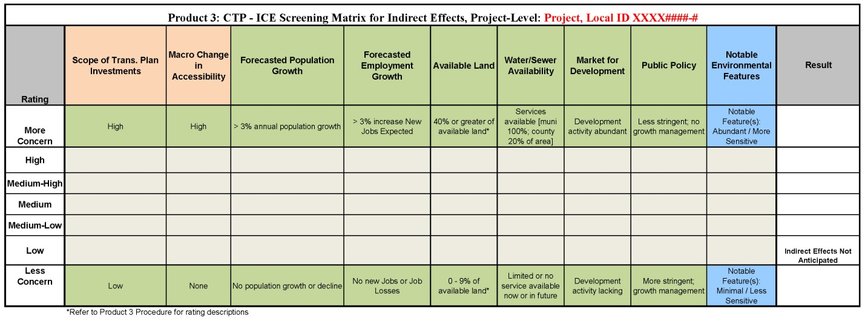
Figure 2 – See attached matrix for larger image

Following the plan-level instructions provided above in this template, include written descriptions for each of the nine categories shown in the matrix above. The descriptions should reflect the analysis conducted at the project-level. If analysis is not possible at the project-level, document that the result is from the plan-level screening.

